|  |  |
| --- | --- |
|  | **MINISTRY OF EDUCATION AND TRAINING** |

|  |
| --- |
| **FPT UNIVERSITY** |
| Capstone Project Document |
| [MYSTERY MINIS - BLIND BOX SALE SYSTEM] |

|  |  |
| --- | --- |
| **<Mystery Minis Team>** | |
| **Group Members** | Nguyen Quang Giap - SE182477 - GiapNQ  Lam Quoc Phong - SE183161 - PhongLQ  Luong The Minh - SE182480 - MinhLT  Nguyen Vu Thao Vi - SE183117 - ViNVT |
| **Supervisor** | Nguyen Ngoc Lam |
| **Ext Supervisor** | N/A |
| **Capstone Project code** |  |

- HCM, <3>/<2025> -

**Table of Contents**

Acknowledgement 4

Definition and Acronyms 4

I. Project Introduction 5

1. Overview 5

2. Product Background 5

3. Existing Systems 5

4. Business Opportunity 5

5. Software Product Vision 5

6. Project Scope & Limitations 5

II. Project Management Plan 6

1. Overview 6

2. Management Approach 6

3. Master Schedule 6

4. Project Organization 6

5. Project Communication 6

6. Configuration Management 6

III. Software Requirement Specification 7

1. Overall Description 7

2. User Requirements 7

3. Functional Requirements 7

4. Non-Functional Requirements 7

5. Other Requirements 7

IV. Software Design Description 8

1. Overall Description 8

2. System Architecture Design 8

3. System Detailed Design 8

4. Class Specification 8

5. Data & Database Design 10

# Definition and Acronyms

|  |  |
| --- | --- |
| **Acronym** | **Definition** |
| PWM | Psychology website |
| AWS | Amazon Web Services |
| BA | Business Analysis |
| BR | Business Rule |
| ERD | Entity Relationship Diagram |
| GUI | Graphical User Interface |
| PM | Project Manager |
| SDD | Software Design Description |
| SPMP | Software Project Management Plan |
| SRS | Software Requirement Specification |
| UAT | User Acceptance Test |
| UC | Use Case |
| API | Application Program Interface |

# I. Project Introduction (Thảo Vi)

*[Provide final project introduction information follow the template as part II in the Report #1]*

## 1. Overview

### 1.1 Project Information

Project name: BlindBox E-Commerce Platform

Project code: SWD392

Group name:

### 1.2 Project Team

*Project Manager: Nguyen Quang Giap*

*Developers: Nguyen Quang Giap, Lam Quoc Phong , Nguyen Vu Thao Vi, Luong The Minh*

*UI/UX Designers: Lam Quoc Phong, Nguyen Vu Thao Vi, Luong The Minh*

*Stakeholders: Collectible Toy Brand (e.g., Pop Mart, Baby Three,...), Blindbox Enthusiasts.*

## 2. Product Background

*The popularity of* ***blind box collectibles*** *has surged in recent years, especially among young adults and toy enthusiasts who enjoy the thrill of surprise unboxings. The demand for limited-edition figures from well-known brands such as* ***Pop Mart, BabyThree, Sonny Angel, and 100% Soft*** *has created a booming market. However, there is still a lack of an* ***all-in-one*** *e-commerce platform dedicated specifically to blind box sales, community engagement, and exclusive releases. This project aims to fill that gap by providing a seamless shopping experience tailored to collectors and casual buyers alike.*

## 3. Existing Systems

Several platforms currently sell blind boxes, including:

**E-commerce Giants:** Shopee, Lazada, and Amazon sell blind boxes, but they are not specialized in this niche.

**Brand-Specific Websites:** Individual brands like **Pop Mart** have their own online stores, but they lack cross-brand comparisons and variety.

**Resale Platforms:** Many collectors turn to eBay or Mercari to buy/sell rare figures, but these platforms lack authenticity verification and structured trading features.

Our project will take inspiration from these platforms while addressing their limitations to provide a **one-stop solution** for blind box lovers.

## 4. Business Opportunity

The blind box industry is projected to grow rapidly, driven by:

**FOMO (Fear of Missing Out) Culture:** Many collectors seek exclusive and limited-edition items.

**Growing Market Demand:** More brands are launching blind box series, expanding the market scope.

**Social Media Influence:** Unboxing videos on TikTok, YouTube, and Instagram have created an engaging and viral market.

**Lack of a Dedicated Platform:** Current e-commerce sites do not provide a specialized, collector-focused experience.

By introducing a dedicated **BlindBox E-Commerce Platform**, we aim to:

Offer a marketplace with **verified** collectibles.

Enable pre-orders for upcoming **exclusive** releases.

Create a **community-driven** space with forums, trading features, and collector rankings.

## 6. Project Scope & Limitations

#### Scope:

**E-commerce System:** Secure checkout, payment integration, and inventory management.

**Collector Community Features:** Wishlist, trade listings, and discussion forums.

**Authenticity Verification:** Ensuring all items are genuine and factory-sealed.

#### Limitations:

**No Physical Stores Initially:** The platform will be online-only at launch.

**Limited Brands at Launch:** We will start with major brands (e.g., Pop Mart, BabyThree) before expanding.

**Regional Availability:** Shipping and services may be limited to specific countries at first.

# II. Project Management Plan (Quang Giáp)

|  |  |  |  |  |  |  |
| --- | --- | --- | --- | --- | --- | --- |
| **Sprint** | **STT** | **Task** | **Complexity** | **FE** | **BE** | **Deadline FE** |

|  |  |  |  |  |  |  |
| --- | --- | --- | --- | --- | --- | --- |
| 1 | 1 | Login page | Medium | PhongLQ | GiapNQ | 16/02/2025 |
| 2 | User registration | Easy | PhongLQ | GiapNQ | 16/02/2025 |
| 3 | Forget password | Easy | PhongLQ | GiapNQ | 16/02/2025 |
| 5 | Reset password | Easy | ViNVT | GiapNQ | 16/02/2025 |
| 6 | Homepage | Medium | MinhLT | GiapNQ | 16/02/2025 |
| 7 | Populate database | Medium |  | GiapNQ | 16/02/2025 |
| 8 | Staff page | Easy | ViNVT | PhongLQ | 16/02/2025 |
| 9 | Manage order page | Easy | ViNVT | PhongLQ | 16/02/2025 |
| 2 | 10 | User profile | Easy | MinhLT | GiapNQ | 23/02/2025 |
| 11 | Manage order | Complex | MinhLT | GiapNQ | 23/02/2025 |
| 12 | Order history | Easy | MinhLT | GiapNQ | 23/02/2025 |
| 13 | Our blindbox | Easy | PhongLQ | PhongLQ | 23/02/2025 |
| 14 | Blind Box detail | Easy | ViNVT | PhongLQ | 23/02/2025 |
| 15 | Limited BlindBox package page | Easy | MinhLT | GiapNQ | 23/02/2025 |
| 16 | Package Information | Easy | MinhLT | GiapNQ | 23/02/2025 |
| 17 | Order product use case | Complex | PhongLQ | GiapNQ | 23/02/2025 |
| 3 | 18 | Deploy server | Complex |  | GiapNQ | 02/03/2025 |
| 19 | Deploy database | Complex |  | GiapNQ | 02/03/2025 |
| 20 | Feedback use case | Easy | ViNVT | GiapNQ | 02/03/2025 |
| 21 | Refund use case | Easy | PhongLQ | GiapNQ | 02/03/2025 |
| 22 | Open blindbox use case | Complex | MinhLT | GiapNQ | 02/03/2025 |
| 23 | Blog use case | Medium | ViNVT | PhongLQ | 02/03/2025 |
| 24 | Chat use case | Complex | PhongLQ | GiapNQ | 02/03/2025 |
| 25 | Manage brand | Easy | ViNVT | PhongLQ | 02/03/2025 |
| 26 | Manage product | Easy | ViNVT | GiapNQ | 02/03/2025 |
| 4 | 26 | Dashboard use case | Complex | PhongLQ | PhongLQ | 09/03/2025 |
| 27 | Collection | Easy | PhongLQ | PhongLQ | 09/03/2025 |
| 28 | Manage Box Item | Easy | PhongLQ | PhongLQ | 09/03/2025 |
|  | Shipping use case | Complex |  | PhongLQ |  |
| 29 | Manage account page | Easy | ViNVT | GiapNQ | 09/03/2025 |
| 30 | Manage voucher use case | Easy | MinhLT | GiapNQ | 09/03/2025 |
| 31 | Unbox blindbox for customer use case | Easy | PhongLQ | GiapNQ | 09/03/2025 |
| 5 | 32 | Mobile HomeScreen | Medium | MinhLT |  | 12/03/2025 |
| 33 | Mobile LoginScreen | Medium | ViNVT |  | 12/03/2025 |
| 34 | Mobile RegisterScreen | Medium | ViNVT |  | 12/03/2025 |
| 35 | Mobile Product Screen | Medium | PhongLQ |  | 12/03/2025 |
| 36 | Mobile Product Detail Screen | Medium | PhongLQ |  | 12/03/2025 |
| 37 | Mobile Cart Screen | Medium | PhongLQ |  | 12/03/2025 |
| 38 | Mobile Favorites Screen | Medium | PhongLQ |  | 12/03/2025 |
| 39 | Mobile User Menu | Medium | MinhLT |  | 12/03/2025 |
| 40 | Mobile User Profile Screen | Medium | MinhLT |  | 12/03/2025 |
| 41 | Mobile User Manage Order | Medium | MinhLT |  | 12/03/2025 |
| 42 | Mobile User Manage Address | Medium | MinhLT |  | 12/03/2025 |
| 43 | Mobile Box item screen | Medium | ViNVT |  | 12/03/2025 |
| 44 | Mobile Box Item Detail Screen | Medium | ViNVT |  | 12/03/2025 |
| 45 | Mobile Order pay Success | Medium | ViNVT |  | 12/03/2025 |
| 46 | Mobile Blog page | Medium | ViNVT |  | 12/03/2025 |

# III. Software Requirement Specification

*[Provide final software requirement specification follow the template as part II in the Report #3]*

## 1. Product Overview

The **Blindbox Product Sale System** is an online e-commerce platform that enables customers to purchase blind boxes. It provides an engaging shopping experience while allowing the company to efficiently manage its blind box inventory. The system supports features such as order management, customer feedback, and a live chat system for customer support.

### Product Environment

The system is a **web-based application** accessible via modern web browsers. It integrates with the VNPay payment gateway for secure transactions and utilizes Firebase for cloud storage. The backend is built using **ASP .Net Core 8.0**, with a **PostgreSQL database** to store user and product data.

### Anticipated Users

* **Customers**: Browse products, make purchases, manage orders, and participate in promotional events.
* **Staff**: Manage inventory, oversee customer support chat, and handle refunds/returns.
* **Administrators**: Oversee system operations, manage staff accounts, and track business performance via a dashboard.

### Known Constraints

* The system supports only online transactions; no physical store integration.
* Limited to VNPay as the payment gateway.
* The initial version does not support international orders.

### Assumptions:

* Users will have access to a stable internet connection.
* The business will provide timely support and maintain the inventory.
* Promotional campaigns will be managed internally without third-party involvement.

### Dependencies:

* Firebase for cloud storage.
* VNPay for payment processing.
* ReactJS for the front-end, ASP .Net Core 8.0 for backend logic.

## 

## 2. User Requirements

### 2.1 Overview

### 2.2 Use Case diagram

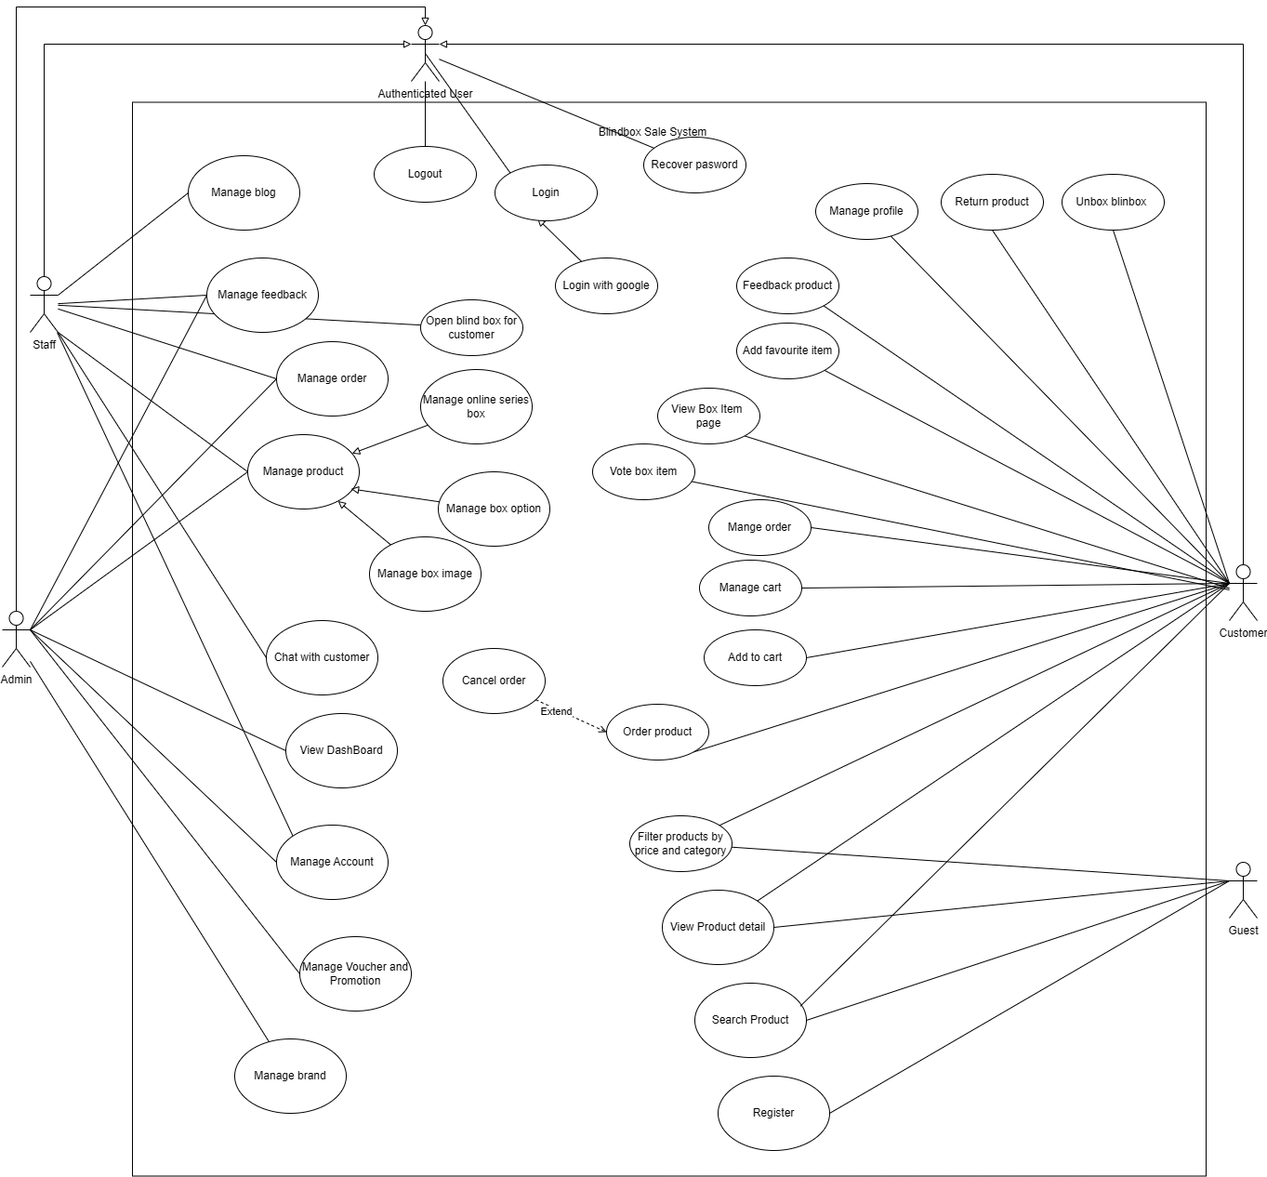

#### 2.2.1 System Actors (Lương Thế Minh)

|  |  |  |
| --- | --- | --- |
| **#** | **Actor** | **Description** |
| 1 | Guest | Users who have not registered or logged in. |
| 2 | Customer | Registered users who can purchase blind boxes and have role customer |
| 3 | Staff | Employees responsible for managing products, feedback, orders, blogs, and customer support and have role staff |
| 4 | Admin | System administrators responsible for managing all system operations, users, and promotions, have role admin and can do everything staff can. |

### 

#### 2.2.2 Use Cases Description (Lương Thế Minh)

|  |  |  |  |
| --- | --- | --- | --- |
| **ID** | **Use Case** | **Actors** | **Use Case Description** |
| UC-01 | Order Product | Customer | Customers can place an order for selected products. |
| UC-02 | Login | Customer | Customers log in to access additional features. |
| UC-03 | Register | Guest | Guests can create an account to become a customer. |
| UC-04 | Log out | Customer | Customer can log out |
| UC-05 | Open blind box for customer | Staff | Staff can open blind box for customer and upload image for them |
| UC-06 | Return Products | Customer | Customers can initiate return requests with image/video proof. |
| UC-07 | Manage Order | Customer | Customers can track, cancel, or return orders. |
| UC-08 | Search Products | Guest, Customer | Users can browse and search for blind boxes. |
| UC-09 | Manage Products | Staff  Admin | Staff can create, update, delete, and manage blind box products. |
| UC-11 | Manage Feedback | Staff  Admin | Staff can respond to customer feedback. |
| UC-12 | Manage Blog | Staff, Admin | Staff can create, edit, and delete blog posts. |
| UC-13 | Manage Voucher and promotion | Admin, Staff | Admin can create and manage promo codes and discount campaigns. |
| UC-14 | View Product Details | Guest, Customer | Users can see detailed descriptions, images, and ratings of products. |
| UC-15 | Unbox blindbox | Customer | Customers can buy and open an online blind box to reveal items. |
| UC-16 | Filter Products | Guest, Customer | Users can filter products by price and category. |
| UC-17 | Add to Cart | Customer | Customers can add products to their shopping cart. |
| UC-18 | Manage Cart | Customer | Customers can modify the quantity or remove items from the cart. |
| UC-19 | Add favourite item | Customer | Customers can add products to their favourite item list |
| UC-20 | Feedback product | Customer | Customers can leave ratings and reviews for purchased products. |
| UC-21 | Manage profile | Customer | Customers can update personal details and manage their accounts. |
| UC-22 | View collection page | Customer | Customer can view collection of box item |
| UC-23 | Vote box item | Customer | Customer can vote box item they like on collection page |
| UC-24 | Recover password | Customer | Customer can recover password when they forget it using email |
| UC-25 | Login google | Customer | Customer can login using their google account |
| UC-26 | Cancel order | Customer | Customer can cancel order at certain state |
| UC-27 | Manage brand | Staff, Admin |  |
| UC-28 | Manage Orders | Staff  Admin | Staff can process and update order statuses. |
| UC-29 | View dashboard | Admin | Admin can monitor revenue statistics (monthly, quarterly, yearly). |
| UC-30 | Manage Account | Admin, Staff | Admin can create, update, and delete user accounts. |
| UC-31 | Manage box image | Admin, Staff | Admin and staff can CRUD box item |
| UC-32 | Manage online serie box | Admin, Staff | Admin and staff can create and delete online serie box |
| UC-33 | Manage box option | Admin, Staff | Admin and staff can CRUD box option |

### 

###### 2.2.2.1 UC-01 Order Product

|  |  |  |  |
| --- | --- | --- | --- |
| **Use Case Specification** | | | |
| **Use Case ID and Name:** | Order product | | |
| **Created By:** | Quang Giap | Date Created: | 17/02/2025 |
| **Primary Actor:** | Customer | Secondary Actors: | Payment gateway, Shipping agency |
| **Trigger:** | The customer initiates the order process by deciding to purchase a blind box product from the catalog. | | |
| **Description:** | This use case details the process a customer follows to order a blind box product through the online system. It covers browsing the product catalog, viewing product details, adding the product to the shopping cart (referencing the separate “Add to Cart” use case), proceeding through checkout, selecting a shipping address and payment method, and finalizing the order. | | |
| **Preconditions:** | PRE-1. The customer is registered and logged into the system.  PRE-2. The product catalog is accessible and up-to-date.  PRE-3. The “Add to Cart” functionality is operational.  PRE-4. Payment gateway integration and shipping services are active. | | |
| **Post–conditions:** | POST-1. The order is confirmed, and payment is processed successfully.  POST-2. The system updates the order status to “Pending”.  POST-3. Inventory is adjusted accordingly, and the shipping process is initiated. | | |
| **Normal Flow:** | Order product   1. Customer browse the blind box product 2. Customer view blind box detail 3. Customer add to cart 4. The customer reviews the cart and clicks “Proceed to Checkout.” 5. Customer selects address 6. Customer selects delivery type 7. Customer selects voucher 8. Customer selects payment method 9. Customer proceeds payment 10. Upon successful payment, the system pending the order 11. After 5 minutes the system put the order to shipping agency 12. The system send email to customer to confirm the order successfully | | |
| **Alternative Flows:** | 5. Adding a New Shipping Address.  5.1. If the customer wants to use a new shipping address, they select “Add New Address.”  5.2. The system prompts the customer to enter the new address details, saves it, and sets it as the selected address.  9. Payment Failure  9.1 At step 8 if the payment fail the system displays an error message indicating the failure.  9.2. The customer is prompted to re-enter payment details or choose an alternative payment method.  9.3. The process returns to Step 8. | | |
| **Exceptions:** | 5.0.E1. Product Out of Stock: If the selected product is out of stock, the system notifies the customer of the unavailability.  5.0.E2. System Unavailability: If the payment gateway is unreachable during Step 8, the system informs the customer of the temporary unavailability and advises them to try again later. | | |
| **Priority:** | High | | |
| **Frequency of Use:** | Expected to be used multiple times daily by customers. | | |
| **Business Rules:** | BR-006: After place the order the customer have 5 minutes to cancel the order with COD payment method | | |
| **Other Information:** | None | | |
| **Assumptions:** | Product information, including pricing and stock levels, is accurate and updated in real time. | | |

###### 

###### 2.2.2.2 UC-02 Login

#### 

|  |  |  |  |
| --- | --- | --- | --- |
| **ID and Name:** | **UC-02 Login** | | |
| **Created By:** | Thao Vi | Date Created: | 18/2/2025 |
| **Primary Actor:** | User, Staff, Admin | Secondary Actors: | N/A |
| **Description:** | This use case allows the user to login the system. | | |
| **Trigger:** | User clicks the “Login” button to navigate to the Login page. | | |
| **Preconditions:** | PRE-1. The user must have a registered account in the system. | | |
| **Post-conditions:** | POST-1. User successfully logged in the system.  POST-2. User is navigated to “Home” page. | | |
| **Normal Flow:** | 1. User navigates to the Login page. 2. User enters information to login, including Email and Password. 3. User clicks “Login” button to submit. 4. The system validates user’s information. 5. The system redirects users to the Home page. | | |
| **Alternative Flows:** | **Step 2: User clicks “Google” button.**  2.1. The system redirects user to Google page.  2.2. User enter login information for a Google account.  2.3. Return to Step 4.  **Step 4: The submitted information is incorrect**  4.1. Display failed message.  4.2. The system stays on the Login page. | | |
| **Exceptions:** | **EX-01. Lost connection with the server or the internet.**  Display the Lost Connection Screen for user. | | |
| **Priority:** | High | | |
| **Frequency of Use:** | High | | |
| **Business Rules:** | N/A | | |
| **Other Information:** | N/A | | |
| **Assumptions:** | N/A | | |

#### 

###### 2.2.2.3 UC-03 Register

|  |  |  |  |
| --- | --- | --- | --- |
| **Use Case Specification** | | | |
| **Use Case ID and Name:** | UC-03 Register | | |
| **Created By:** | Phong Lâm | **Date Created:** | 17/02/2025 |
| **Primary Actor:** | Guest | **Secondary Actors:** | none |
| **Trigger:** | User clicks "Register" button | | |
| **Description:** | Enables new users to create an account in the blind box system | | |
| **Preconditions:** | PRE-1. User is not logged in  PRE-2. Registration system is operational  PRE-3. Email verification system is functional | | |
| **Post–conditions:** | PRE-1. New user account created  PRE-2. User profile initialized  PRE-3. Verification email sent | | |
| **Normal Flow:** | 1. User clicks Register  2. System displays registration form  3. User enters required information  4. System validates inputs  5. System sends verification email  6. User verifies email  7. System activates account  8. System redirects to login | | |
| **Alternative Flows:** | **1.1. Email Already Exists**  1. System notifies user  2. Returns to registration  **1.2. Invalid Information**  1. System highlights errors  2. User corrects information  3. Continues registration | | |
| **Exceptions:** | 1. Email System Failure   * System logs error   2. Database Error   * System rolls back registration * Displays error message | | |
| **Priority:** | High | | |
| **Frequency of Use:** | Medium (Daily) | | |
| **Business Rules:** | BR-009 | | |
| **Other Information:** | 1. Data encryption for sensitive information | | |
| **Assumptions:** | Email service is reliable  User provides valid information  User has email access | | |

###### 2.2.2.4 UC-04 Log out

#### 

|  |  |  |  |
| --- | --- | --- | --- |
| **UC ID and Name:** | UC-04 Logout | | |
| **Created By:** | Thao Vi | **Date Created:** | 18/2/2025 |
| **Primary Actor:** | User, Staff, Admin | **Secondary Actors**: | N/A |
| **Description:** | This use case allows the user to logout the system. | | |
| **Trigger:** | User clicks the “Logout” button. | | |
| **Preconditions:** | PRE-1. The user must have logged in. | | |
| **Post-conditions:** | POST-1. Users successfully logout the system.  POST-2. User is redirected to the Login page. | | |
| **Normal Flow:** | 1. User clicks the “Logout” button. 2. User is redirected to the Login page. | | |
| **Alternative Flows:** | N/A | | |
| **Exceptions:** | **EX-01. Lost connection with the server or the internet.**  Display the Lost Connection Screen for users. | | |
| **Priority:** | High | | |
| **Frequency of Use:** | High | | |
| **Business Rules:** | N/A | | |
| **Other Information:** | N/A | | |
| **Assumptions:** | N/A | | |

###### 2.2.2.5 UC-05 Open blind box for customer

|  |  |  |  |
| --- | --- | --- | --- |
| **Use Case Specification** | | | |
| **Use Case ID and Name:** | UC-05 Open blind box for customer | | |
| **Created By:** | Quang Giap | **Date Created:** | 17/02/2025 |
| **Primary Actor:** | Staff | **Secondary Actors:** | Customer |
| **Trigger:** | The customer opts for the "Open Blindbox" service by selecting a checkbox when placing an order. | | |
| **Description:** | This use case describes the process where staff members open the blind box on behalf of the customer, capture an image of the revealed item, and update the order details in the system. The customer can later view the blind box result in the "Manage Orders" tab. | | |
| **Preconditions:** | PRE-1. The customer has placed an order and selected the "Open Blindbox" option.  PRE-2. The order is in processing status.  PRE-3. The system allows staff to update order details and upload images.  PRE-4: The user must be logged in to the system | | |
| **Post–conditions:** | POST-1. The blind box is opened by staff, and the item inside is revealed.  POST-2. The staff uploads an image of the revealed item to the system.  POST-3. The customer can view the revealed item image in the "Manage Orders" tab. | | |
| **Normal Flow:** | 1. The customer places an order and ticks the "Open Blindbox" option at checkout. 2. The order enters "Processing" status, and the system notifies staff that the order requires blind box opening. 3. Staff selects the order item in the Manage order 4. Staff opens the blind box and reveals the item inside. 5. Staff captures an image of the revealed item and uploads it to the system. 6. The customer accesses the "Manage Orders" tab and views the revealed item image. | | |
| **Alternative Flows:** | None | | |
| **Exceptions:** | 5.0.E1 – Image Upload Failure:  1a. If the image upload fails, the system notifies staff to retry.  1b. If the issue persists, the system logs the error and allows staff to manually enter item details instead. | | |
| **Priority:** | Medium | | |
| **Frequency of Use:** | Expected to be used frequently by staff for customers who opt for this service.  Usage may increase during special promotions or events featuring blind box products. | | |
| **Business Rules:** | BR-010, BR-011 | | |
| **Other Information:** | None | | |
| **Assumptions:** | The customer understands that selecting "Open Blindbox" means they will not receive a sealed box.  Staff members have the necessary tools to open and photograph the blind box contents.  The system can handle high-volume image uploads efficiently. | | |

###### 2.2.2.6 UC-06 Return product

|  |  |  |  |
| --- | --- | --- | --- |
| **Use Case Specification** | | | |
| **Use Case ID and Name:** | UC-06Return product | | |
| **Created By:** | Quang Giap | **Date Created:** | 17/02/2025 |
| **Primary Actor:** | Customer | **Secondary Actors:** | Staff |
| **Trigger:** | The customer selects an item from a previously placed order and presses the "Refund" button in the Manage Orders tab. | | |
| **Description:** | This use case describes the product return process, where a customer selects an order item for a refund, initiates a return request, and communicates with staff for verification. The staff may accept or decline the request based on the evidence (images/videos) provided. If the request is accepted, the system updates the number of returned items in the order details. | | |
| **Preconditions:** | PRE-1. The customer must be logged into the system.  PRE-2. The product must be eligible for return (within 3 days of order completion).  PRE-3. The order must have been successfully delivered before a return request can be initiated. | | |
| **Post–conditions:** | POST-1. If the return request is approved, the system updates the number of returned items in the order details.  POST-2. If the return request is declined, the system notifies the customer of the decision. | | |
| **Normal Flow:** | 1. Customer navigates to the "Manage Orders" page. 2. Customer selects an item from a completed order that is eligible for return. 3. Customer presses the "Refund" button to initiate a return request. 4. Staff check the manage order and saw the return request. 5. Staff opens a chat with the customer and asks for supporting images/videos of the product condition. 6. Customer uploads images/videos in the chat for verification. 7. Staff reviews the provided evidence and chooses to either:    1. Accept the return request    2. Decline the request with a reason.   8.1. If staff accepts the return:  a.The system updates the number of returned items in the order details.  b. The system notifies the customer of the successful return request.  8.2. If staff declines the return: Request ticket close | | |
| **Alternative Flows:** | None | | |
| **Exceptions:** | 5.0.E.1 – System Unavailability: If the chat system is down, the customer cannot upload files, and the request is put on hold until the system is restored. | | |
| **Priority:** | Medium | | |
| **Frequency of Use:** | Expected not to be used frequently | | |
| **Business Rules:** | BR-004 | | |
| **Other Information:** | The chat system support file uploads (images/videos) for verification | | |
| **Assumptions:** | Customers understand and agree to the return policy before making a request. | | |

###### 

###### 2.2.2.7 UC-07 Manage Order

|  |  |  |  |
| --- | --- | --- | --- |
| **Use Case Specification** | | | |
| **Use Case ID and Name:** | UC-09 Manage order | | |
| **Created By:** | Quang Giáp | **Date Created:** | 18/02/2025 |
| **Primary Actor:** | User | **Secondary Actors:** |  |
| **Trigger:** | The customer navigates to the "Manage Orders" section in the application. | | |
| **Description:** | This use case describes the process where a customer can view their current orders, check the status of each order, and access order history. The system retrieves the necessary data and displays it in an organized manner. | | |
| **Preconditions:** | PRE-1. The customer must be logged into the system.  PRE-2. The system must have order records associated with the customer’s account. | | |
| **Post–conditions:** | POST-1. The customer can successfully view their ongoing and past orders.  POST-2. The system correctly displays order statuses for ongoing orders.  POST-3. The system ensures order history is accessible and accurate. | | |
| **Normal Flow:** | 1. Customer navigates to the "Manage Orders" page. 2. The system retrieves and displays the customer’s orders, categorized as:  * Current Orders (Orders in progress: Pending, Processing, Shipping) * Order History (Completed or Canceled orders)  1. Customer selects a current order to view more details (e.g., items, tracking info). 2. Customer selects an order from history to review past purchases in detail. 3. The system displays the selected past order’s details, including 4. Customer exits the "Manage Orders" page. | | |
| **Alternative Flows:** | None | | |
| **Exceptions:** | None | | |
| **Priority:** | High | | |
| **Frequency of Use:** | Expected to be used frequently as customers regularly check their order status.  Higher usage expected during peak sales periods (e.g., promotions, holidays). | | |
| **Business Rules:** | BR-013 | | |
| **Other Information:** | None | | |
| **Assumptions:** | The order management system has all necessary order data stored correctly. | | |

###### 2.2.2.8 UC-08 Search Product

|  |  |  |  |
| --- | --- | --- | --- |
| **Use Case Specification** | | | |
| **Use Case ID and Name:** | UC-08 Search Product | | |
| **Created By:** | Phong Lâm | **Date Created:** | 17/02/2025 |
| **Primary Actor:** | Customer, Guest | **Secondary Actors:** |  |
| **Trigger:** | User selects search function or enters search terms | | |
| **Description:** | Allows users to search for blind box products using keywords | | |
| **Preconditions:** | PRE-1. System is operational  PRE-2. Product database is accessible  PRE-3. Search function is available | | |
| **Post–conditions:** | PRE-1. Search results are displayed  PRE-2. Product availability status is current | | |
| **Normal Flow:** | 1. User accesses search function  2. User enters search criteria  3. System performs search in database  4. System displays matching products  5. User can view product details from results  6. System displays pagination if results > 10 items | | |
| **Alternative Flows:** | **1.1. No Results Found**  1. System shows "No products found" message | | |
| **Exceptions:** | 1. Database Error   * System displays error message * System logs error * System notifies technical support   2. Invalid Search Input   * System shows input requirements * Returns to search input | | |
| **Priority:** | High | | |
| **Frequency of Use:** | Very High (Multiple times per day) | | |
| **Business Rules:** | BR-015  BR-014  BR-016 | | |
| **Other Information:** | 1. Search includes product name, description, and tags | | |
| **Assumptions:** | Internet connection is stable  Product database is up to date | | |

###### 2.2.2.9 UC-09 Manage Product

|  |  |  |  |
| --- | --- | --- | --- |
| **Use Case Specification** | | | |
| **Use Case ID and Name:** | UC-09 Manage Product | | |
| **Created By:** | Phong Lâm | **Date Created:** | 17/02/2025 |
| **Primary Actor:** | Admin, Staff | **Secondary Actors:** | none |
| **Trigger:** | Admin selects "Manage Product" option | | |
| **Description:** | Allows administrators to manage blind box products | | |
| **Preconditions:** | PRE-1. Admin and Staff is authenticated  PRE-2. Admin and Staff has product management rights  PRE-3. Product database is accessible | | |
| **Post–conditions:** | PRE-1. Product changes saved  PRE-2. Audit log created  PRE-3. Product cache refreshed | | |
| **Normal Flow:** | 1. Admin (or Staff) accesses product management  2. System displays product interface  3. Admin (or Staff) selects product action  4. Admin (or Staff) makes changes  5. System validates changes  6. System saves changes  7. System confirms update | | |
| **Alternative Flows:** | **1.1. Product Creation**  1. Admin (or Staff) enters new product details  2. System validates information  3. System creates product  **1.2. Product Modification**  1. Admin (or Staff) modifies existing product  2. System validates changes  3. System updates product | | |
| **Exceptions:** | 1. Validation Error   * System displays error details * Maintains current state * Allows correction   2. Invalid Search Input   * System logs error * Rolls back changes | | |
| **Priority:** | High | | |
| **Frequency of Use:** | High (Multiple times per day) | | |
| **Business Rules:** | BR-017 | | |
| **Other Information:** | 1. Bulk update capability  2. Image optimization required | | |
| **Assumptions:** | Storage system available  Image processing available  Cache system operational | | |

###### 

###### 2.2.2.10 UC-10 Chat with customer

|  |  |  |  |
| --- | --- | --- | --- |
| **Use Case Specification** | | | |
| **Use Case ID and Name:** | UC-10 Chat with Customer | | |
| **Created By:** | Phong Lâm | **Date Created:** | 17/02/2025 |
| **Primary Actor:** | Staff | **Secondary Actors:** | Customer |
| **Trigger:** | Customer initiates chat or staff responds to queue | | |
| **Description:** | Enables real-time customer support through chat interface | | |
| **Preconditions:** | PRE-1. Staff is logged in  PRE-2. Chat system operational  PRE-3. Customer support available | | |
| **Post–conditions:** | PRE-1. Chat transcript saved  PRE-2. Chat properly closed | | |
| **Normal Flow:** | 1. Staff receives chat request  2. Staff accepts chat  3. System loads customer info  4. Staff and customer communicate  5. Staff resolves inquiry  6. Staff closes chat | | |
| **Alternative Flows:** | **1.1. Chat Transfer**  1. Staff initiates transfer  2. New staff accepts  3. Chat continues  **1.2. Customer Disconnect**  1. System attempts reconnection  2. Staff waits timeout period  3. Chat archived | | |
| **Exceptions:** | 1. System Failure   * Chat archived   2. High Volume   * Alternative contact offered | | |
| **Priority:** | High | | |
| **Frequency of Use:** | Very High (Continuous) | | |
| **Business Rules:** | Protect user’s private chat information | | |
| **Other Information:** | BR-019 | | |
| **Assumptions:** | Stable internet connection  Staff properly trained  Customer information available | | |

###### 2.2.2.11 UC-11 Manage Feedback

#### 

|  |  |  |  |
| --- | --- | --- | --- |
| **ID and Name:** | **UC-11 Manage *Feedback*** | | |
| **Created By:** | Thao Vi | Date Created: | 18/02/2025 |
| **Primary Actor:** | Staff, Admin | Secondary Actors: | N/A |
| **Description:** | This use case allows users to perform actions on view and delete feedback | | |
| **Trigger:** | User clicks the “Feedback” link and performs Delete actions. | | |
| **Preconditions:** | PRE-1. The user must have logged in. | | |
| **Postconditions:** | POST-1. User successfully perform actions on Delete Feedback. | | |
| **Normal Flow:** | 1. User clicks “Manage Feedback” on the sidebar. 2. The system displays a list of all feedback. 3. User performs deleting feedback.   3.1. User click delete icon on a feedback  3.2. User clicks “OK” button to submit.  3.3. The system shows popup success.  3.4. The system redirects users to the “Manage Feedback” page. | | |
| **Alternative Flows:** | **Step 3.2: User clicks “Cancel” button**  3.2.1. Display failed message.  3.2.2. Return to Step 3.4. | | |
| **Exceptions:** | **EX-01. Lost connection with the server or the internet.**  Display the Lost Connection Screen for users. | | |
| **Priority:** | Low | | |
| **Frequency of Use:** | Medium | | |
| **Business Rules:** | BR-019, BR-020, BR-021 | | |
| **Other Information:** | N/A | | |
| **Assumptions:** | N/A | | |

###### 2.2.2.12 UC-12 Manage Blog

#### 

|  |  |  |  |
| --- | --- | --- | --- |
| **ID and Name:** | **UC-12 Manage *Blog*** | | |
| **Created By:** | Thao Vi | **Date Created:** | 18/02/2025 |
| **Primary Actor:** | Staff | **Secondary Actors:** | N/A |
| **Description:** | This use case allows users to perform actions on Create, View, Update and Delete Blog. | | |
| **Trigger:** | User clicks the “Manage Blog” on the sidebar and performs Create, View, Update and Delete Blog. | | |
| **Preconditions:** | PRE-1. The user must have logged in. | | |
| **Postconditions:** | POST-1. User successfully perform actions on Create, View, Update and Delete Blog. | | |
| **Normal Flow:** | 1. User clicks “Manage Blog” on the sidebar. 2. The system displays a list of all blog. 3. User performs creating a new blog.   3.1. User click on the “Add blog” button.  3.2. User enters information for a blog on popup.  3.3. User clicks “Add” button to submit.  3.4. The system validates all input fields.  3.5. The system show popup success   1. User performs editing a blog.   4.1. User clicks the “Update” icon on a blog tab to turn on “Update Blog” popup.  4.2. User enters new information for the blog.  4.3. User clicks “Update” button to submit.  4.4. The system validates all input fields.  4.5. The system show popup success   1. User performs deleting a blog.   5.1. User clicks the “Delete” icon on a blog tab to turn on the “Delete Blog” popup.  5.2. The system displays a popup for deleting confirmation.  5.3. User clicks “Delete” button.  5.4. The system deletes the blog.  5.5. The system show popup success | | |
| **Alternative Flows:** | **Step 3.3: User clicks “Cancel” button**  3.3.1. Display add fail popup  **Step 3.4: The input field(s) is invalid**  3.4.1. Display failed message.  3.4.2. Return to Step 3.2.  **Step 4.3: User clicks “Cancel” button**  4.3.1. Display failed popup.  **Step 4.4: The input field(s) is invalid**  4.4.1. Display failed message.  4.4.2. Return to Step 4.2.  **Step 5.3: User clicks “Cancel” button**  5.3.1. Display failed popup | | |
| **Exceptions:** | **EX-01. Lost connection with the server or the internet.**  Display the Lost Connection Screen for users. | | |
| **Priority:** | Low | | |
| **Frequency of Use:** | Medium | | |
| **Business Rules:** | BR-022, BR-023 | | |
| **Other Information:** | N/A | | |
| **Assumptions:** | N/A | | |

### 

###### 2.2.2.13 UC-13 Manage Voucher and Promotion

|  |  |  |  |
| --- | --- | --- | --- |
| **Use Case Specification** | | | |
| **Use Case ID and Name:** | UC-13 Manage Voucher and Promotion | | |
| **Created By:** | The Minh | **Date Created:** | 17/02/2025 |
| **Primary Actor:** | Admin | **Secondary Actors:** |  |
| **Trigger:** | Admin initiates voucher or promotion management actions. | | |
| **Description:** | This use case allows an administrator to manage discount vouchers and promotional campaigns, including creating, updating, activating, deactivating, and deleting vouchers or promotions. The admin can set discount conditions, validity periods, and usage limits. | | |
| **Preconditions:** | PRE-1. Admin must be logged into the system.  PRE-2. Admin must have appropriate permissions to manage vouchers and promotions. | | |
| **Post–conditions:** | POST-1. A new voucher or promotion is created, updated, activated, deactivated, or deleted.  POST-2. The system reflects the changes in real-time, and customers can use the vouchers or see the promotions accordingly. | | |
| **Normal Flow:** | 1. Admin logs into the system.  2. Admin navigates to the "Voucher & Promotion Management" section.  3. Admin selects an action (Create, Update, Activate, Deactivate, Delete).  4. Admin enters or modifies voucher/promotion details (discount value, conditions, validity period, usage limits).  5. Admin confirms the changes.  6. The system processes the request and updates the database.  7. A confirmation message is displayed. | | |
| **Alternative Flows:** | * A1: If the admin chooses to update an existing voucher/promotion, they can modify details before saving. * A2: If the admin wants to deactivate a voucher instead of deleting it, they can disable it temporarily. | | |
| **Exceptions:** | * E1: If the admin enters invalid data (e.g., negative discount value or incorrect date format), the system prompts an error message. * E2: If the admin tries to delete an active promotion that is currently in use, the system prevents deletion and provides a warning. * E3: If the admin's session expires during the process, they are redirected to the login page and lose unsaved changes. | | |
| **Priority:** | High | | |
| **Frequency of Use:** | Expected to be used multiple times daily by customers. | | |
| **Business Rules:** | BR-024, BR-025, BR-026 | | |
| **Other Information:** | This use case applies to both percentage-based and fixed-amount discounts, as well as site-wide and category-specific promotions. | | |
| **Assumptions:** |  | | |

###### 

###### 2.2.2.14 UC-14 View Product Detail

|  |  |  |  |
| --- | --- | --- | --- |
| **Use Case Specification** | | | |
| **Use Case ID and Name:** | UC-14 View Product Detail | | |
| **Created By:** | The Minh | **Date Created:** | 17/02/2025 |
| **Primary Actor:** | Customer | **Secondary Actors:** |  |
| **Trigger:** | The user clicks on a BlindBox product to view its details. | | |
| **Description:** | This use case allows a user to view detailed information about a BlindBox product, including its price, description, available stock, and possible rewards inside. The user can also see images, ratings, and purchasing options. | | |
| **Preconditions:** | PRE-1. The BlindBox product must exist in the system.  PRE-2. The user must have access to the product page. | | |
| **Post–conditions:** | POST-1. The product details are displayed successfully.  POST-2. The system logs the user’s interaction for analytics purposes. | | |
| **Normal Flow:** | 1. The user navigates to the product listing page.  2. The user selects a BlindBox product.  3. The system retrieves product details from the database.  4. The system displays the product name, price, description, available stock, and possible rewards.  5. The user can view images, ratings, and reviews.  6. The user can proceed to purchase or return to the product list.. | | |
| **Alternative Flows:** | * A1: If the product has multiple variations, the system allows the user to select a specific type before displaying full details. * A2: If the user wants more details, they can expand sections for additional information (e.g., reward probabilities, terms & conditions). | | |
| **Exceptions:** | * E1: If the product is out of stock, the system displays an "Out of Stock" message and prevents purchasing. * E2: If the product details fail to load due to a system error, the system displays a relevant error message and suggests retrying later. * E3: If the user is not logged in and tries to access member-exclusive details, the system prompts them to log in first. | | |
| **Priority:** | High | | |
| **Frequency of Use:** | Expected to be used multiple times daily by customers. | | |
| **Business Rules:** | BR-027 | | |
| **Other Information:** | This use case applies to both web and mobile app platforms, ensuring a consistent user experience. | | |
| **Assumptions:** |  | | |

###### 2.2.2.15 UC-15 Unbox Blind box

|  |  |  |  |
| --- | --- | --- | --- |
| **Use Case Specification** | | | |
| **Use Case ID and Name:** | UC-15 Unbox online Blindbox | | |
| **Created By:** | The Minh | **Date Created:** | 17/02/2025 |
| **Primary Actor:** | Customer | **Secondary Actors:** | Payment gateway, Shipping agency |
| **Trigger:** | The use case is triggered when a customer decides to unbox an online blind box. | | |
| **Description:** | This use case describes the process of unboxing an online blind box by a customer. A blind box is a surprise package that contains a random item or set of items. | | |
| **Preconditions:** | PRE-1. The customer is registered and logged into the system.  PRE-2. The customer must choose a blind box and pay for it. | | |
| **Post–conditions:** | POST-1. The contents of the blind box are revealed to the customer.  POST-2. The system records the unboxing event and updates the customer's inventory with the revealed items. | | |
| **Normal Flow:** | Order product   1. The customer navigates to the blind box section of the online store. 2. The customer selects a blind box they wish to purchase. 3. The system displays the details and price of the selected blind box. 4. The customer proceeds to checkout and provides payment information. 5. The system processes the payment and confirms the purchase. 6. The system prompts the customer to unbox the purchased blind box. 7. The customer confirms the unboxing action. 8. The system generates the contents of the blind box based on predefined probabilities. 9. The system reveals the contents of the blind box to the customer. 10. The system updates the customer's inventory with the revealed items. | | |
| **Alternative Flows:** | 5. Alternative Flow 1: If the customer decides not to proceed with the purchase after selecting a blind box, the system cancels the purchase process and returns to the blind box selection screen.   * Alternative Flow 2: If the customer decides not to unbox the blind box immediately after purchase, the system stores the purchased blind box in the customer's inventory for future unboxing. | | |
| **Exceptions:** | * Exception 1: If there is an error in processing the payment, the system displays an error message and prompts the customer to try again with a different payment method. * Exception 2: If there is an error in generating the contents of the blind box, the system displays an error message and prompts the customer to try unboxing again later. | | |
| **Priority:** | High | | |
| **Frequency of Use:** | Expected to be used multiple times daily by customers. | | |
| **Business Rules:** | BR-028, BR-029, BR-030 | | |
| **Other Information:** | None | | |
| **Assumptions:** | Product information, including pricing and stock levels, is accurate and updated in real time. | | |

###### 2.2.2.17 UC-24 Recovery Password

|  |  |  |  |
| --- | --- | --- | --- |
| **Use Case Specification** | | | |
| **Use Case ID and Name:** | UC-24 Recovery Password | | |
| **Created By:** | Quang Giap | **Date Created:** | **25/02/2025** |
| **Primary Actor:** | Customer | **Secondary Actors:** |  |
| **Trigger:** | The user clicks the "Forgot Password" or "Recovery Password" link on the login page. | | |
| **Description:** | Customer can recover password when they forget it using email | | |
| **Preconditions:** | The user has an existing account in the system with a valid email address.  The system is able to send emails (i.e., mail server is configured and functioning).  The user is on the login page and can click the "Forgot Password" or "Recovery Password" link. | | |
| **Post–conditions:** | The user’s password is updated in the system.  The user can now log in using the new password. | | |
| **Normal Flow:** | 1. User clicks "Recovery Password": The user is on the login page and clicks the “Forgot Password” or “Recovery Password” link. 2. System displays "Enter Email" screen: The system prompts the user to enter their email address. 3. User enters email address and submits: The user inputs the email associated with their account. 4. System validates the email:  * If the email exists in the system, proceed to Step 5. * If the email is invalid or not found, see Alternative Flow A1.  1. System sends reset link: The system generates a unique, time-limited reset link and sends it to the user’s email address. 2. User checks email: The user opens their email inbox and finds the password reset message. 3. User clicks the reset link: The link redirects the user to the reset password page in the system. 4. System displays "Reset Password" page: The user is prompted to enter a new password (and possibly confirm it). 5. User enters a new password and submits: The user provides the new password and confirms. 6. System updates the password: The system validates the new password (e.g., checks password policy) and updates the user’s account. 7. System confirms success: A confirmation message is displayed indicating the password has been successfully reset. | | |
| **Alternative Flows:** | 5.1 Email Not Found   1. User enters an email address that does not exist in the system. 2. System displays an error message: “Email not found” or “Invalid email address.” 3. User can re-enter a different email address or cancel the process.   7.1 Link Expired or Invalid   1. The user clicks a reset link that is no longer valid (expired or tampered with). 2. System displays an error message: “This link is invalid or has expired.” 3. User must request a new reset link by repeating the process. | | |
| **Exceptions:** | 5. Email Sending Failure:   * If the email service is down or cannot send the email, the system shows an error message. The user may retry later. | | |
| **Priority:** | High (Medium, Low) | | |
| **Frequency of Use:** | Occasional : Only used when a user forgets their password or needs to reset it for security reasons. | | |
| **Business Rules:** | BR-031 | | |
| **Other Information:** |  | | |
| **Assumptions:** |  | | |

## 3. Functional Requirements (Quang Giáp, Thế Minh)

### 3.1 System Functional Overview

#### 3.1.1. Screen flow (Lương Thế Minh)

<https://drive.google.com/file/d/1I7_Cg0OPzdh_hg1U16TUMJOeOxR__CNO/view?usp=sharing>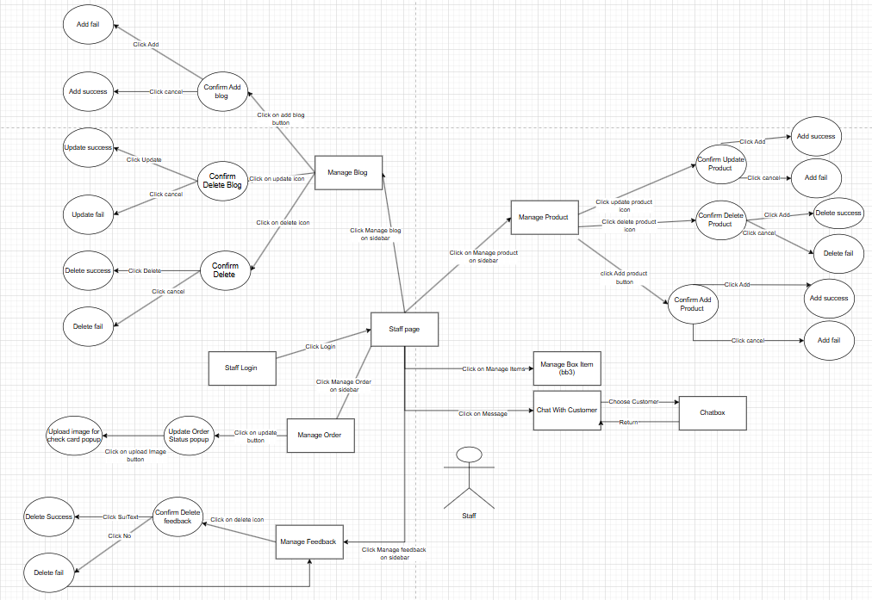

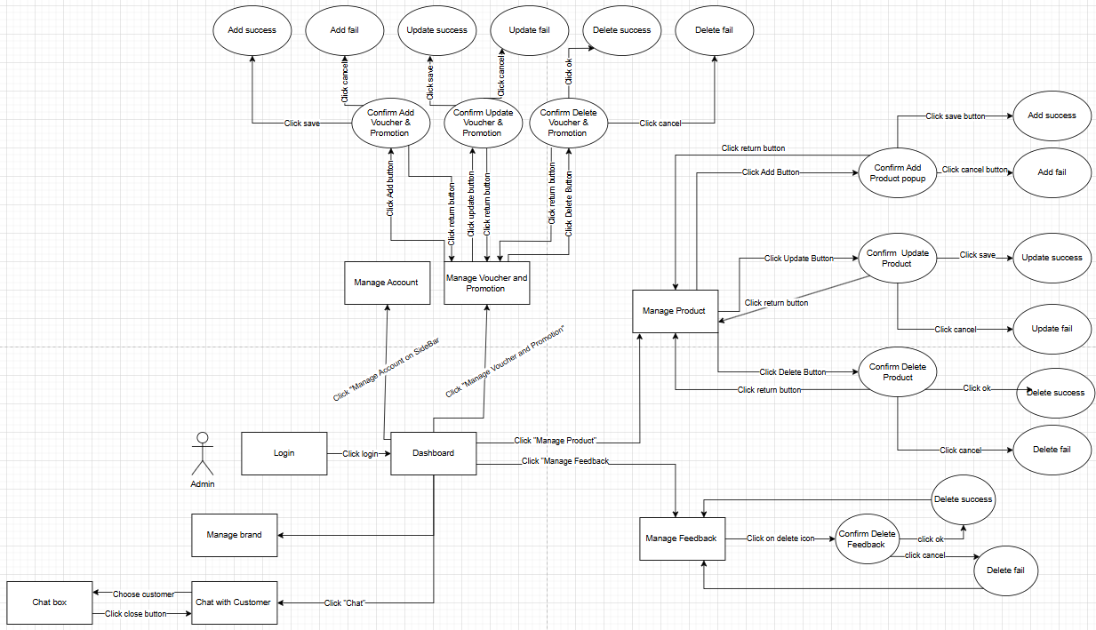

## 

#### 3.1.2. Screen descriptions (Lương Thế Minh)

|  |  |  |  |
| --- | --- | --- | --- |
| **#** | **Screen** | **Feature** | **Description** |
| FR-01 | Home | Website management | Display the homepage with navigation to key sections such as blind boxes, promotions, and user accounts. |
| FR-02 | User Login | Account Registration and Management | Allow customers to log in to their accounts using email/password or third-party authentication. |
| FR-03 | User Registration | Account Registration and Management | Enable new customers to create an account with email verification. |
| FR-04 | Forget Password | Account Registration and Management | Provide an option to reset passwords via email verification. |
| FR-05 | User Profile | Account Registration and Management | Allow users to view and edit their profile details. |
| FR-06 | User Manage Order | Order Management | Display customers' past and current orders with tracking details. |
| FR-07 | Feedback | Feedback | Customers can submit reviews or feedback about products and services. |
| FR-08 | Confirm Refund | Refund Management | Customers can request refunds for eligible orders and track their status. |
| FR-09 | Confirm Arrived | Order Confirmation | Customers can confirm that their order has been received successfully. |
| FR-10 | Edit User Profile | Account Management | Allow customers to update personal information like name, phone number, and address. |
| FR-11 | Change Password | Account Management | Enable customers to update their passwords for security. |
| FR-12 | Blog Page | Blog Content | Display blogs or articles related to promotions, product guides, or industry news. |
| FR-13 | ChatList | Chat System | Show a list of ongoing conversations between customers and customer support. |
| FR-14 | Chatbox | Chat System | Enable real-time chat between customers and support agents. |
| FR-15 | Hot Items | Product Showcase | Highlight trending or popular blind boxes for customers. |
| FR-16 | Online Blindbox | Open online Blindbox | Display available blind boxes for online purchase and participation. |
| FR-17 | Package Information | Open online Blindbox Feature | Show details about different blind box packages, pricing, and possible rewards. |
| FR-18 | Open Blind Box and Show Rewards | Open online Blindbox Feature | Allow customers to open purchased blind boxes and reveal rewards in an engaging animation. |
| FR-19 | Our BlindBox | Blindbox Collection | Showcase all available blind boxes with categories and filters. |
| FR-20 | BlindBox Detail | Blind Box Detail Page | Provide in-depth details about each blind box, including possible prizes, odds, and pricing. |
| FR-21 | My Cart | Shopping Cart | Display selected blind boxes before proceeding to checkout. |
| FR-22 | Buy Overview | Checkout Process | Show an overview of the order, including items, total price, and applicable discounts. |
| FR-23 | VNPay Screen | Payment Processing | Redirect customers to VNPay for secure payment transactions. |
| FR-24 | Select Address | Address Selection | Allow customers to choose or add a shipping address during checkout. |
| FR-25 | Select Voucher | Discount & Promotion | Enable customers to apply discount vouchers or promo codes to their orders. |
| FR-26 | Thank You Page | Post-Purchase Engagement | Show a thank-you message with order details and recommendations after purchase. |
| FR-27 | Staff Home | Staff Dashboard | Displays an overview of key statistics, recent orders, and management tools for staff. |
| FR-28 | Staff Login | Staff Authentication | Allows staff to log in securely to the admin panel using email and password. |
| FR-29 | Manage Order | Order Management | Staff can view, manage, and track customer orders. |
| FR-30 | Update Order Status | Order Processing | Staff can update the status of customer orders (e.g., pending, shipped, delivered, refunded). |
| FR-31 | Upload Image for Check Card | Order Processing | Staff can upload images of checked blind box cards for orders that are requested to open. |
| FR-32 | Manage Blog Page | Blog Management | Staff can create, edit, and delete blog posts. |
| FR-33 | Manage Product Page | Product Management | Staff, Admin can add, edit, or remove blind box products from the system. |
| FR-34 | Manage Box Item | Blindbox Item Management | Staff, Admin can add, edit, or remove individual items inside blind boxes. |
| FR-35 | Chat with Customer | Customer Support | Staff, Admin can chat with customers in real-time to provide support. |
| FR-36 | Manage Feedback | Feedback Management | Staff, Admin can view, manage, and respond to customer feedback. |
| FR-37 | Dashboard | Admin Dashboard | Displays an overview of system performance, including sales, orders, users, and product statistics. |
| FR-38 | Manage Account Page | User Management | Staff, Admin can view, edit, and manage customer and staff accounts. |
| FR-39 | Manage Voucher and Promotion Page | Promotion Management | Admin can create, update, and delete discount vouchers and promotional campaigns. |
| FR-40 | Manage Brand | Brand Management | Admin can manage brand-related content, including logos, descriptions, and associated products. |

#### 3.1.3. Screen authorization (Lương Thế Minh)

|  |  |  |  |
| --- | --- | --- | --- |
| **Screen** | **Customer** | **Staff** | **Admin** |
| Home | X | X | X |
| User Login | X | X | X |
| User Registration | X | X | X |
| Forget Password | X | X | X |
| User Profile | X |  |  |
| User Manage Order | X |  |  |
| Feedback | X |  |  |
| Edit User Profile | X |  |  |
| Change Password | X |  |  |
| Blog Page | X |  |  |
| ChatList | X | X | X |
| Chatbox | X | X | X |
| Hot Items | X | X | X |
| Online Blindbox | X | X | X |
| Package Information | X | X | X |
| Open Blind Box and Show Rewards | X |  |  |
| Our BlindBox | X | X | X |
| BlindBox Detail | X | X | X |
| My Cart | X |  |  |
| Buy Overview | X |  |  |
| Select Address | X |  |  |
| Select Voucher | X |  |  |
| Thank You Page | X |  |  |
| Manage Order |  | X | X |
| Update Order Status |  | X | X |
| Upload Image for Check Card |  | X | X |
| Manage Blog Page |  | X | X |
| Manage Product Page |  | X | X |
| Manage Box Item |  | X | X |
| Chat with Customer |  | X | X |
| Manage Feedback |  | X | X |
| Confirm Delete Feedback |  | X | X |
| Dashboard |  |  | X |
| Manage Account Page |  | X | X |
| Manage Voucher and Promotion Page |  | X | X |
| Manage Brand |  | X | X |

#### 3.1.4. Non-Screen Functions (Lương Thế Minh)

|  |  |  |  |
| --- | --- | --- | --- |
| **#** | **System Function** | **Feature** | **Description** |
| NS-01 | User Authentication | Email Verification | Validate user registration via email |
| NS-02 | User Authentication | Password Encryption | Securely hash and store user passwords |
| NS-03 | User Authentication | Password Reset | Allow users to reset passwords securely via email |
| NS-04 | Security & Access Control | Role-Based Authorization | Manage user permissions for customers, staff, and admin |
| NS-05 | Security & Access Control | Session Management | Handle login sessions, expiration, and logout |
| NS-06 | Payment Processing | Transaction Verification | Verify VNPay transactions and order status |
| NS-07 | Payment Processing | Refund Processing | Handle and validate customer refund requests |
| NS-08 | Order Management | Order Status Update | Allow staff to update order statuses |
| NS-09 | Order Management | Inventory Management | Update stock when blind boxes are purchased |
| NS-10 | Notification System | Email Notifications | Send order confirmations and system alerts |
| NS-11 | Chat System | Message Storage | Store customer-support chat history |
| NS-12 | Chat System | Real-Time Messaging | Enable live chat between users and staff |
| NS-13 | Blind Box System | Randomized Rewards | Randomly generate rewards when opening a blind box |
| NS-14 | Blind Box System | Probability Management | Set and manage the probability of rewards |
| NS-15 | Discount & Promotion | Voucher Validation | Ensure valid promo codes are applied |
| NS-16 | Background Processing | Update pending order | Periodically update pending order to processing |

#### 3.1.5. Entity-Relationship Diagram (ERD) (Quang Giáp)

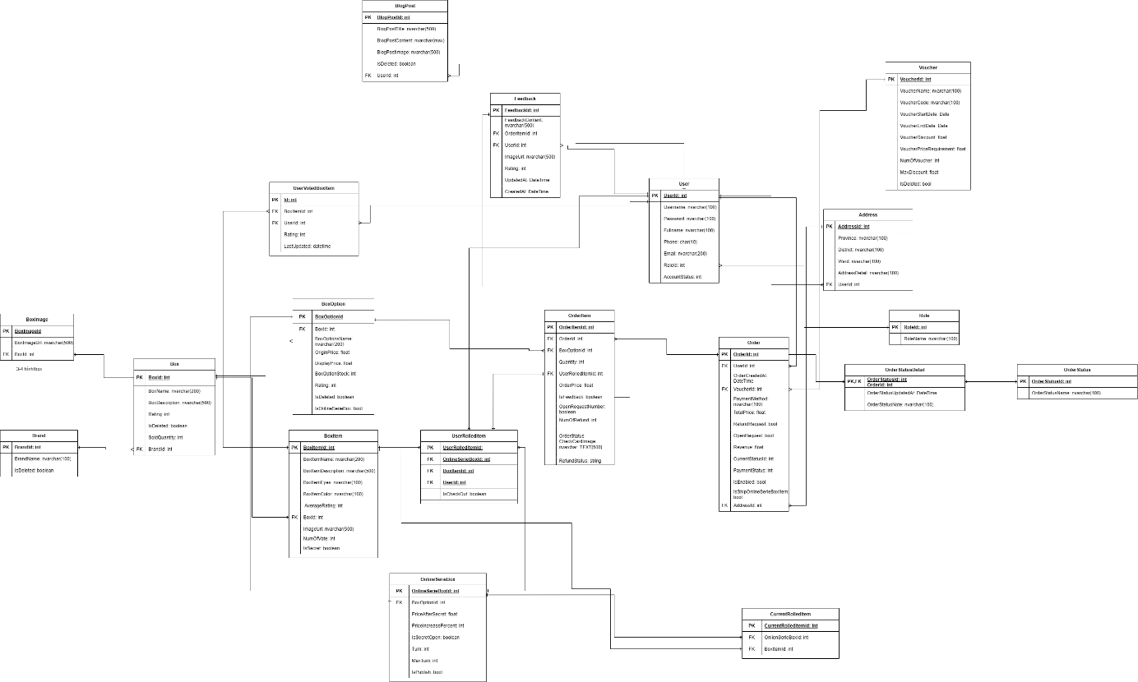

[BlindBoxSystem entity relationship diagram](https://drive.google.com/file/d/1e4iKpHWapluPbGEOwZg1LNUJjOl2fZOt/view?usp=sharing)

### 3.2 Authentication/ Authorization

#### 3.2.1 Login

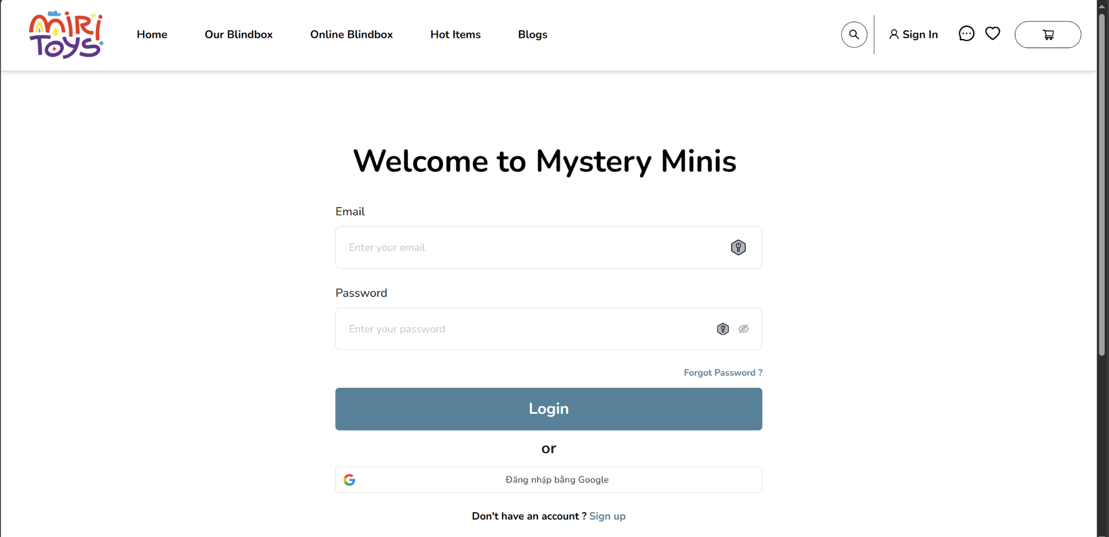

Customer input email and password to login.

#### 3.2.2 Register

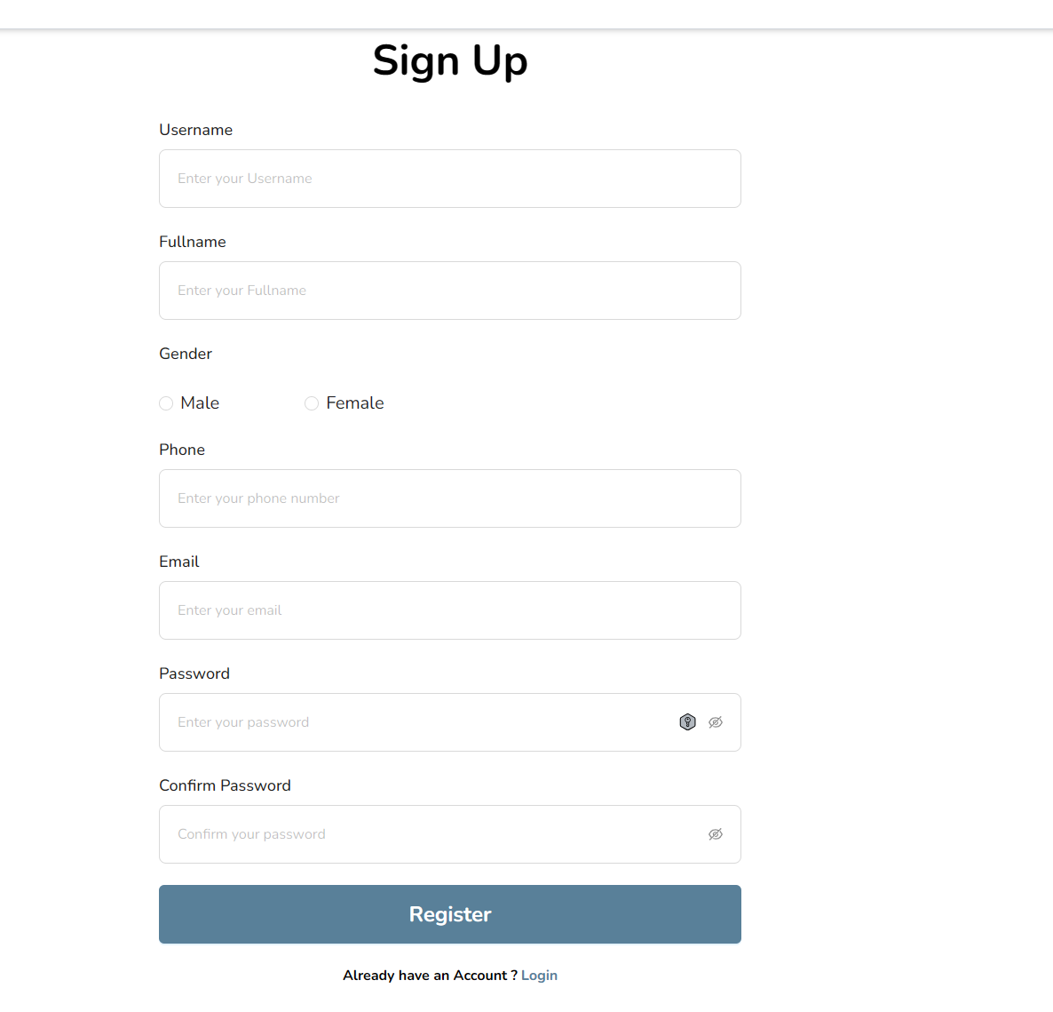

Customers fill up necessary information in order to register an account.

#### 3.2.3 Login by google

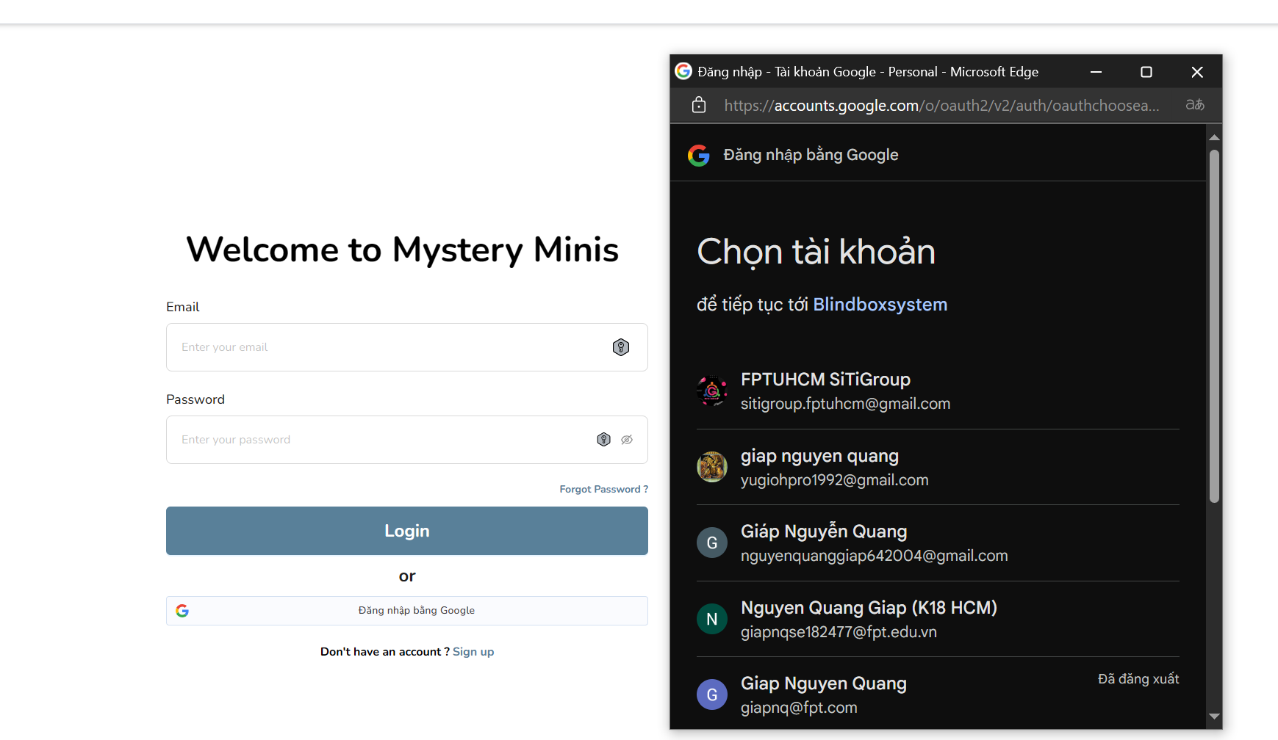

Customers can use their own account to login to the system instead of registering new account.

### 3.3 Order blind box

#### 3.3.1 Add to cart

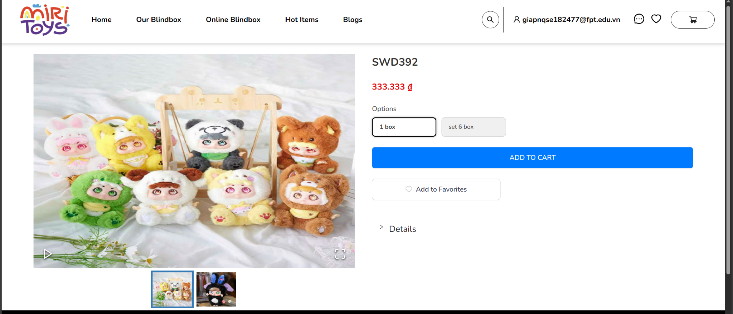

User choose box option and add to cart

#### 3.3.2 Check out

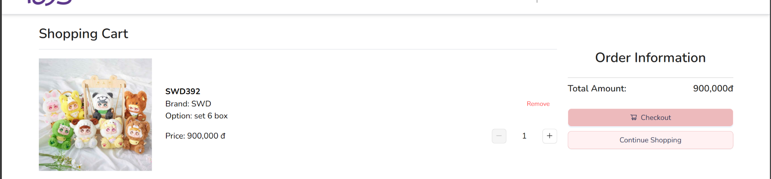

Customers check their cart again then checkout

**3.3.3 Fill necessary information**

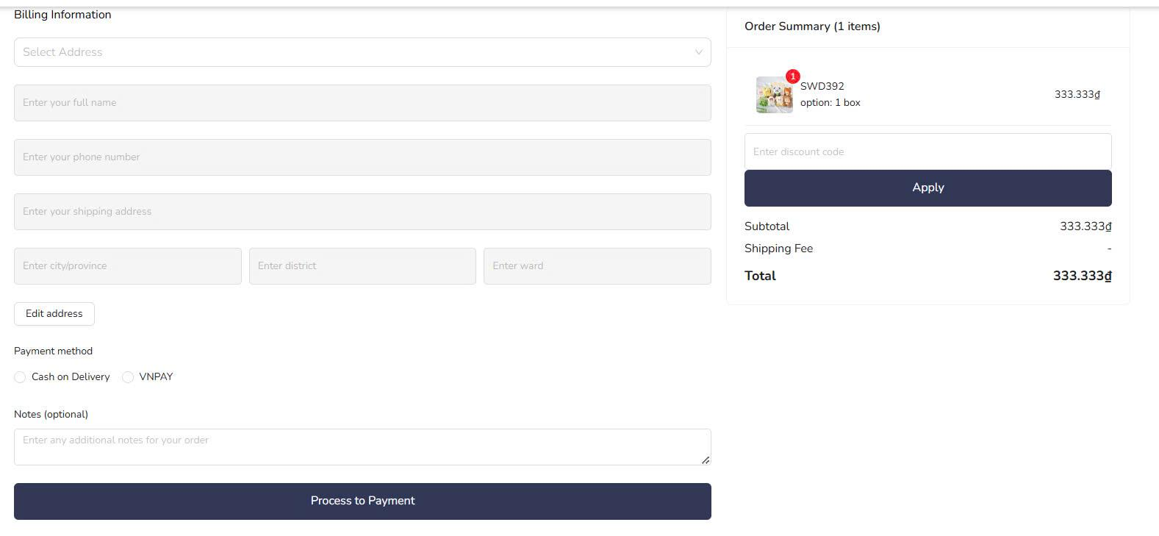

Customers choose address, Payment method, apply voucher.

#### 3.3.3 Customer process payment with VnPay

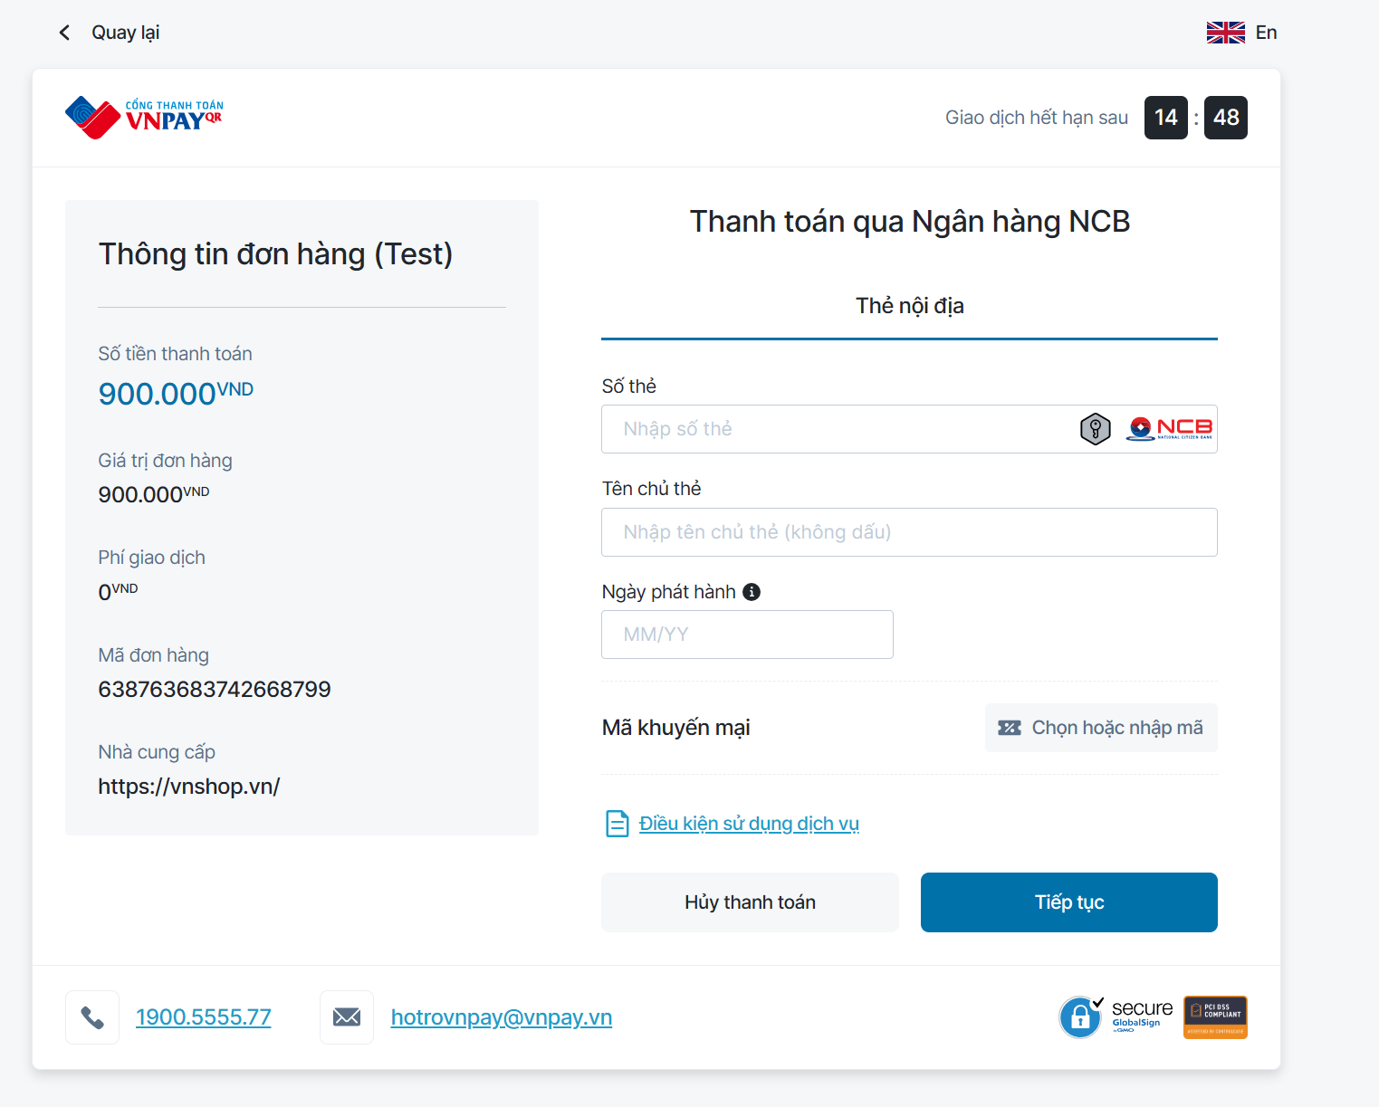

Customers input account information for payment.

### 3.4 Customer manage order

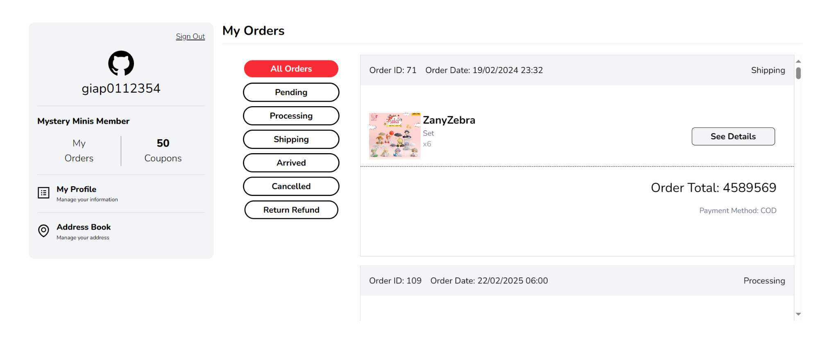

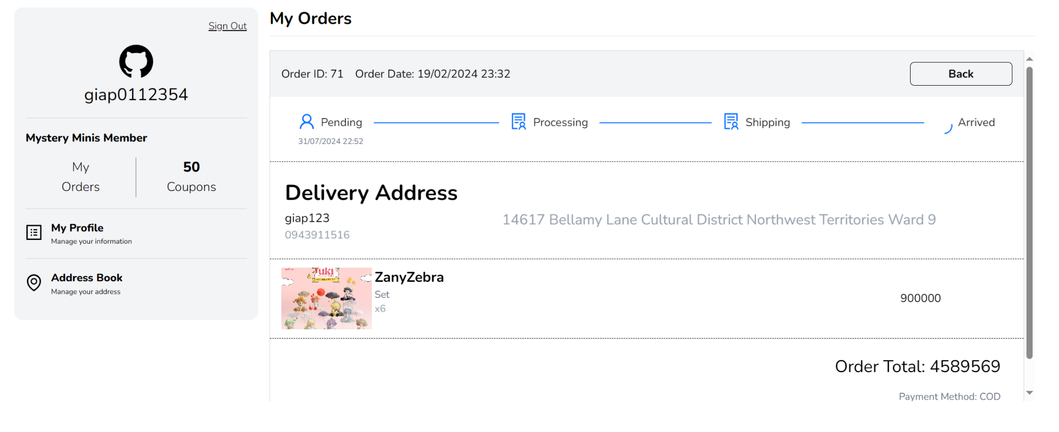

Customers can view their order status and their order history.

### 3.5. Staff manage product

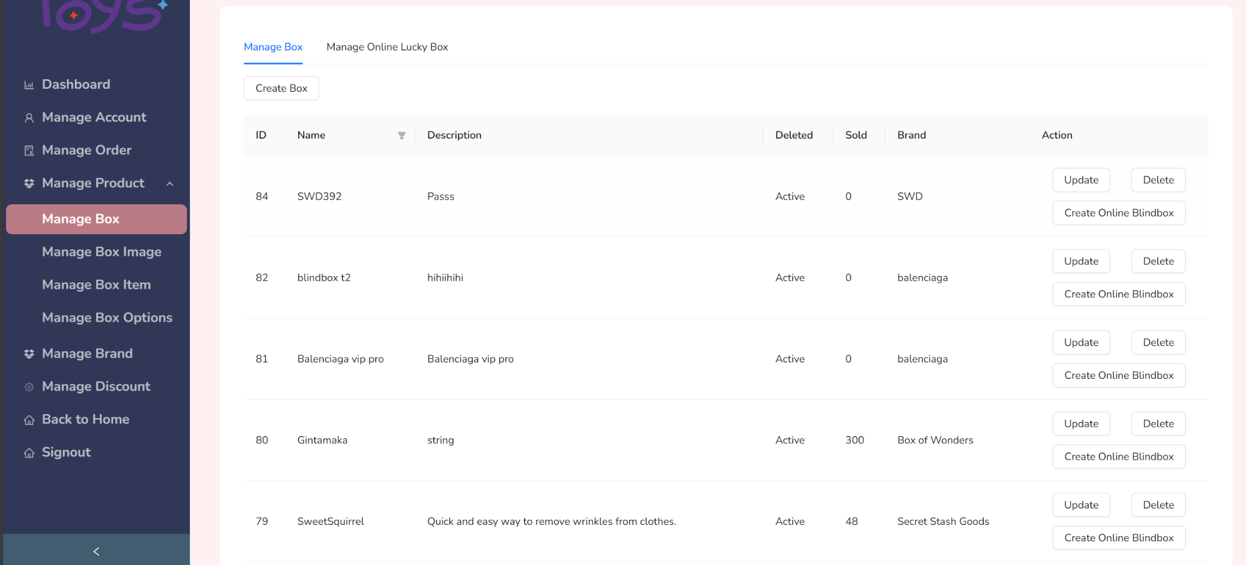

Staff can perform action related to manage their product:

* CRUD box
* CRUD box image
* CRUD box item
* CRUD box options

### 3.6. Staff manage account

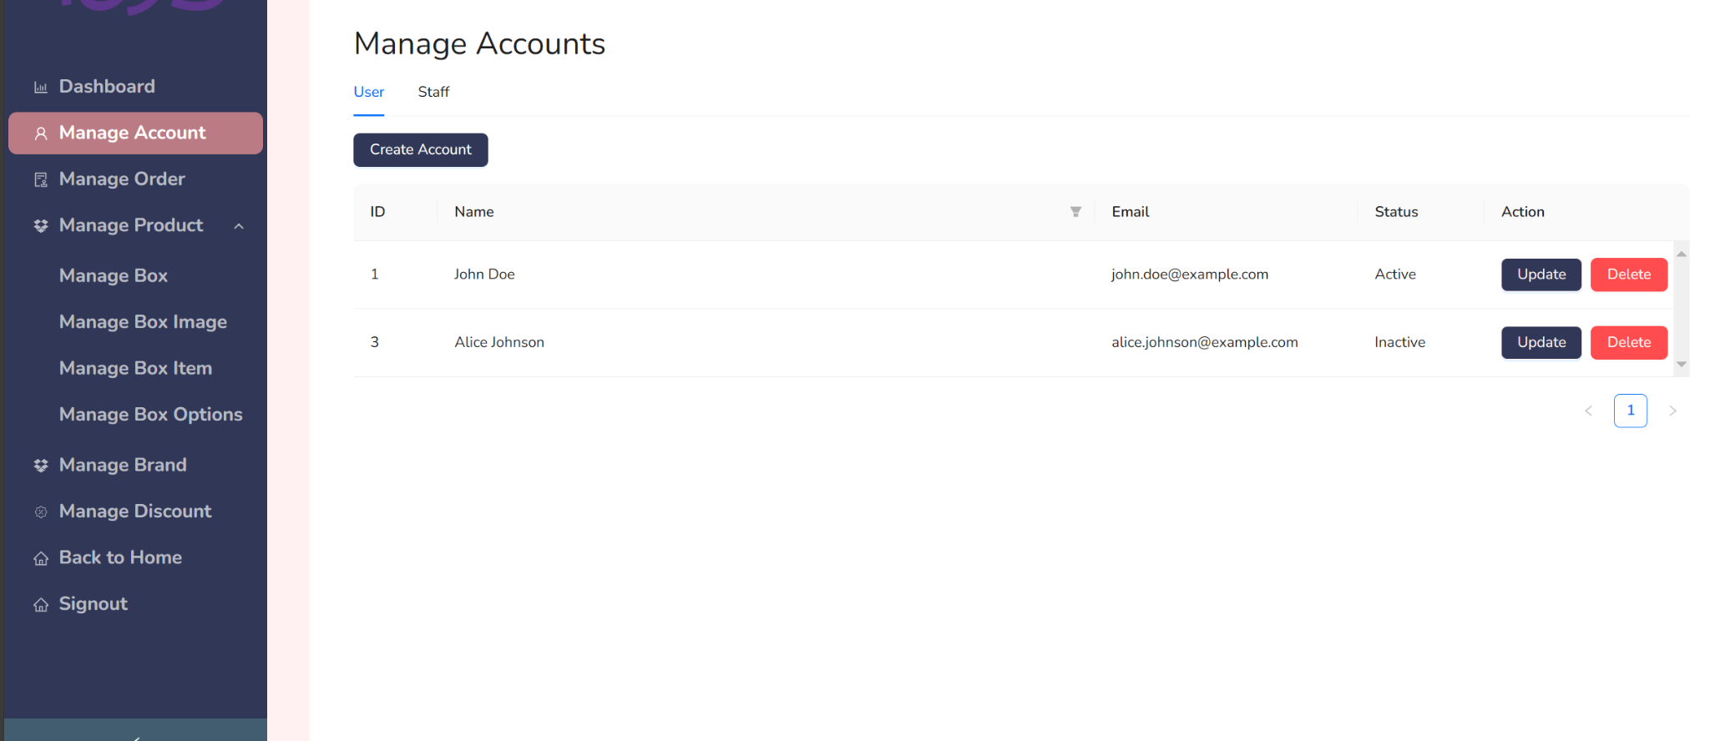

Staff can perform CRUD with account of staff and user

### 3.7. User view collection page

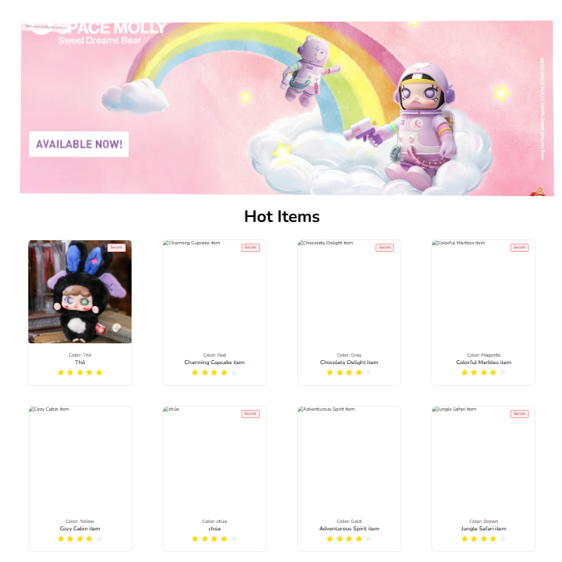

Users can view trending blind boxes with high ratings.

#### 3.7.1 User vote a box item

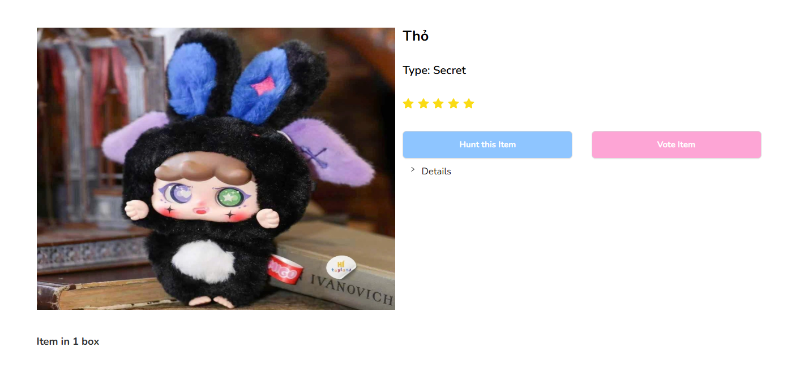

Users can vote for the blind box or hunt it if this blind box is available.

### 

### 3.8 User open blind box online

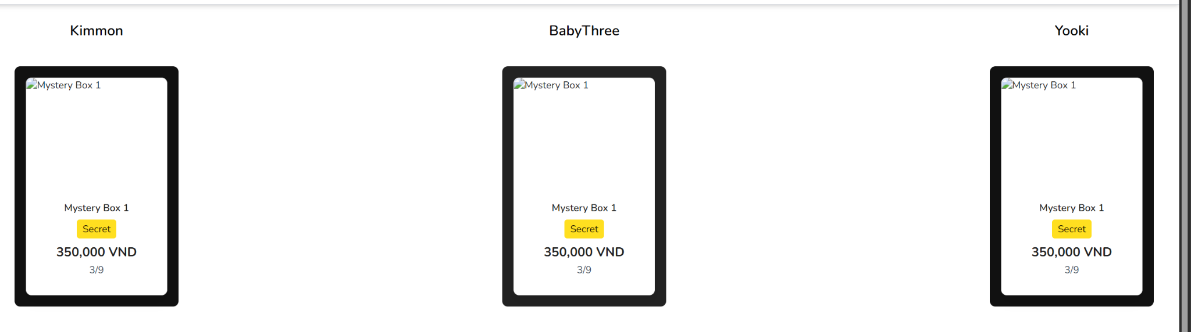

User can choose online serie blind box to roll

## 4. Non-Functional Requirements *(Lương Thế Minh)*

### 4.1 External Interfaces

#### 4.1.1 User Interfaces

* + - * UI-1: The UI must be in English and Vietnamese to support local users.
      * UI-2: The GUI must be intuitive, modern, and user-friendly for easy navigation.
      * UI-3: Information pages should be concise and clearly structured to enhance readability.
      * UI-4: The application should be responsive and optimized for Android and iOS devices, ensuring no horizontal scrolling is required.
      * UI-5: Elements should be designed with touch gestures to facilitate smooth interaction on mobile devices.
      * UI-6: Background and font colors should maintain high contrast for better readability and accessibility.

#### 4.1.2 Software Interfaces

SI-1: Web application must be compatible with:

* Google Chrome (version 90 or higher)
* Firefox (version 85 or higher)
* Microsoft Edge (version 80 or higher)
* Any browser supporting HTML5 & CSS3

SI-2: Mobile application must support:

* Android (version 7.0 or higher)
* iOS (version 12.0 or higher)

SI-3: API integrations:

* + - * VNPay Payment Gateway
      * Firebase Authentication & Cloud Storage
      * WebSocket or SignalR for real-time chat

#### 4.1.3 Hardware Interfaces

HI-1: The system should be accessible via:

* Desktop or Laptop
* Mobile (Android/iOS)
* Point-of-Sale (POS) terminals (if applicable)

HI-2: The server should support:

* + - * Cloud hosting on AWS, Firebase, or DigitalOcean
      * PostgreSQL database storage

#### 4.1.4 Communications Interfaces

* + - * CI-1: System should send real-time notifications, emails, and SMS alerts to administrators, staff, and customers.
      * CI-2: Integration with email services (e.g., SendGrid, SMTP) for transactional emails.
      * CI-3: The system should support live chat functionality via WebSocket or Firebase messaging.

### 4.2 Quality Attributes *(Lương Thế Minh)*

#### 4.2.1 Usability

* U-1: New users should require a maximum of 2 days to learn system operations.
* U-2: The UI should be consistent across all browsers and devices.
* U-3: The system should be intuitive enough for non-technical staff to operate with minimal training.

#### 4.2.2 Reliability

* R-1: The system should operate with an uptime of 99.9%.
* R-2: The error rate for transaction processing should be less than 1%.
* R-3: The chat system should deliver messages within 200ms latency.
* R-4: Payment transactions should be processed with a 99% success rate.

#### 4.2.3 Performance

* P-1: The system should handle at least 500 concurrent users.
* P-2: API response time should be less than 200ms under normal load conditions.
* P-3: Live chat messages should be delivered in real-time with a delay of less than 100ms.
* P-4: Page load times should be less than 2 seconds for 95% of **users.**

#### 4.2.4 Dependability

* **Security**
  + S-1: Role-based access control (RBAC) should ensure each user can only access authorized functionalities.
  + S-2: Only admin users should have full system access.
  + S-3: All user input should be validated before being stored in the database.
  + S-4: Encryption (AES-256) should be applied to sensitive user data.
* **Safety**
  + SA-1: Integration of the chat system should not affect core e-commerce functions.
  + SA-2: Secure OAuth 2.0 authentication must be enforced for all API calls.

#### 4.2.5 Availability

* A-1: The system must be operational 24/7.
* A-2: Maintenance and upgrades must occur no more than once every 3 months.
* A-3: System downtime should not exceed 1 hour per year.

#### 4.2.6 Supportability

* SP-1: The system must follow RESTful API standards.
* SP-2: Coding conventions should be documented and followed.
* SP-3: All third-party dependencies must be listed and maintained in documentation.

#### 4.2.7 Design Constraints

* DC-1: The system must use open-source frameworks where possible.
* DC-2: Programming languages for different components:
  + Backend (API): ASP .NET Core 8.0
  + Frontend Web: ReactJS (TypeScript)
  + Mobile App: React Native
  + Database: PostgreSQL
* DC-3: The system should be containerized using Docker for deployment.

## 5. Requirement Appendix (Quang Giáp, Quốc Phong)

### 5.1 Business Rules (Quang Giáp)

|  |  |  |
| --- | --- | --- |
| **Rule ID** | **Rule Description** | **Details** |
| BR-001 | Lucky Blind box event | Customer can attend in a lucky blindbox, which will have a blind box included a secret item, once customer open at first turn, the price at upcoming turn will be raise up |
| BR-002 | Stock Management | Each blind box series has a limited number of items, and stock updates automatically upon purchase. |
| BR-003 | Blind Box Opening | Customers can open their purchased blind boxes through an option when they checkout. The Staff will open the blindbox that customers choose and upload pictures for the customer to see. |
| BR-004 | Refund Policy | A blindbox can be refunded within 5 days after purchases if the item inside has a manufacturer defect |
| BR-005 | Loyalty Program | User can receive points for each Purchase, which can be redeemed for discounts or vouchers. |
| BR-006 | Cancel order policy | After place the order the customer have 5 minutes to cancel the order with COD payment method |
| BR-007 | Online box price | Staff can custom base price, increase percent and price after customer get secret. |
| BR-008 | Account management | Only admin can update user information account |
| BR-009 | Password strength | 1. Password minimum 8 characters and have at least 1 Uppercase character and 1 Lowercase character  2. Unique email required  3. Username must be unique |
| BR-010 | Open blind box image rule | The uploaded blind box image must match the actual item received to prevent disputes. |
| BR-011 | Cannot cancel product once open | Customers cannot reverse the "Open Blindbox" option after placing an order. |
| BR-012 | Open blind box for customer not for COD | Only order with pay before method can request open |
| BR-013 | Cannot delete order | Cannot delete existing order record |
| BR-014 | Searching rules | Hide sold-out items unless specified  Sort by relevance by default |
| BR-015 | Limit search result rules | Maximum 20 records displayed per pages |
| BR-016 | Limit search characters | Minimum 2 characters for search terms and maximum 700 characters |
| BR-017 | Product image required | Every product must have image |
| BR-018 | Protect user’s privacy | Protect user’s private chat information |
| BR-019 | Behave in the right manner | Staff can ban account with inappropriate feedback or chat message. |
| BR-020 | Feedback rules | Customer can only feedback once per order item |
| BR-021 | Feedback time | Customer can only feedback within 5 days since the order switch into arrived status |
| BR-022 | Blog limit image | Only 1 image per blog |
| BR-023 | Blog content supervision | Blog content must use appropriate words |
| BR-024 | Voucher application | Voucher is can be used by any user when placing order if they satisfy voucher requirement. |
| BR-025 | Voucher expiration | Expired vouchers cannot be reactivated |
| BR-026 | Maximum discount price | Discounts must not exceed a predefined percentage or amount set by the business policy. |
| BR-027 | Limited edition blind boxes quantity | Limited edition BlindBoxes may have restrictions on purchase quantity. |
| BR-028 | Open blind box online fairness rule | The contents of the blind box must be generated based on predefined probabilities and can’t be changed once created to ensure fairness. |
| BR-029 | Open blind box payment process | The system must ensure that the payment process is secure and reliable |
| BR-030 | Open blind box UI | The unboxing process must be visually engaging and exciting for the customer. |
| BR-031 | Recovery password rules | User must be verified by token from email to be able to recovery their password |

### 5.2 Common Requirements (Quốc Phong)

*[Fill all the common requirements here..]*

1. **User Authentication & Authorization**

* Users must register and log in before making a purchase.
* Admins have separate access to manage stock, orders, and users.

1. **Order & Delivery Tracking**

* Users should be able to view their order history and track shipments.
* The system should send email notifications for order confirmations and shipping updates.

1. **Promotions & Discounts**

* Admins should be able to create promotional campaigns (e.g., discount codes, limited-time sales).
* The system should support automatic discounts based on loyalty points.

1. **Reports & Analytics**

* Admins should have access to sales reports, stock reports, and user activity data.

1. **Inventory & Stock Management**

* The system should track available stock in real time.
* Admins must be able to add/update/delete blind box series and their stock levels.

1. **Blind Box Unboxing Mechanism**

* After purchase, users must be able to open the blind box through an animation or reveal page.

### 5.3 Application Messages List (Quốc Phong)

|  |  |  |
| --- | --- | --- |
| Message ID | Trigger Event | Message Content |
| MSG-001 | Successful Registration | "Welcome! Your account has been successfully created." |
| MSG-002 | Login Success | "Login successful. Welcome back!" |
| MSG-003 | Login Failed | "Invalid username or password. Please try again." |
| MSG-004 | Blind Box Opening | "Congratulations! You received [Item Name]." |
| MSG-005 | Secret Item Found | "You’re lucky! You discovered the Secret Item!" |
| MSG-006 | Lucky Blind Box Price Increase | "The price has increased to [$New Price] for the next purchase." |
| MSG-007 | Out of Stock | "Sorry, this blind box series is currently out of stock." |
| MSG-008 | Order Confirmation | "Your order #[Order ID] has been confirmed. You will receive a notification once it ships." |
| MSG-009 | Refund Request Approved | "Your refund request has been processed successfully." |
| MSG-010 | Refund Request Denied | "Your refund request was denied. Opened blind boxes are non-refundable." |

### 5.4 Other Requirements (Quốc Phong)

1. **Security & Compliance**

* The system must comply with data protection laws and secure customer information.
* All payments must be processed through encrypted and PCI-compliant gateways.

1. **Performance & Scalability**

* The system should be able to handle high traffic during limited-time events.
* The backend must support real-time stock updates and random item generation efficiently.

1. **Audit & Logging**

* The system should log all transactions, including purchases, refunds, and blind box openings.
* Admins must have access to detailed reports on sales, user activities, and system errors.

# IV. Software Design Description

*[Provide final software design information follow the template as part II in the Report #4]*

## 1. System Design

### 1.1 System Architecture (Quốc Phong)

#### 

### 1.2 Package Diagram (Quốc Phong)

#### 1.2.1 Back-End

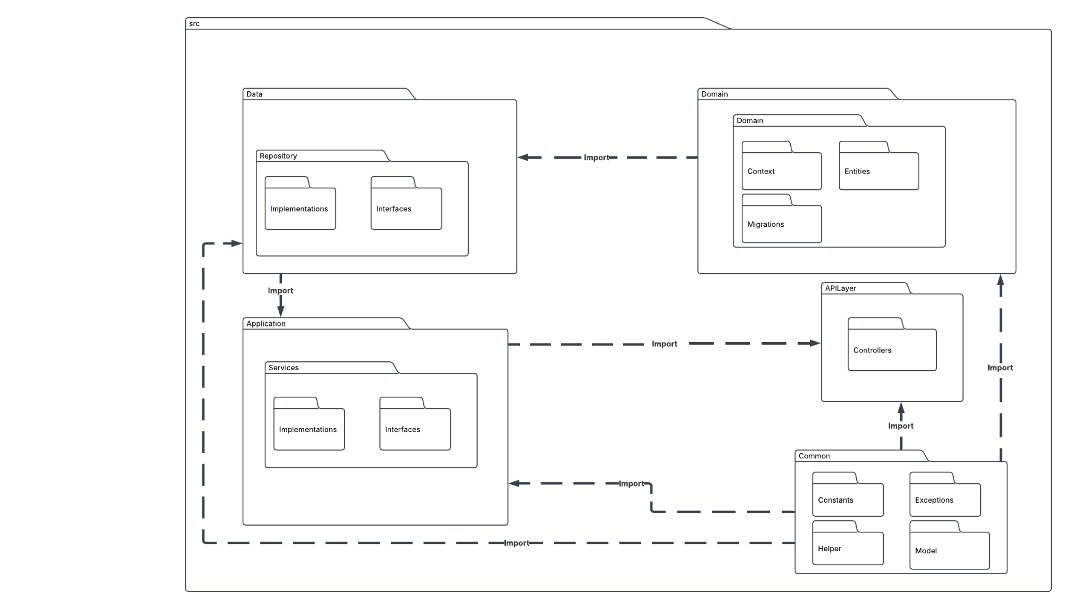

#### 1.2.2 Front-End

#### 

## 2. Database Design (Quang Giáp)

**2.1 Brands**

|  |  |  |  |  |  |  |
| --- | --- | --- | --- | --- | --- | --- |
| **Field Name** | **Data Type** | **Size** | **Unique** | **Not Null** | **PK/FK** | **Notes** |
| BrandId | integer | – | No | Yes | PK | Auto-generated identity; unique identifier for each brand |
| BrandName | text | – | No | Yes |  | Name of the brand |
| ImageUrl | text | – | No | No |  | URL or path to the brand image |

**2.2 OrderStatuses**

|  |  |  |  |  |  |  |
| --- | --- | --- | --- | --- | --- | --- |
| **Field Name** | **Data Type** | **Size** | **Unique** | **Not Null** | **PK/FK** | **Notes** |
| OrderStatusId | integer | – | No | Yes | PK | Auto-generated identity; unique identifier for each status |
| OrderStatusName | text | – | No | Yes |  | Name describing the order status |
| ImageUrl | text | – | No | No |  | URL or path to the brand image |

**2.3 Roles**

|  |  |  |  |  |  |  |
| --- | --- | --- | --- | --- | --- | --- |
| **Field Name** | **Data Type** | **Size** | **Unique** | **Not Null** | **PK/FK** | **Notes** |
| RoleId | integer | – | No | Yes | PK | Auto-generated identity; unique identifier for a role |
| RoleName | text | – | No | Yes |  | Name of the role |

**2.4 Vouchers**

|  |  |  |  |  |  |  |
| --- | --- | --- | --- | --- | --- | --- |
| **Field Name** | **Data Type** | **Size** | **Unique** | **Not Null** | **PK/FK** | **Notes** |
| VoucherId | integer | – | No | Yes | PK | Auto-generated identity; unique identifier for each voucher |
| VoucherName | text | – | No | Yes |  | Name of the voucher |
| VoucherCode | text | – | No* | Yes |  | Code for the voucher (a unique index is created on this field) |
| VoucherDiscount | integer | – | No | Yes |  | Discount value or percentage |
| VoucherStartDate | timestamp with time zone | – | No | Yes |  | Start date/time for voucher validity |
| VoucherEndDate | timestamp with time zone | – | No | Yes |  | End date/time for voucher validity |
| MaxDiscount | real | – | No | Yes |  | Maximum discount amount |
| IsDeleted | boolean | – | No | Yes |  | Soft delete flag |
| VoucherPriceRequirement | real | – | No | Yes |  | Minimum price requirement for voucher usage; default is 0 |
| NumOfVoucher | integer | – | No | Yes |  | Available quantity of vouchers; default is 0 |

**2.5 Boxes**

|  |  |  |  |  |  |  |
| --- | --- | --- | --- | --- | --- | --- |
| **Field Name** | **Data Type** | **Size** | **Unique** | **Not Null** | **PK/FK** | **Notes** |
| BoxId | integer | – | No | Yes | PK | Auto-generated identity; unique identifier for each box |
| BoxName | text | – | Yes (Index) | Yes |  | Name of the box (unique index created on this field) |
| BoxDescription | text | – | No | No |  | Description of the box |
| BrandId | integer | – | No | Yes | FK | Foreign key referencing Brands(BrandId) |
| IsDeleted | boolean | – | No | Yes |  | Soft delete flag; default value is false |
| SoldQuantity | integer | – | No | Yes |  | Number of boxes sold; default is 0 |
| MaxDiscount | real | – | No | Yes |  | Maximum discount amount |
| IsDeleted | boolean | – | No | Yes |  | Soft delete flag |
| VoucherPriceRequirement | real | – | No | Yes |  | Minimum price requirement for voucher usage; default is 0 |
| NumOfVoucher | integer | – | No | Yes |  | Available quantity of vouchers; default is 0 |

**2.6 Users**

|  |  |  |  |  |  |  |
| --- | --- | --- | --- | --- | --- | --- |
| **Field Name** | **Data Type** | **Size** | **Unique** | **Not Null** | **PK/FK** | **Notes** |
| UserId | integer | – | No | Yes | PK | Auto-generated identity; unique identifier for each user |
| Username | text | – | Yes (Index) | Yes |  | Username for the user (unique index created on this field) |
| Password | text | – | No | Yes |  | User password (likely stored encrypted) |
| Fullname | text | – | No | Yes |  | Full name of the user |
| Phone | text | – | No | Yes |  | Phone number |
| Email | text | – | Yes (Index) | Yes |  | Email address (unique index created on this field) |
| RoleId | integer | – | No | Yes | FK | Foreign key referencing Roles(RoleId) |
| Gender | boolean | – | No | Yes |  | Gender flag; default is false (interpretation depends on business logic) |
| IsActive | boolean | – | No | Yes |  | Flag indicating if the user is active; default is false |

**2.7 BoxImages**

|  |  |  |  |  |  |  |
| --- | --- | --- | --- | --- | --- | --- |
| **Field Name** | **Data Type** | **Size** | **Unique** | **Not Null** | **PK/FK** | **Notes** |
| BoxImageId | integer | – | No | Yes | PK | Auto-generated identity; unique identifier for each box image |
| BoxImageUrl | text | – | No | Yes |  | URL or file path of the box image |
| BoxId | integer | – | No | Yes | FK | Foreign key referencing Boxes(BoxId) |

**2.8 BoxItems**

|  |  |  |  |  |  |  |
| --- | --- | --- | --- | --- | --- | --- |
| **Field Name** | **Data Type** | **Size** | **Unique** | **Not Null** | **PK/FK** | **Notes** |
| BoxItemId | integer | – | No | Yes | PK | Auto-generated identity; unique identifier for each box item |
| BoxItemName | text | – | No | Yes |  | Name of the box item |
| BoxItemDescription | text | – | No | Yes |  | Description of the box item |
| BoxItemEyes | text | – | No | Yes |  | “Eyes” property of the item (specific business meaning may apply) |
| BoxItemColor | text | – | No | Yes |  | Color attribute for the item |
| AverageRating | integer | – | No | Yes |  | Average rating value |
| BoxId | integer | – | No | Yes | FK | Foreign key referencing Boxes(BoxId) |
| ImageUrl | text | – | No | Yes |  | Image URL or path for the item |
| NumOfVote | integer | – | No | Yes |  | Total number of votes received |
| IsSecret | boolean | – | No | Yes |  | Flag indicating whether the item is “secret” |

**2.9 OnlineSerieBoxes**

|  |  |  |  |  |  |  |
| --- | --- | --- | --- | --- | --- | --- |
| **Field Name** | **Data Type** | **Size** | **Unique** | **Not Null** | **PK/FK** | **Notes** |
| OnlineSerieBoxId | integer | – | No | Yes | PK | Auto-generated identity; unique identifier for each online series box |
| BoxId | integer | – | No | Yes | FK | Foreign key referencing Boxes(BoxId) |
| Price | real | – | No | Yes |  | Price of the online series box |
| Name | text | – | No | Yes |  | Name of the online series box |
| IsSecretOpen | boolean | – | No | Yes |  | Flag indicating whether the secret is open (visible) |
| Turn | integer | – | No | Yes |  | Turn number or order of the online series box |

**2.10 Addresses**

|  |  |  |  |  |  |  |
| --- | --- | --- | --- | --- | --- | --- |
| **Field Name** | **Data Type** | **Size** | **Unique** | **Not Null** | **PK/FK** | **Notes** |
| AddressId | integer | – | No | Yes | PK | Auto-generated identity; unique identifier for each address |
| Province | text | – | No | Yes |  | Province name |
| District | text | – | No | Yes |  | District name |
| Ward | text | – | No | Yes |  | Ward or locality |
| AddressDetail | text | – | No | No |  | Additional address details |
| UserId | integer | – | No | Yes | FK | Foreign key referencing Users(UserId) |
| Name | text | – | No | No |  | Name associated with the address (e.g. recipient) |
| PhoneNumber | text | – | No | No |  | Contact phone number for this address |

**2.11 BlogPosts**

|  |  |  |  |  |  |  |
| --- | --- | --- | --- | --- | --- | --- |
| **Field Name** | **Data Type** | **Size** | **Unique** | **Not Null** | **PK/FK** | **Notes** |
| BlogPostId | integer | – | No | Yes | PK | Auto-generated identity; unique identifier for each blog post |
| BlogPostTitle | text | – | No | Yes |  | Title of the blog post |
| BlogPostContent | text | – | No | Yes |  | Content body of the blog post |
| BlogPostImage | text | – | No | Yes |  | URL or path for the blog post image |
| UserId | integer | – | No | Yes | FK | Foreign key referencing Users(UserId) |

**2.12 UserVotedBoxItems**

|  |  |  |  |  |  |  |
| --- | --- | --- | --- | --- | --- | --- |
| **Field Name** | **Data Type** | **Size** | **Unique** | **Not Null** | **PK/FK** | **Notes** |
| UserVotedBoxItemId | integer | – | No | Yes | PK | Auto-generated identity; unique identifier for each vote record |
| BoxItemId | integer | – | No | Yes | FK | Foreign key referencing BoxItems(BoxItemId) |
| UserId | integer | – | No | Yes | FK | Foreign key referencing Users(UserId) |
| LastUpdated | timestamp with time zone | – | No | Yes |  | Date/time when the vote was last updated |
| Rating | integer | – | No | Yes |  | Rating given by the user for the box item |

**2.13 RolledItem**

|  |  |  |  |  |  |  |
| --- | --- | --- | --- | --- | --- | --- |
| **Field Name** | **Data Type** | **Size** | **Unique** | **Not Null** | **PK/FK** | **Notes** |
| BoxItemsBoxItemId | integer | – | No | Yes | FK, Part of PK | Foreign key referencing BoxItems(BoxItemId) |
| OnlineSerieBoxesOnlineSerieBoxId | integer | – | No | Yes | FK, Part of PK | Foreign key referencing OnlineSerieBoxes(OnlineSerieBoxId) |

**2.14 Orders**

|  |  |  |  |  |  |  |
| --- | --- | --- | --- | --- | --- | --- |
| **Field Name** | **Data Type** | **Size** | **Unique** | **Not Null** | **PK/FK** | **Notes** |
| OrderId | integer | – | No | Yes | PK | Auto-generated identity; unique identifier for each order |
| UserId | integer | – | No | Yes | FK | Foreign key referencing Users(UserId) |
| OrderCreatedAt | timestamp with time zone | – | No | Yes |  | Date/time when the order was created |
| VoucherId | integer | – | No | Yes | FK | Foreign key referencing Vouchers(VoucherId) |
| PaymentMethod | text | – | No | Yes |  | Payment method used for the order |
| TotalPrice | real | – | No | Yes |  | Total price for the order |
| Revenue | real | – | No | Yes |  | Revenue generated from the order |
| AddressId | integer | – | No | Yes | FK | Foreign key referencing Addresses(AddressId) |
| OpenRequest | boolean | – | No | Yes |  | Flag for open request status; default is false |
| RefundRequest | boolean | – | No | Yes |  | Flag for refund request status; default is false |
| CurrentOrderStatusId | integer | – | No | Yes |  | Identifier for the current order status (default 0) |
| PaymentStatus | text | – | No | Yes |  | Payment status information (default empty string) |
| JsonOrderModel | jsonb | – | No | No |  | JSON field storing detailed order model data |
| IsEnable | boolean | – | No | Yes |  | Flag indicating if the order is enabled (default is false) |

**2.15 OrderStatusesDetail**

|  |  |  |  |  |  |  |
| --- | --- | --- | --- | --- | --- | --- |
| **Field Name** | **Data Type** | **Size** | **Unique** | **Not Null** | **PK/FK** | **Notes** |
| OrderId | integer | – | No | Yes | FK, Part of PK | Foreign key referencing Orders(OrderId); part of composite primary key |
| OrderStatusId | integer | – | No | Yes | FK, Part of PK | Foreign key referencing OrderStatuses(OrderStatusId); part of composite primary key |
| OrderStatusUpdatedAt | timestamp with time zone | – | No | Yes |  | Date/time when the order status was updated |
| OrderStatusNote | text | – | No | No |  | Additional notes or comments regarding the order status |

**2.16 BoxOptions**

|  |  |  |  |  |  |  |
| --- | --- | --- | --- | --- | --- | --- |
| **Field Name** | **Data Type** | **Size** | **Unique** | **Not Null** | **PK/FK** | **Notes** |
| BoxOptionId | integer | – | No | Yes | PK | Auto-generated identity; unique identifier for each box option |
| BoxId | integer | – | No | Yes | FK | Foreign key referencing Boxes(BoxId) |
| BoxOptionName | text | – | No | Yes |  | Name of the box option |
| OriginPrice | real | – | No | Yes |  | Original price of the option |
| DisplayPrice | real | – | No | Yes |  | Price displayed to customers |
| BoxOptionStock | integer | – | No | Yes |  | Stock available for the box option |
| IsDeleted | boolean | – | No | Yes |  | Soft delete flag for the option |

**2.17 OrderItems**

|  |  |  |  |  |  |  |
| --- | --- | --- | --- | --- | --- | --- |
| **Field Name** | **Data Type** | **Size** | **Unique** | **Not Null** | **PK/FK** | **Notes** |
| OrderItemId | integer | – | No | Yes | PK | Auto-generated identity; unique identifier for each order item |
| OrderId | integer | – | No | Yes | FK | Foreign key referencing Orders(OrderId) |
| Quantity | integer | – | No | Yes |  | Quantity of the item ordered |
| OrderPrice | real | – | No | Yes |  | Price for this order item |
| IsFeedback | boolean | – | No | Yes |  | Flag indicating whether feedback has been provided |
| IsRefund | boolean | – | No | Yes |  | Flag for refund status; default is false |
| BoxOptionId | integer | – | No | No | FK | Foreign key referencing BoxOptions(BoxOptionId); can be null |
| OpenRequestNumber | integer | – | No | Yes |  | Counter for open requests; default is 0 |
| OrderStatusCheckCardImage | text[] | – | No | Yes |  | Array of text values (e.g., URLs) for check card images; default is an empty array |

**2.18 Feedbacks**

|  |  |  |  |  |  |  |
| --- | --- | --- | --- | --- | --- | --- |
| **Field Name** | **Data Type** | **Size** | **Unique** | **Not Null** | **PK/FK** | **Notes** |
| FeedbackId | integer | – | No | Yes | PK | Auto-generated identity; unique identifier for each feedback |
| UserId | integer | – | No | Yes | FK | Foreign key referencing Users(UserId) |
| FeedbackContent | text | – | No | Yes |  | Content of the feedback |
| UpdatedAt | timestamp with time zone | – | No | No |  | Date/time when the feedback was last updated |
| CreatedAt | timestamp with time zone | – | No | Yes |  | Date/time when the feedback was created |
| FeedbackType | text | – | No | Yes |  | Category or type of feedback |
| ImageUrl | text | – | No | Yes |  | URL/path for an image associated with the feedback |
| OrderItemId | integer | – | Yes | Yes | FK | Foreign key referencing OrderItems(OrderItemId); unique index created on this field |

**2.19 Message**

|  |  |  |  |  |  |  |
| --- | --- | --- | --- | --- | --- | --- |
| **Field Name** | **Type** | **Size** | **Unique** | **Not Null** | **PK/FK** | **Notes** |
| MessageId | INT | 11 | Yes | Yes | PK | Unique identifier of each message |
| ConversationId | INT | 11 | No | Yes | FK | Foreign key referencing Conversation table |
| SendAt | TIMESTAMP | - | No | Yes |  | Timestamp when the message was sent |
| SenderId | INT | 11 | No | Yes | FK | Foreign key referencing Users table (sender of the message) |
| MessageContent | TEXT | - | No | Yes |  | Content of the message |
| AttachmentUrl | TEXT | - | No | No |  | URL of an attached file (if any) |

**2.20. Conversation**

|  |  |  |  |  |  |  |
| --- | --- | --- | --- | --- | --- | --- |
| **Field Name** | **Type** | **Size** | **Unique** | **Not Null** | **PK/FK** | **Notes** |
| ConversationId | INT | 11 | Yes | Yes | PK | Unique identifier of each conversation |
| UserId | INT | 11 | No | Yes | FK | Foreign key referencing Users table (participant) |
| CreatedAt | TIMESTAMP | - | No | Yes |  | Timestamp when the conversation was created |
| StaffId | INT | 11 | No | No | FK | Foreign key referencing Users table (if a staff is involved) |

## 3. Detailed Design (Quang Giáp)

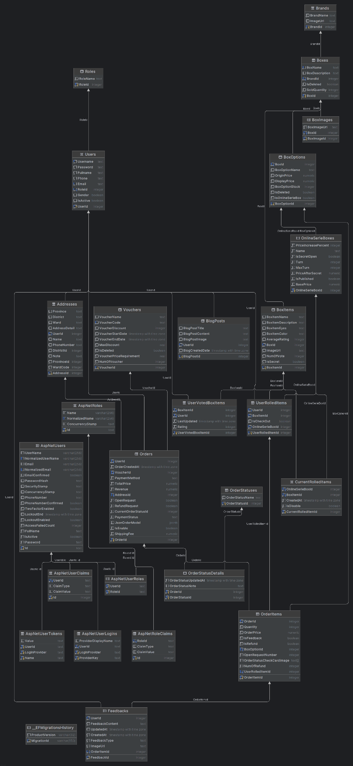

[Database Implementation](https://drive.google.com/file/d/1DWUitVBaX2hyi4fOzP_v86O5-AytdcEQ/view?usp=drive_link)

### 3.1 Activity Diagram

#### 3.1.1 Order product (Quang Giáp)

#### 

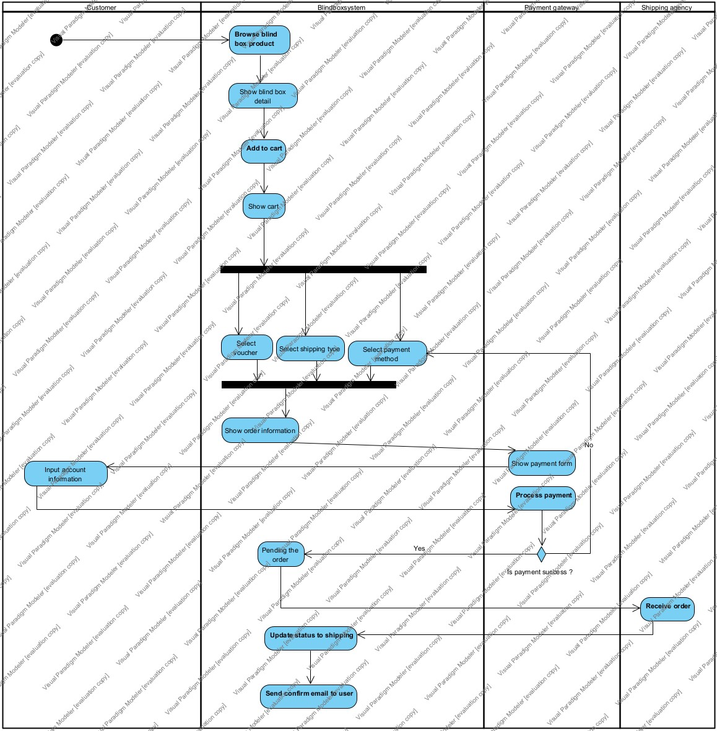

#### 3.1.2 Open blind box for customer (Quang Giáp)

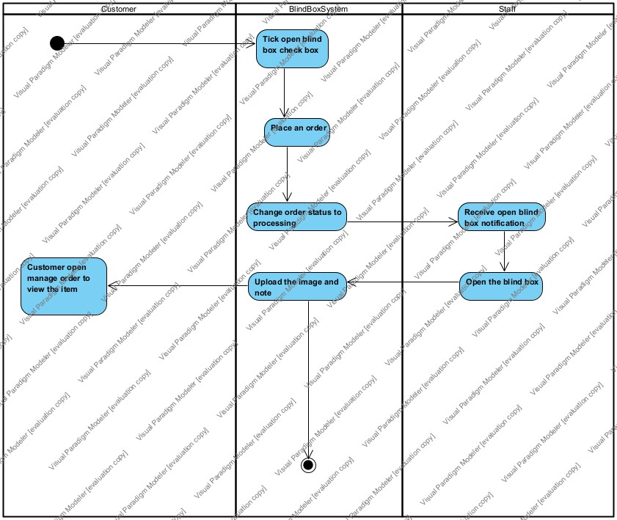

#### 3.1.3 Return product (Quang Giáp)

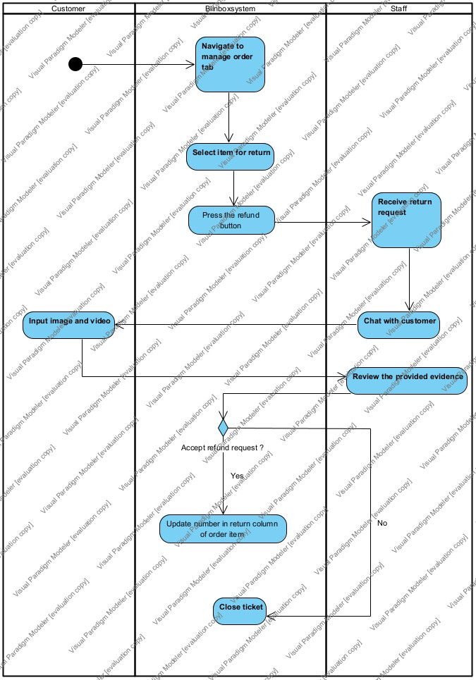

#### 3.1.4 Manage order(Quang Giáp)

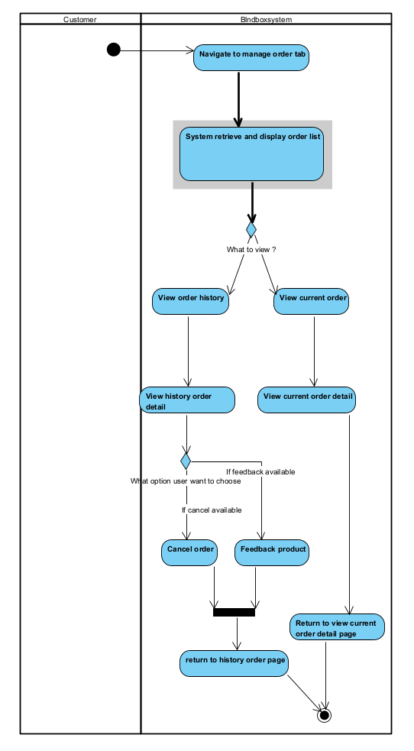

#### 3.1.5 Search Product (Quốc Phong)

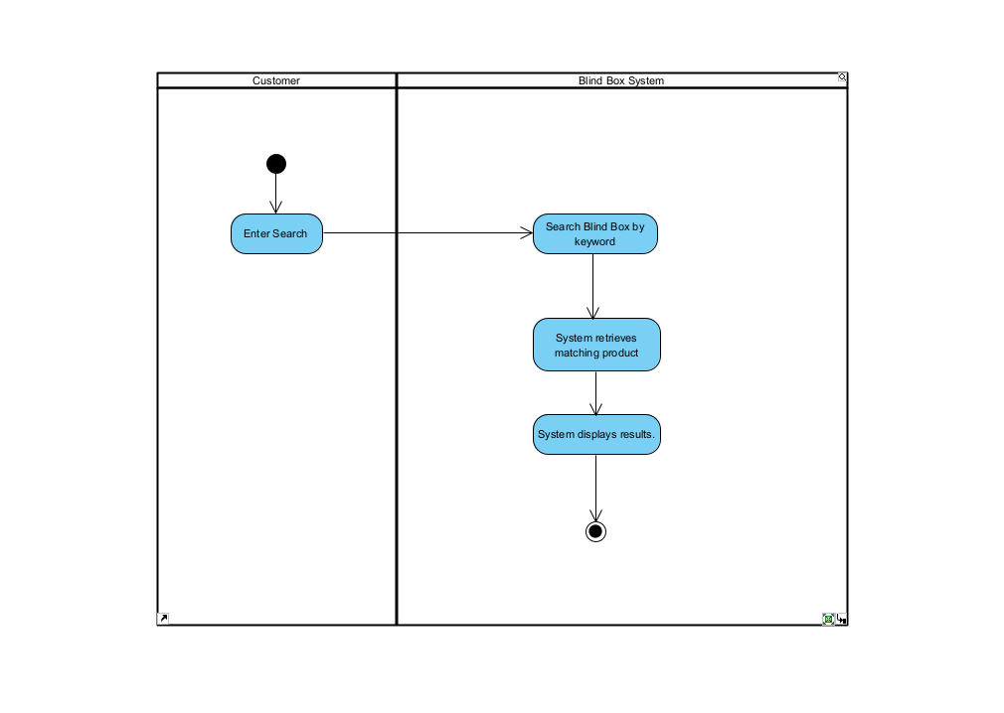

#### 3.1.6 Register (Quốc Phong)

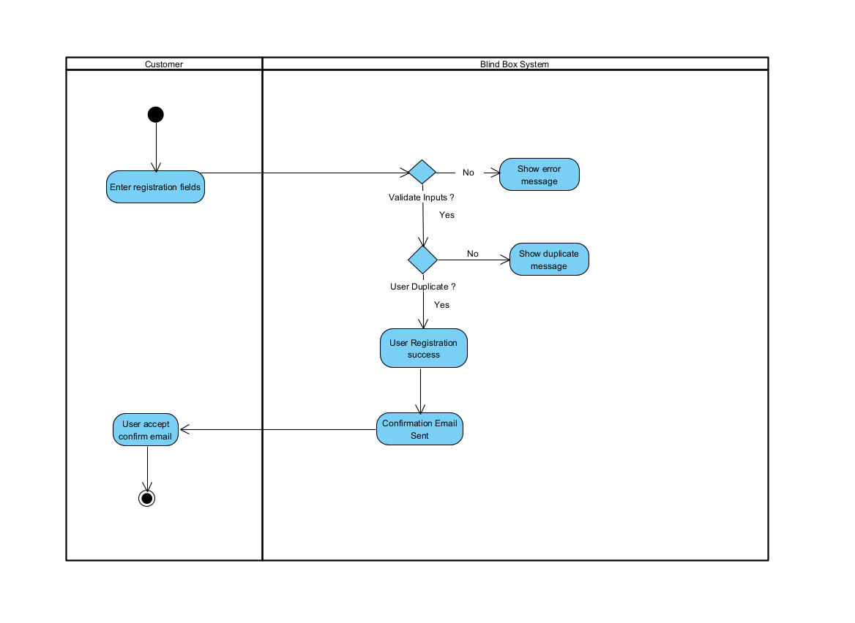

#### 3.1.7 Chat with customer (Quốc Phong)

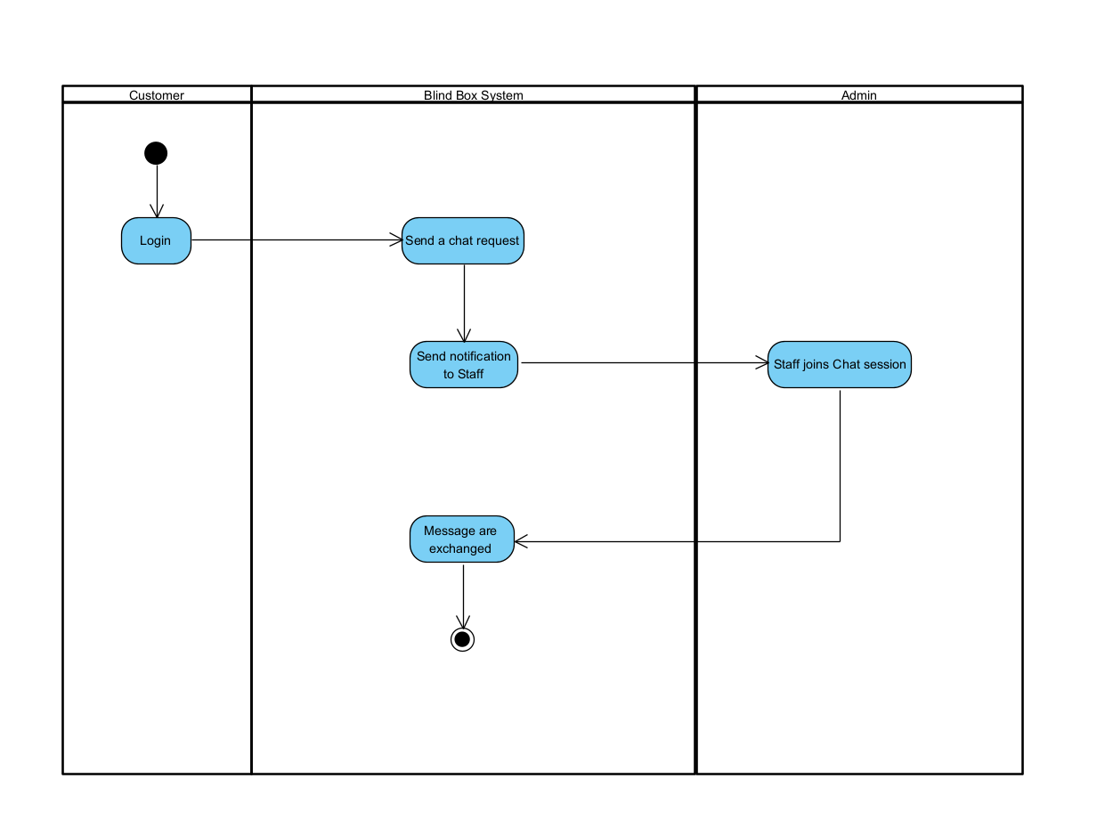

### 

#### 3.1.8 Manage Product (Quốc Phong)

#### 3.1.9 Unbox Online blindbox

### 3.2 Sequence Diagram

#### 3.2.1 Cancel Order (Quang Giáp)

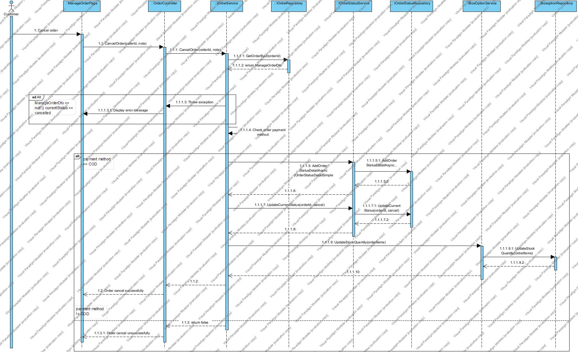

#### 3.2.2 Feedback Product (Quang Giáp)

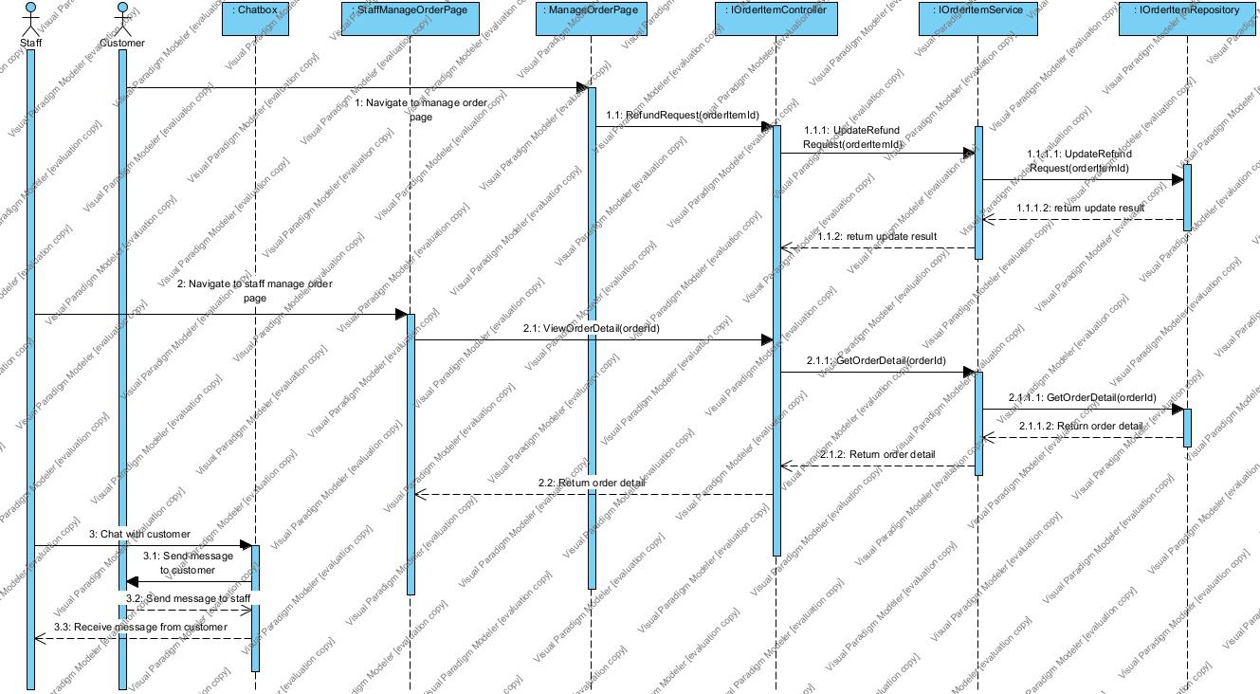

#### 3.2.3 FilterProductByPriceAndCategory (Quang Giáp)

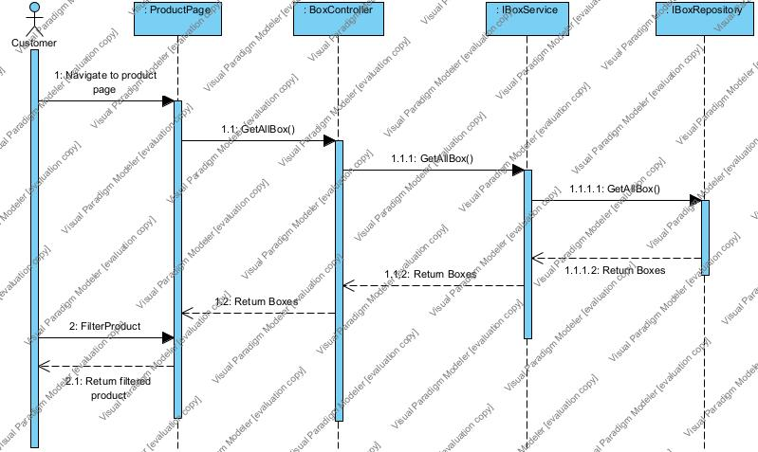

#### 3.2.4 LoginGoogle (Quang Giáp)

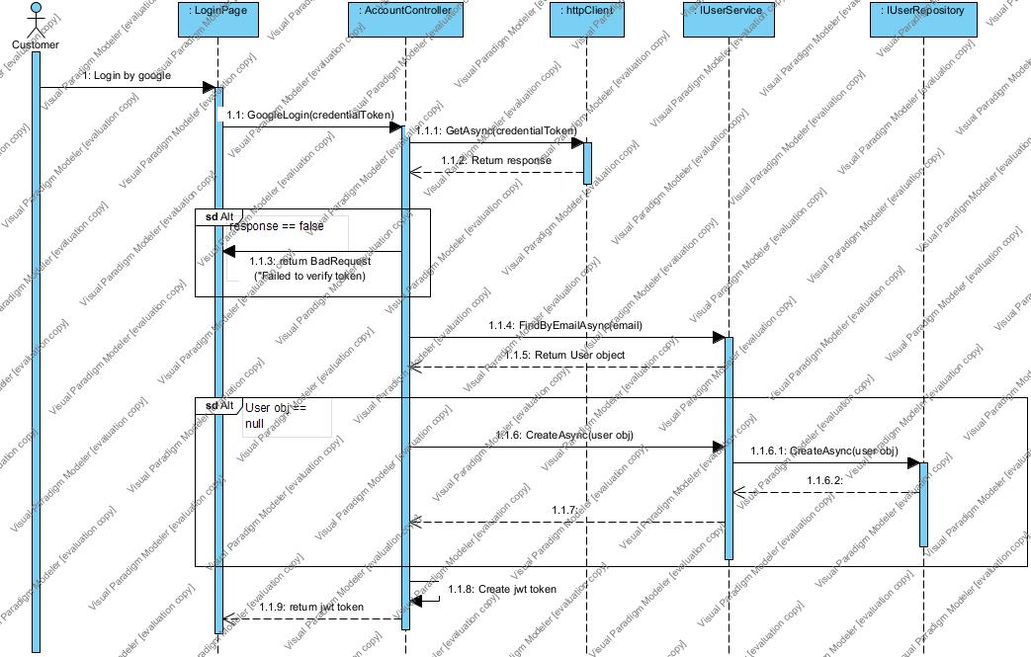

#### 3.2.5 LoginUseCase (Quang Giáp)

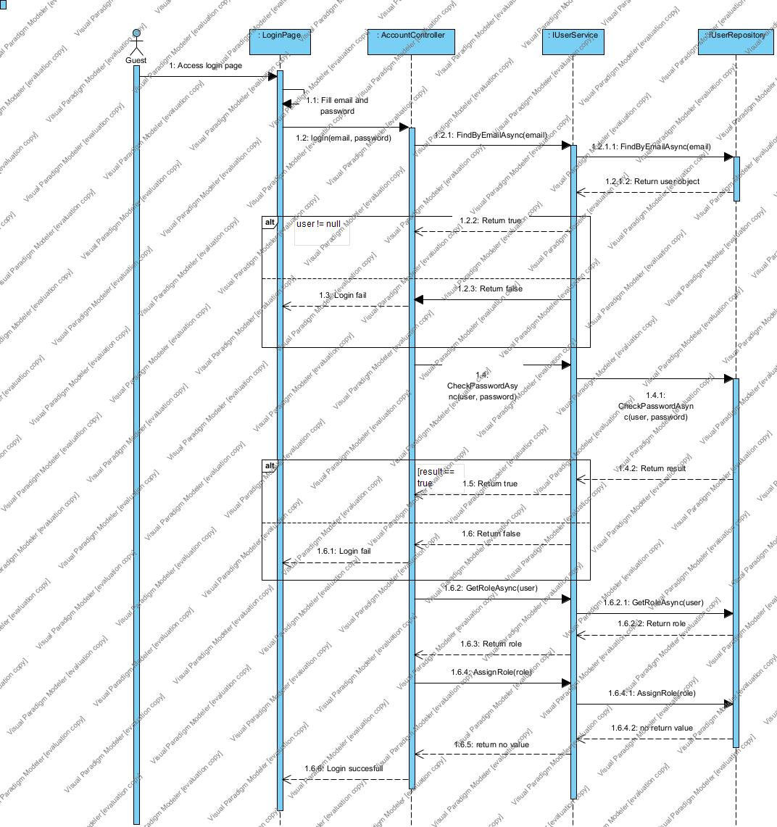

#### 3.2.6 ManageAccount (Quốc Phong)

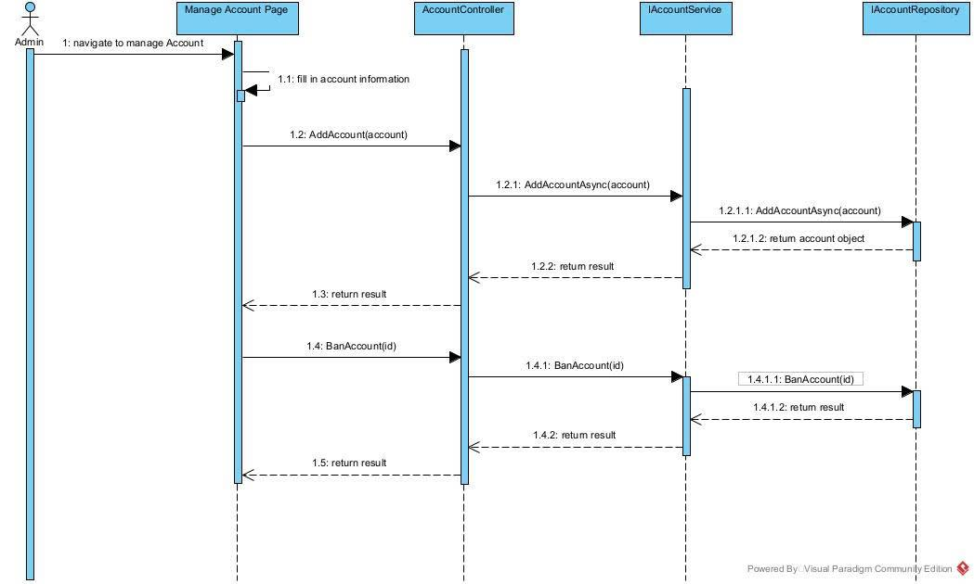

#### 3.2.7 ManageBlog (Quang Giáp)

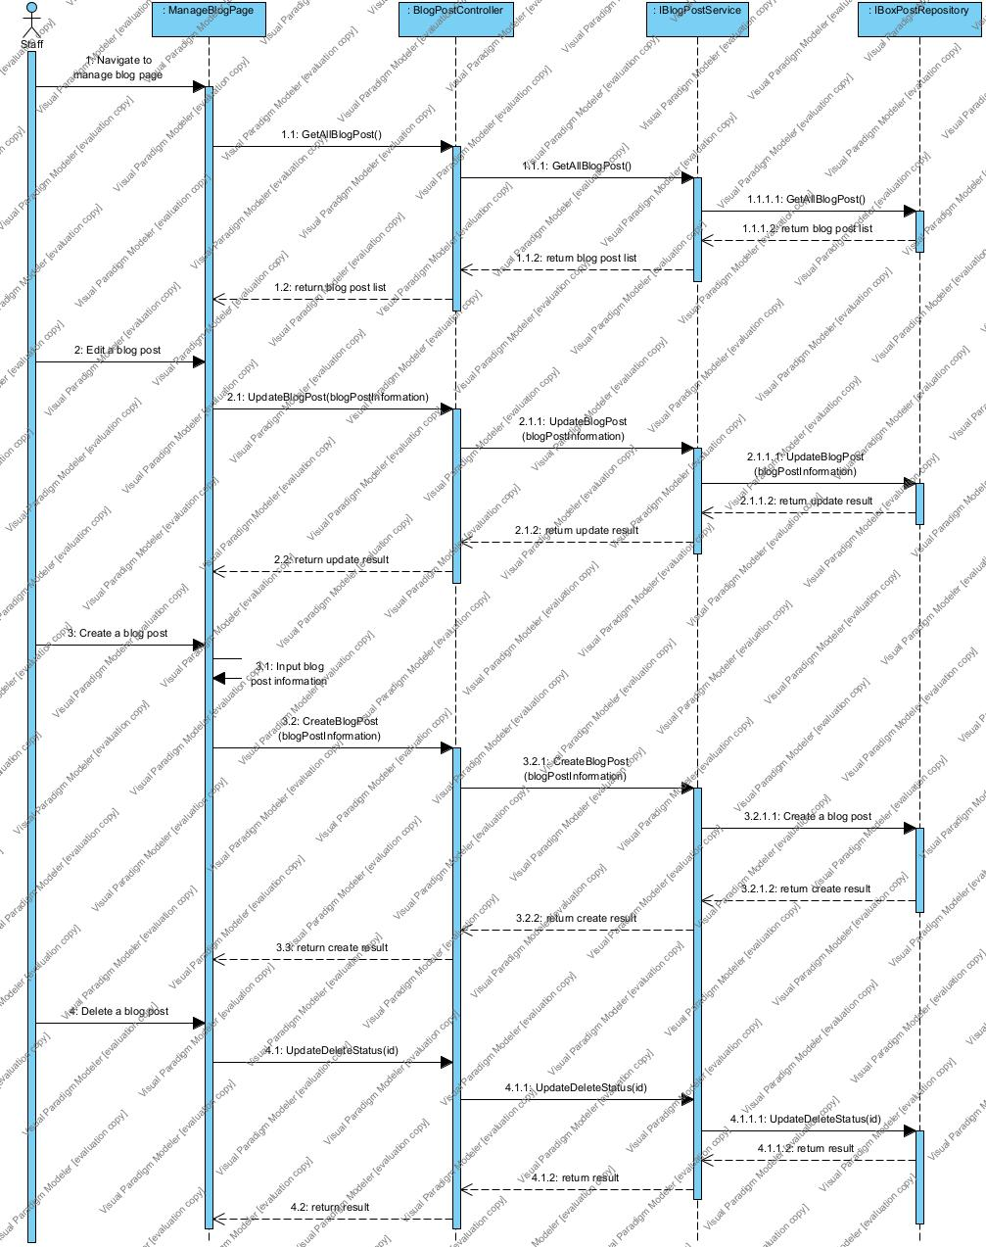

#### 3.2.8 ManageBoxOption (Quang Giáp)

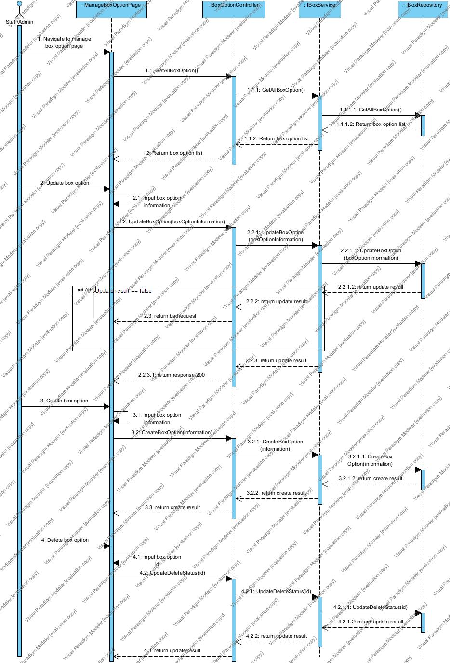

#### 3.2.9 ManageBrand (Quốc Phong)

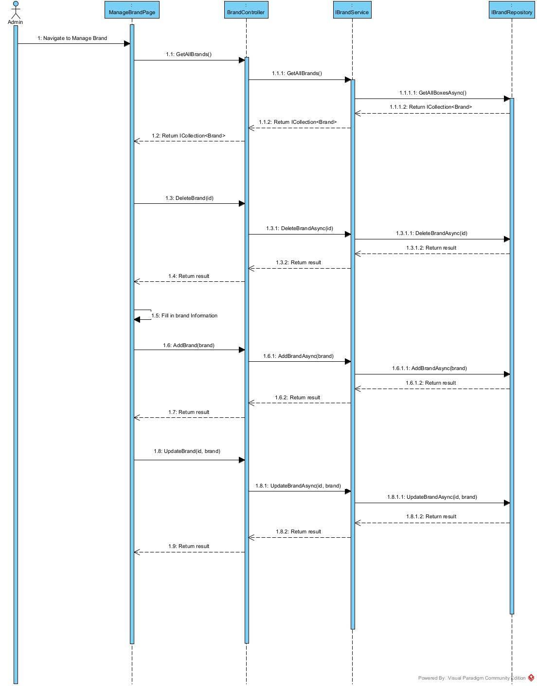

#### 3.2.10 ManageOrderUseCase (Quốc Phong)

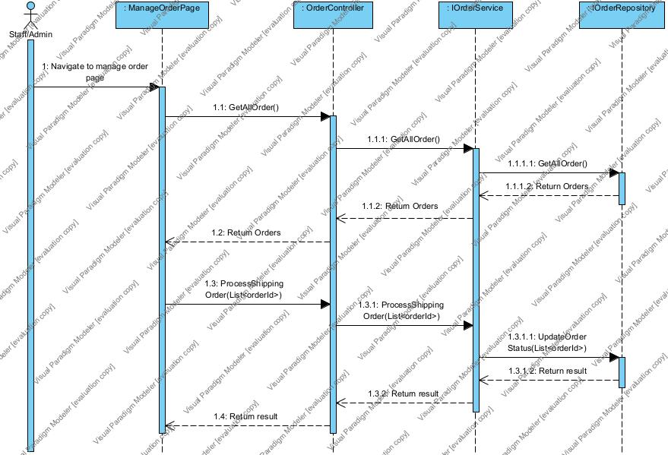

#### 3.2.11 ManageProduct (Quang Giáp)

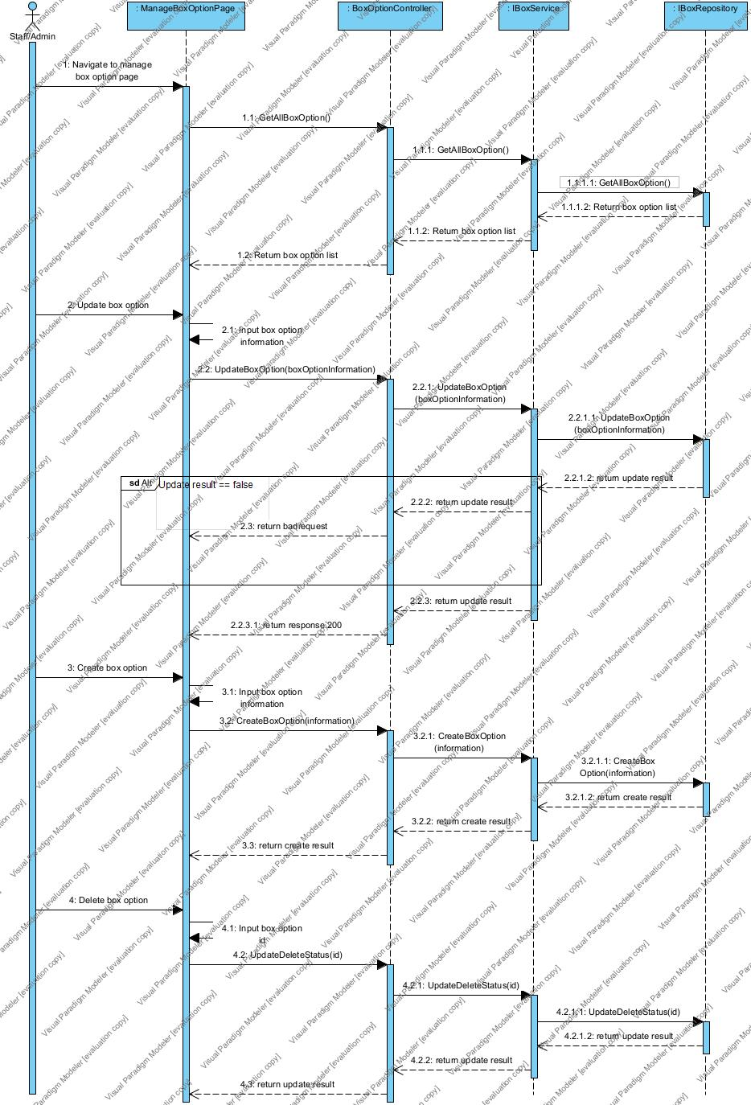

#### 3.2.12 ManageProfile (Quốc Phong)

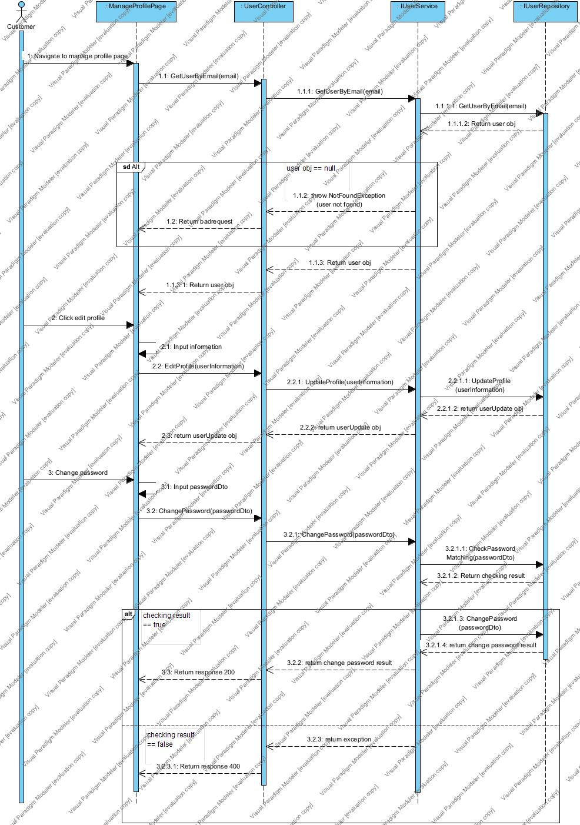

#### 3.2.13 ManagerOrderForCustomer (Quang Giáp)

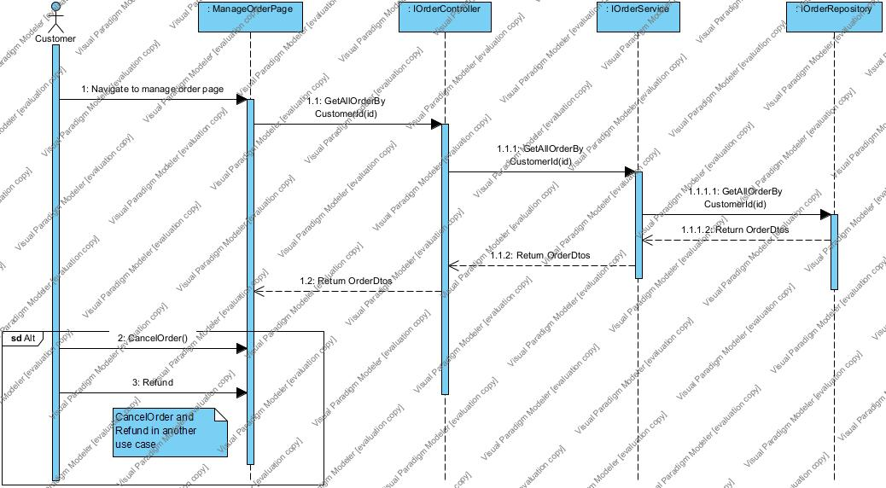

#### 3.2.14 ManageVoucher (Quang Giáp)

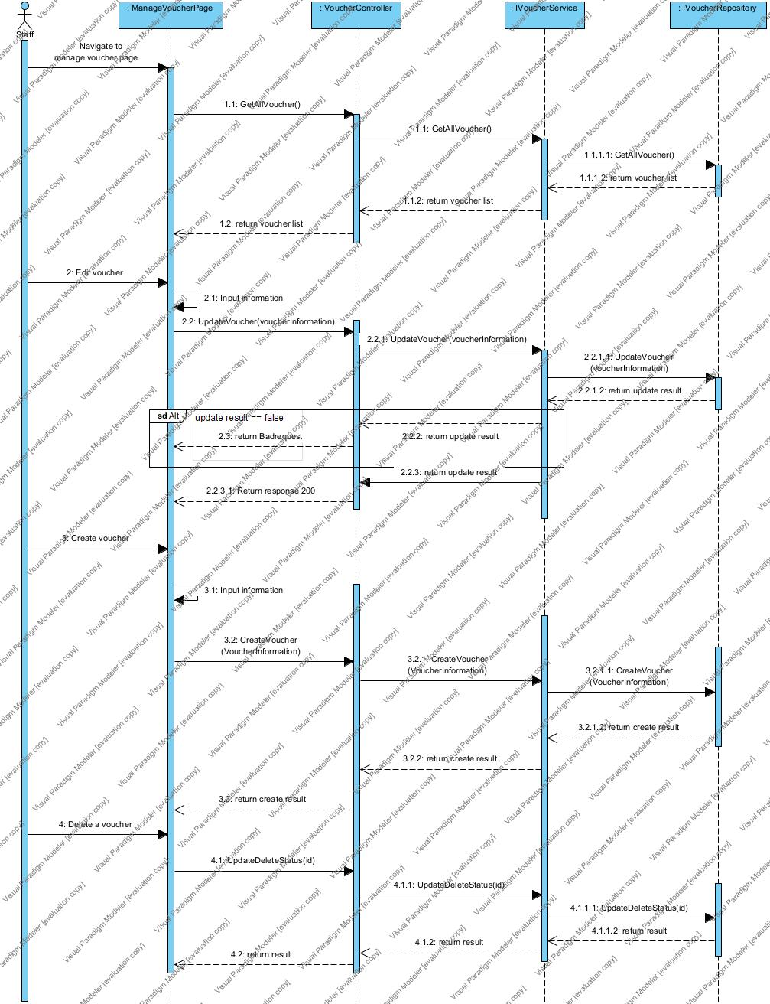

#### 3.2.15 Manage Feedback (Quang Giáp)

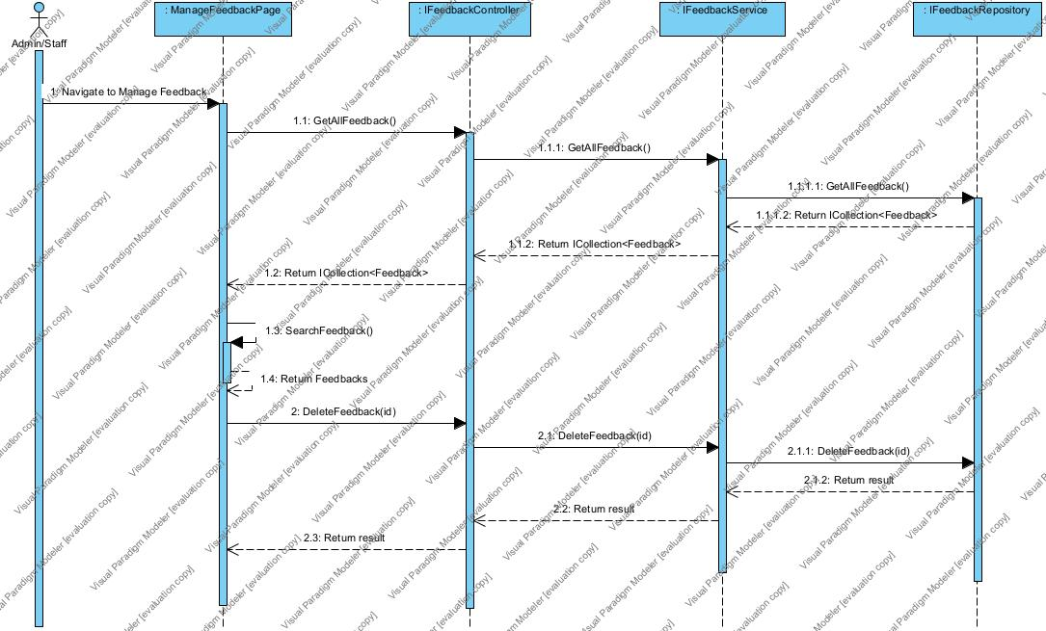

#### 3.2.16 OpenBlindboxForCustomer (Quang Giáp)

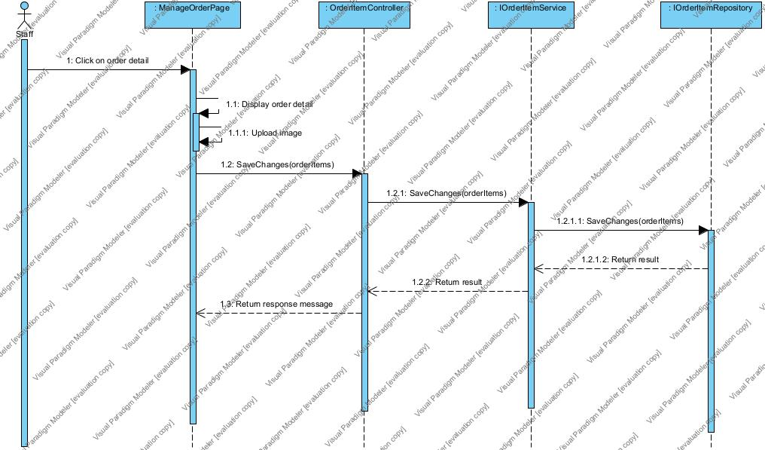

#### 3.2.17 OrderUseCase (Quang Giáp)

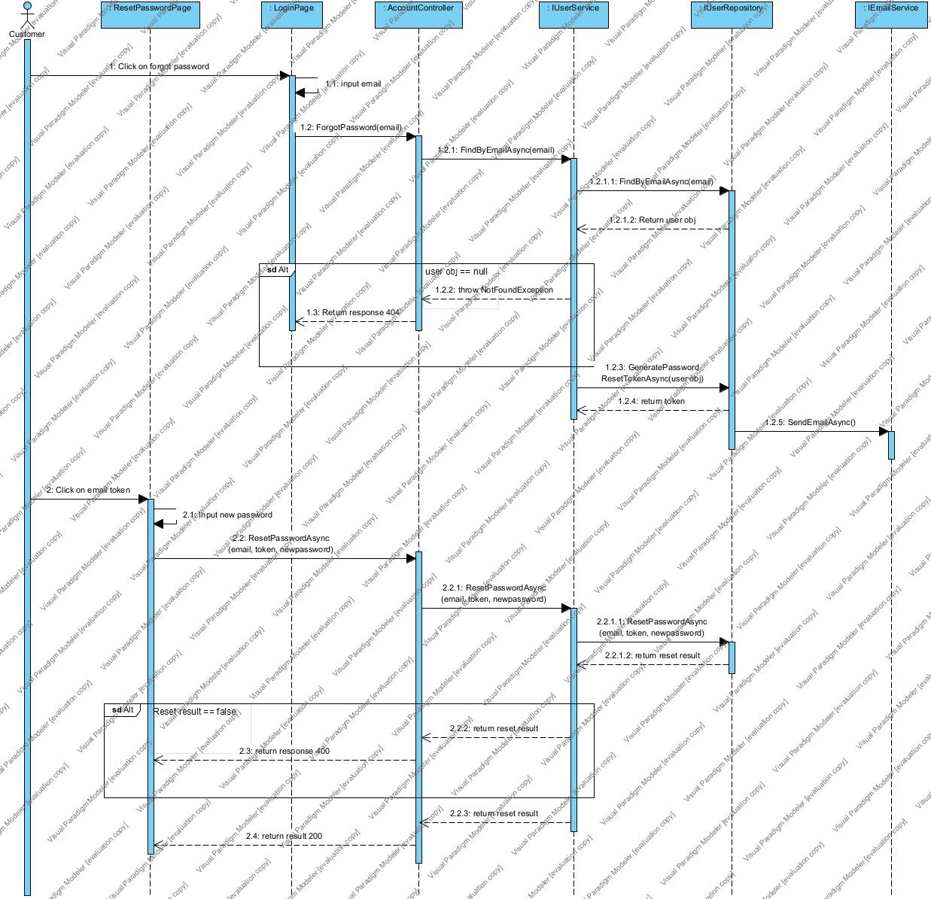

#### 3.2.18 RecoverPassword(Quang Giáp)

#### 3.2.19 RegisterUseCase (Quang Giáp)

#### 

#### 3.2.20 ReturnProduct (Quang Giáp)

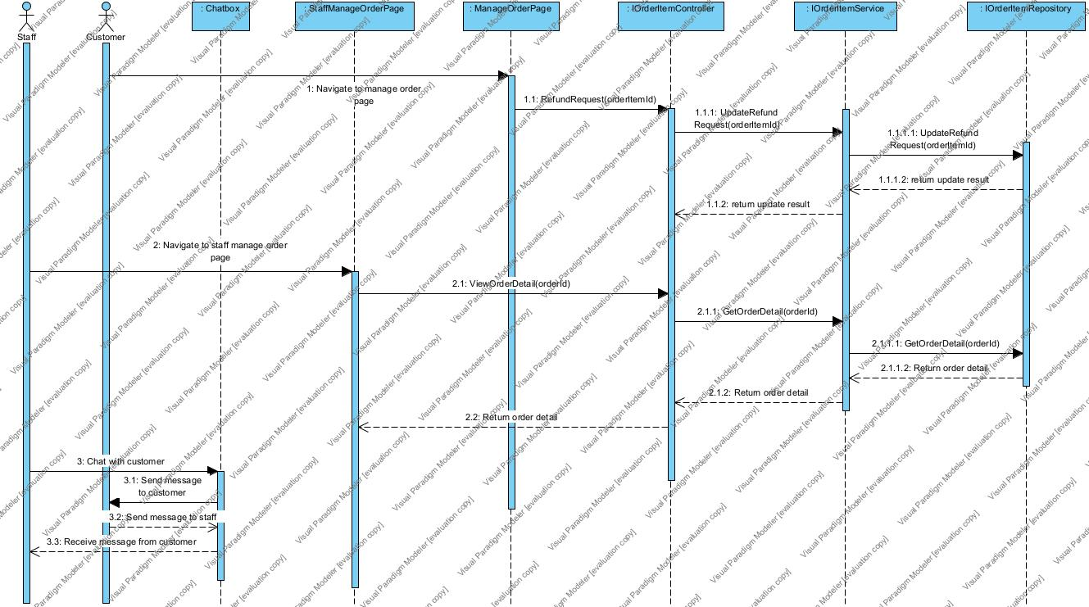

#### 3.2.21 Unbox blindbox

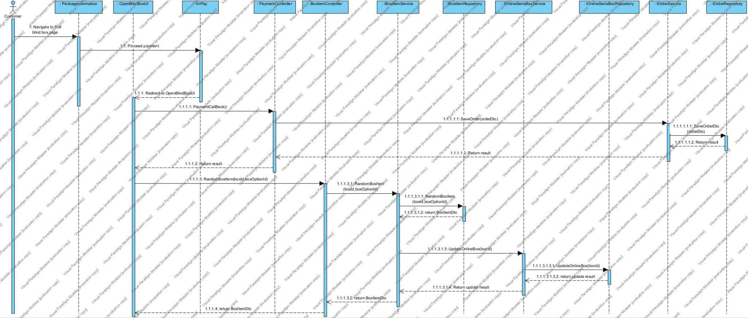

#### 3.2.22 ViewCollectionpage (Quốc Phong)

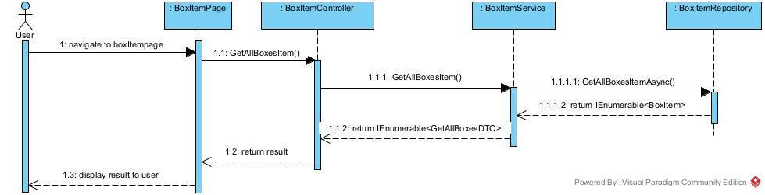

#### 3.2.23 ViewDashboard (Quốc Phong)

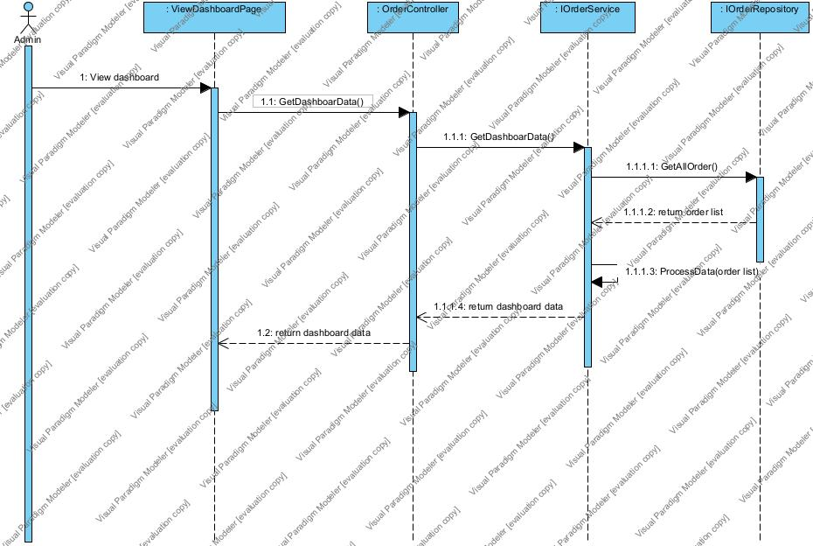

#### 

#### 3.2.24 View Product Detail (Quốc Phong)

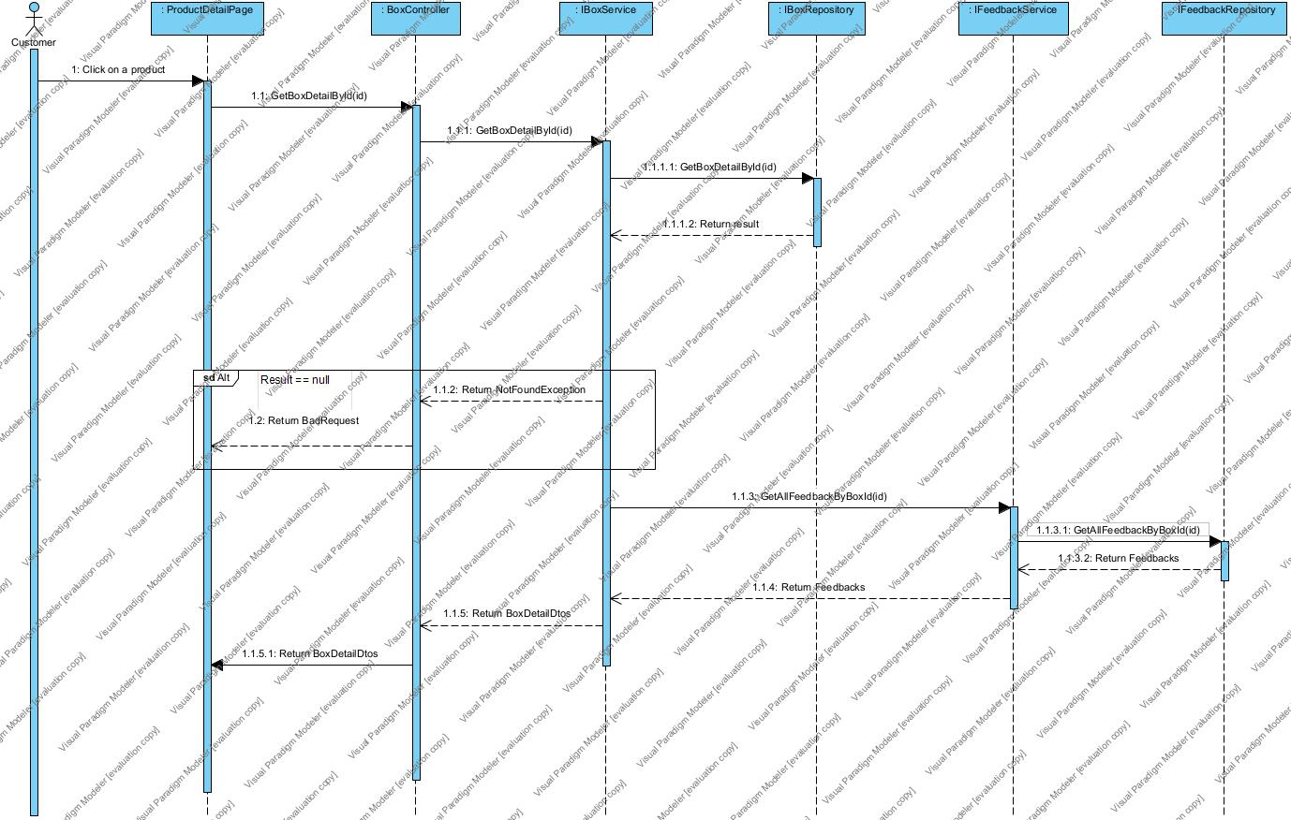

### 3.3. State machine diagram (Quang Giáp)

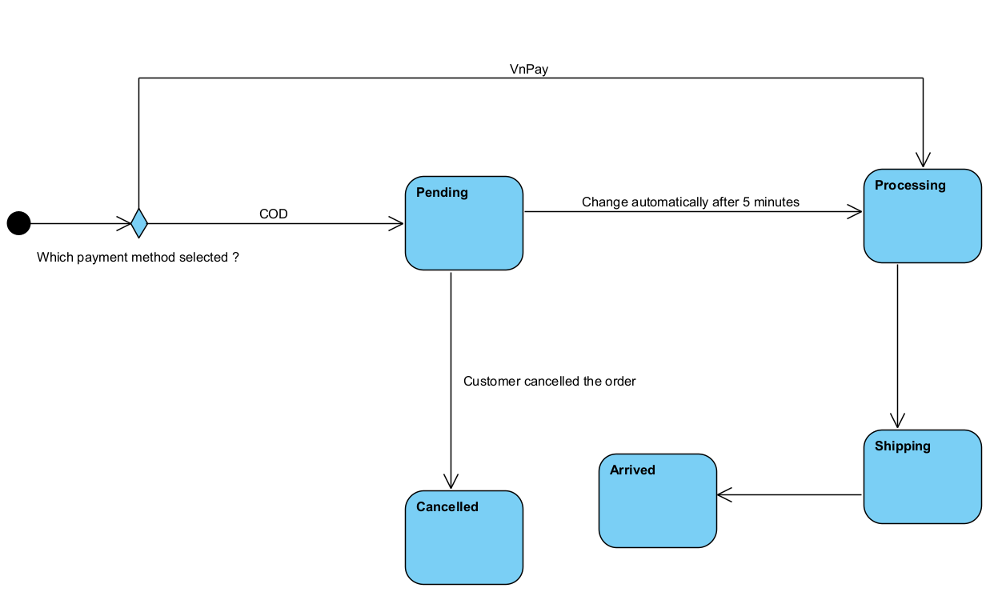

### 3.4. Class Diagram

#### 3.4.1 Role (Thế Minh)

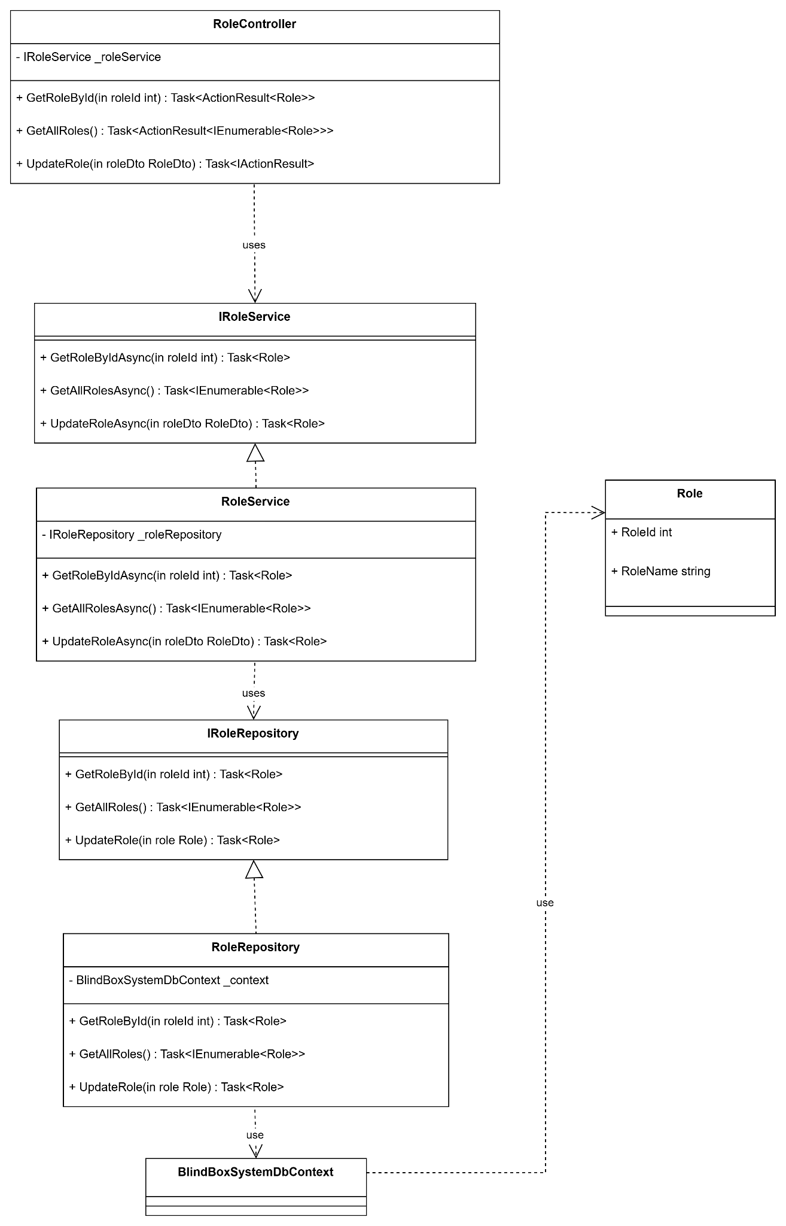

#### 3.4.2 Address (Thế Minh)

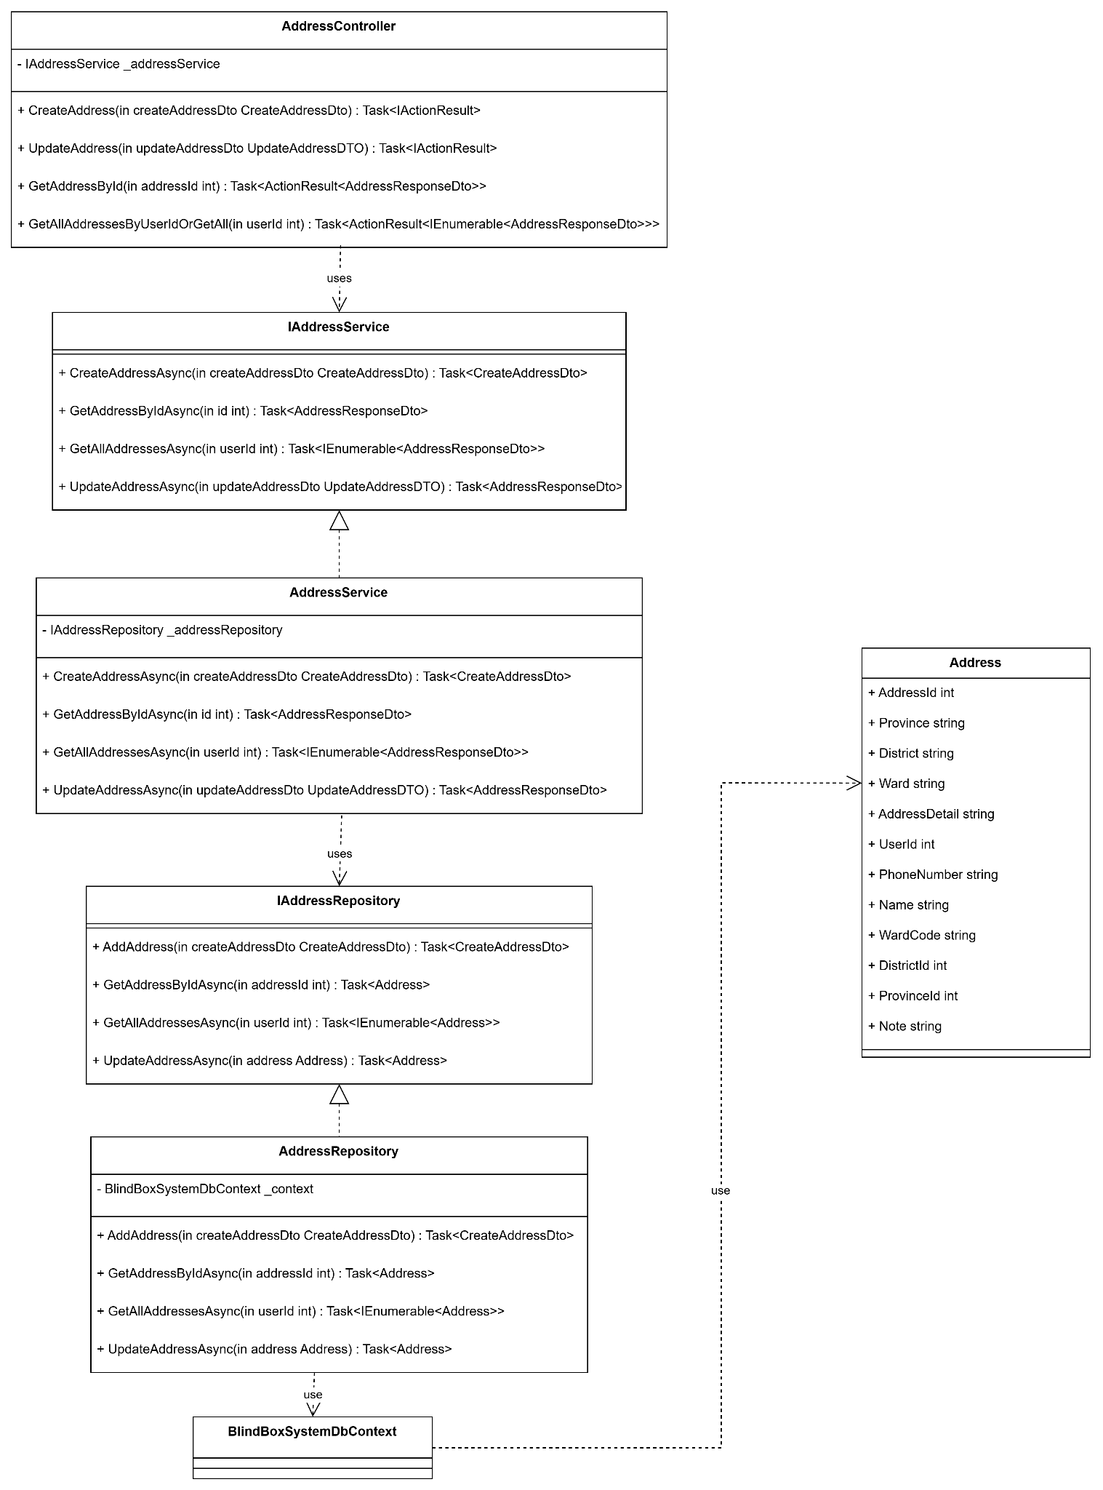

#### 3.4.3 Voucher (Thế Minh)

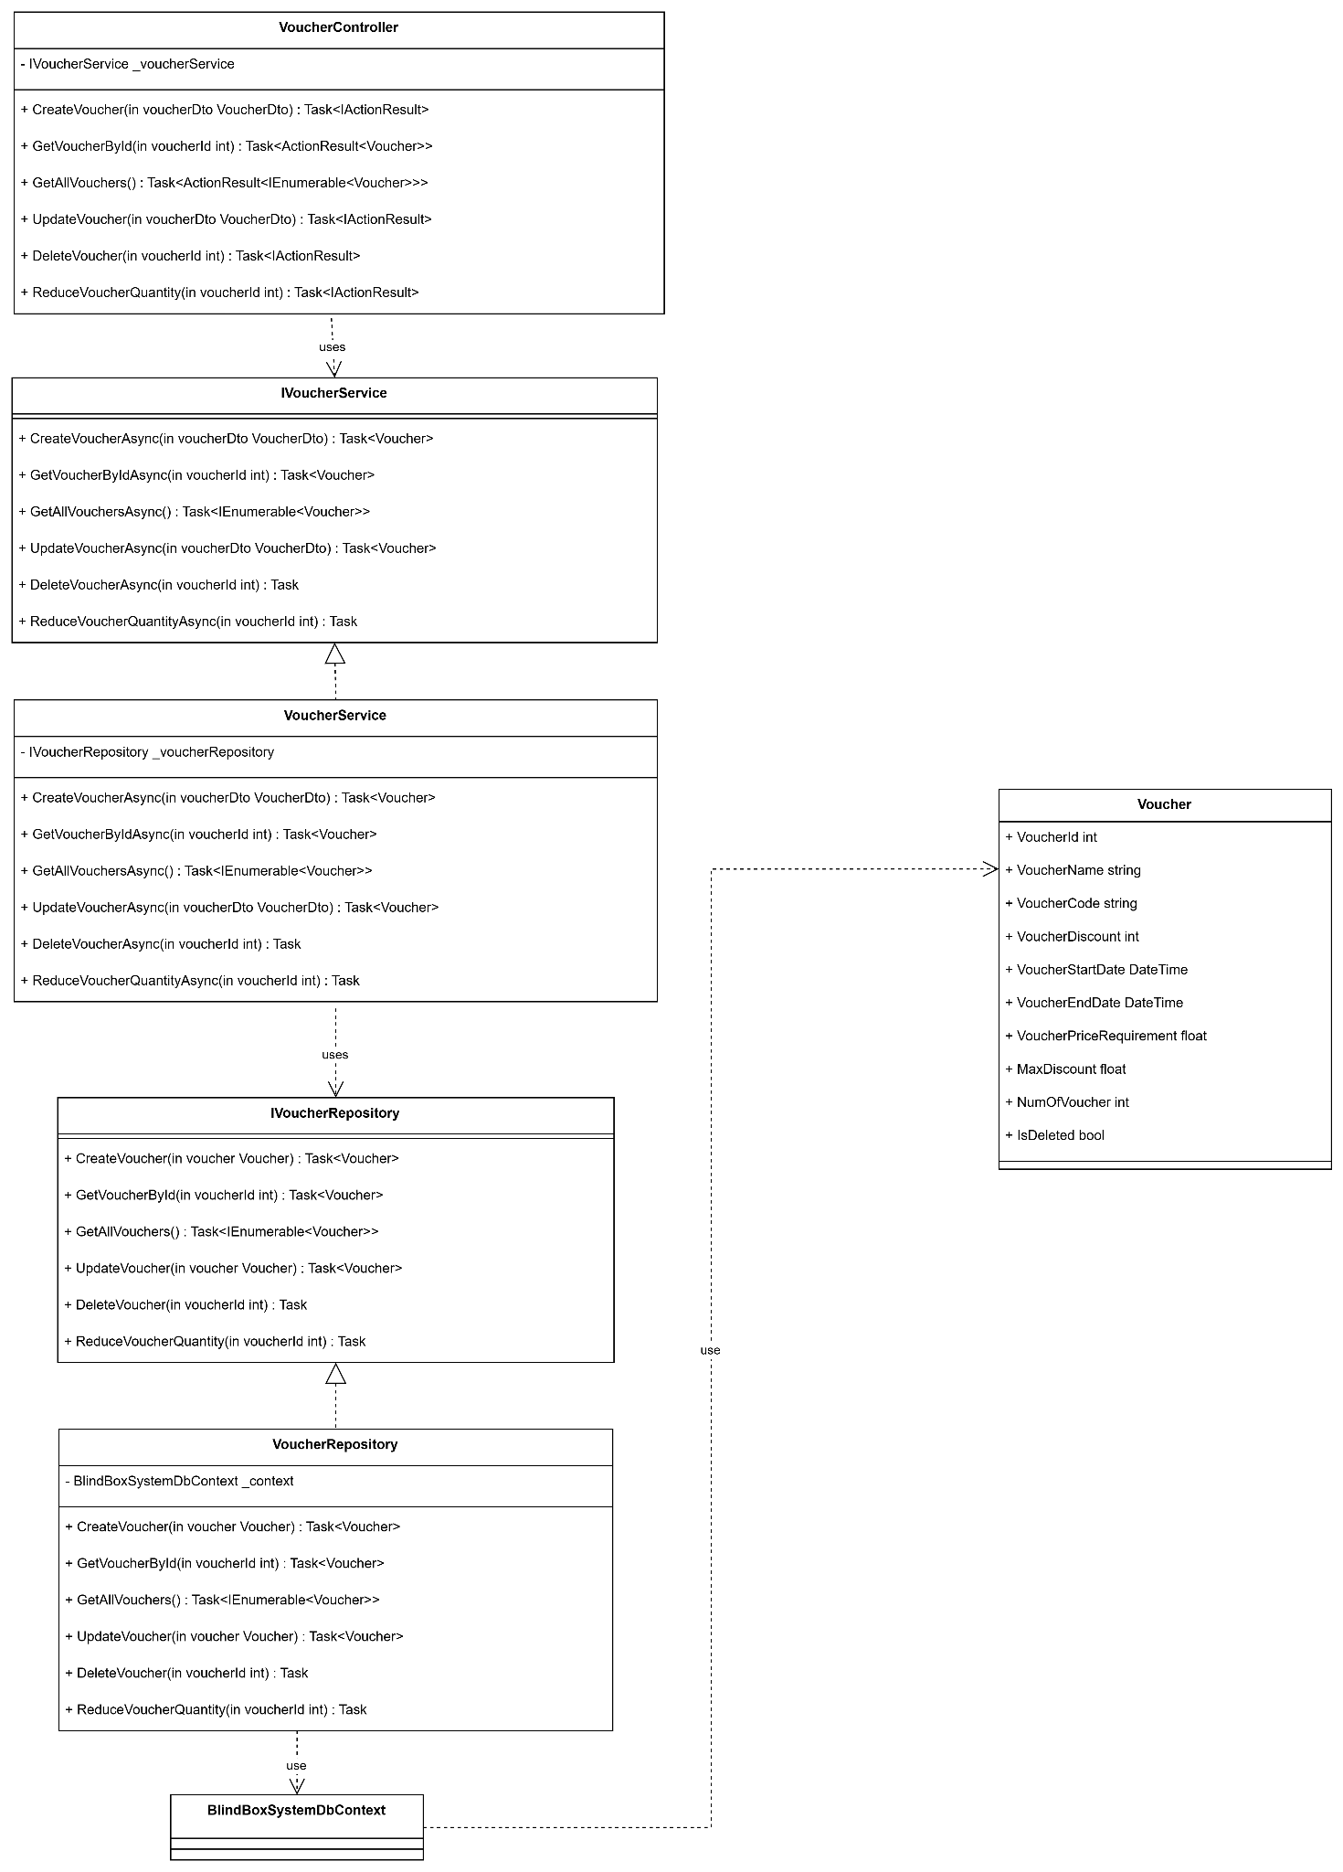

#### 3.4.4 Order Status (Thế Minh)

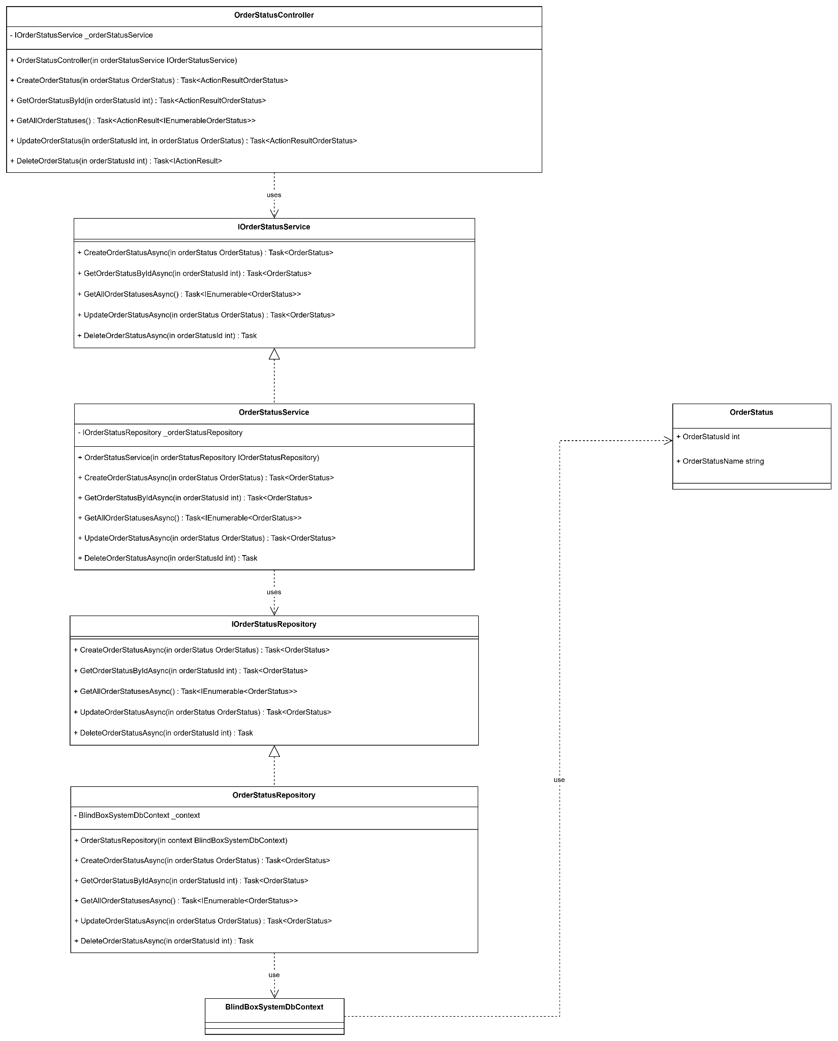

#### 3.4.5 Brand (Thế Minh)

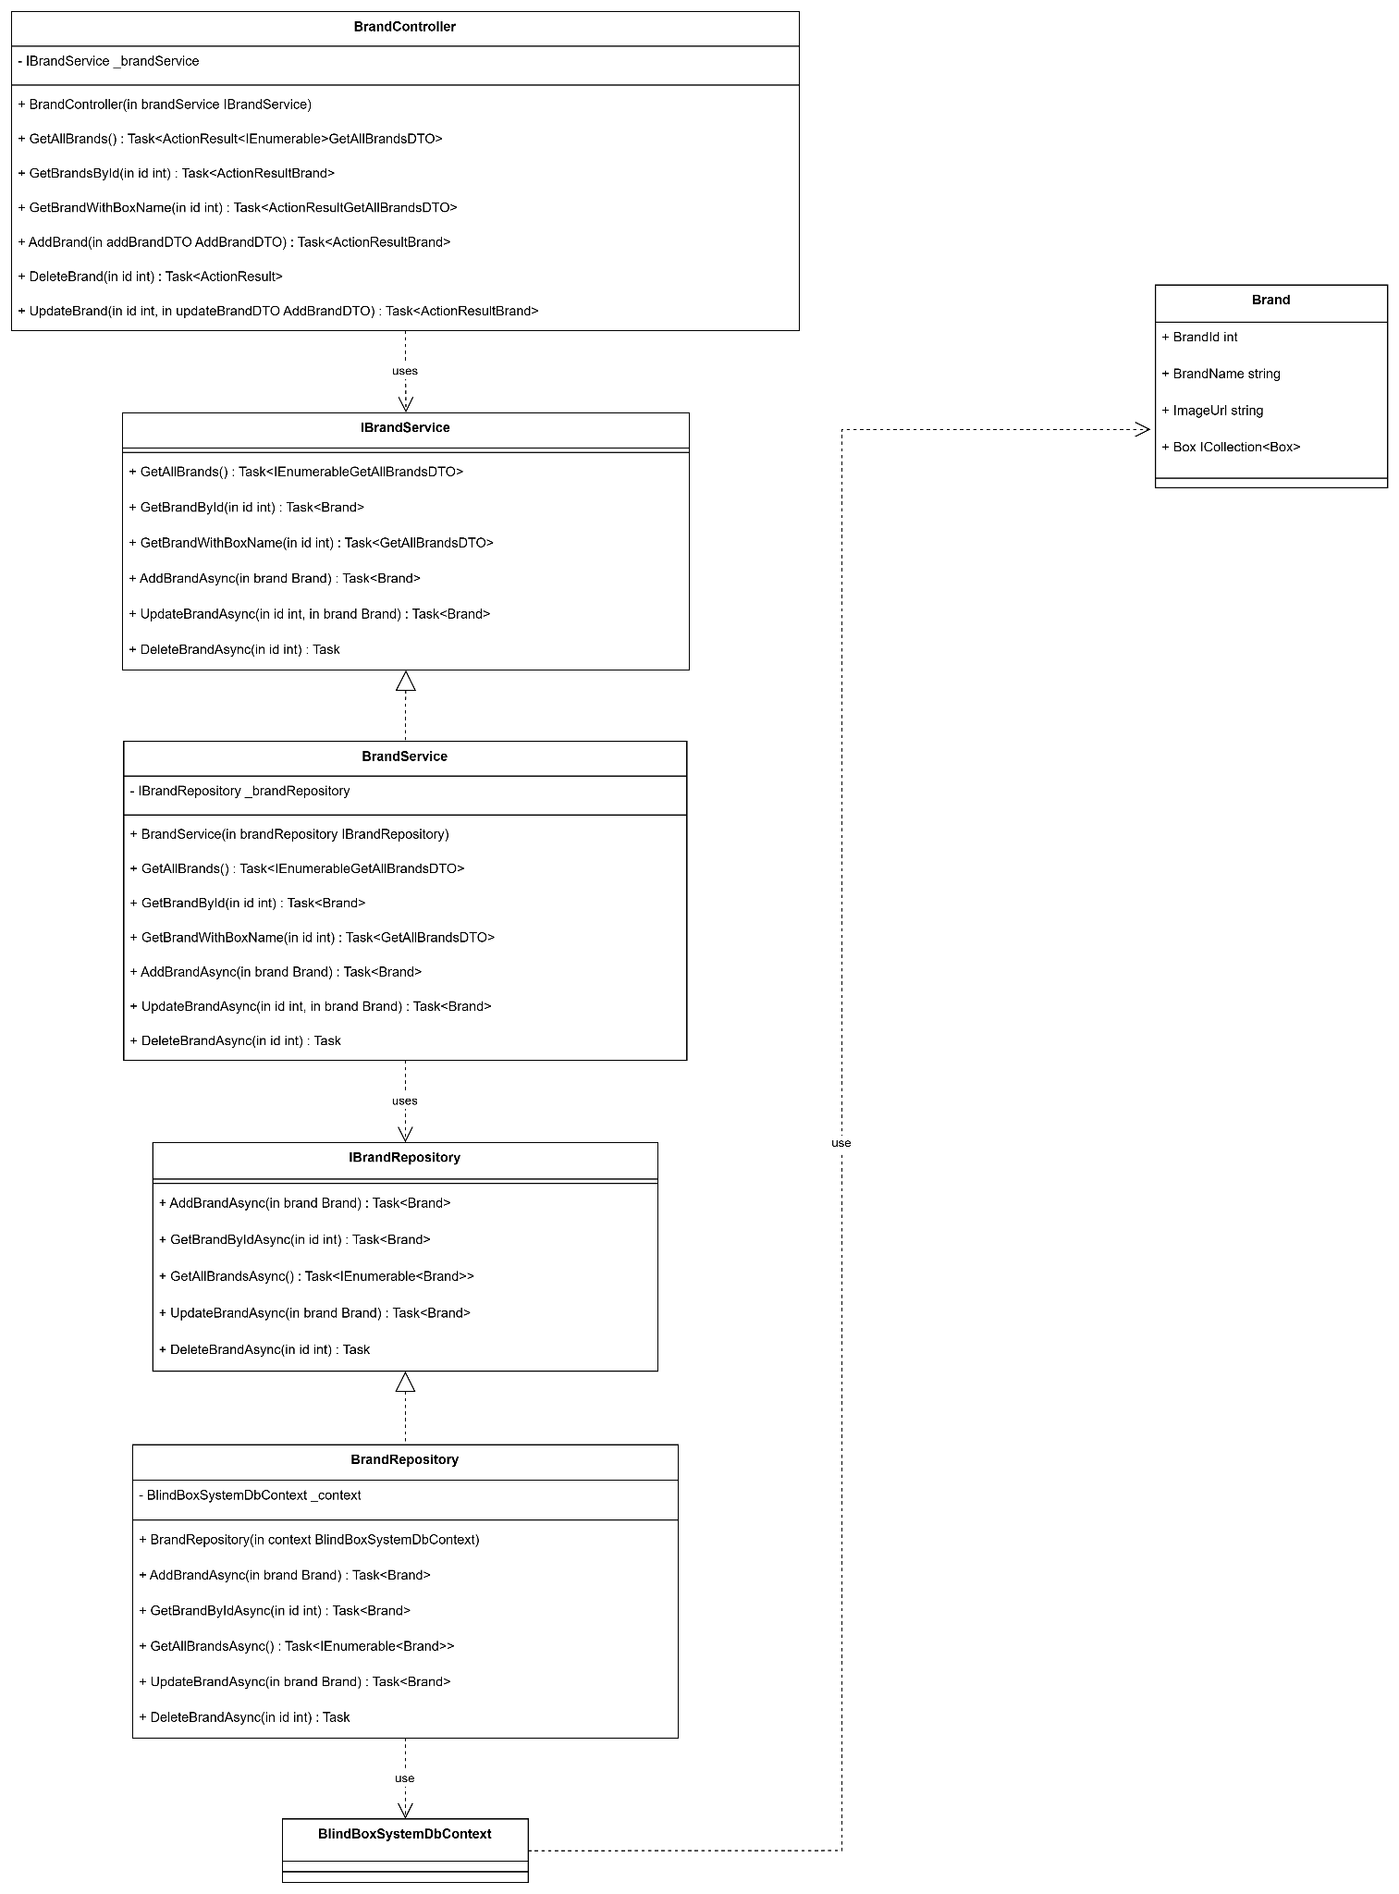

#### 3.4.6 User Voted Box Item (Quốc Phong)

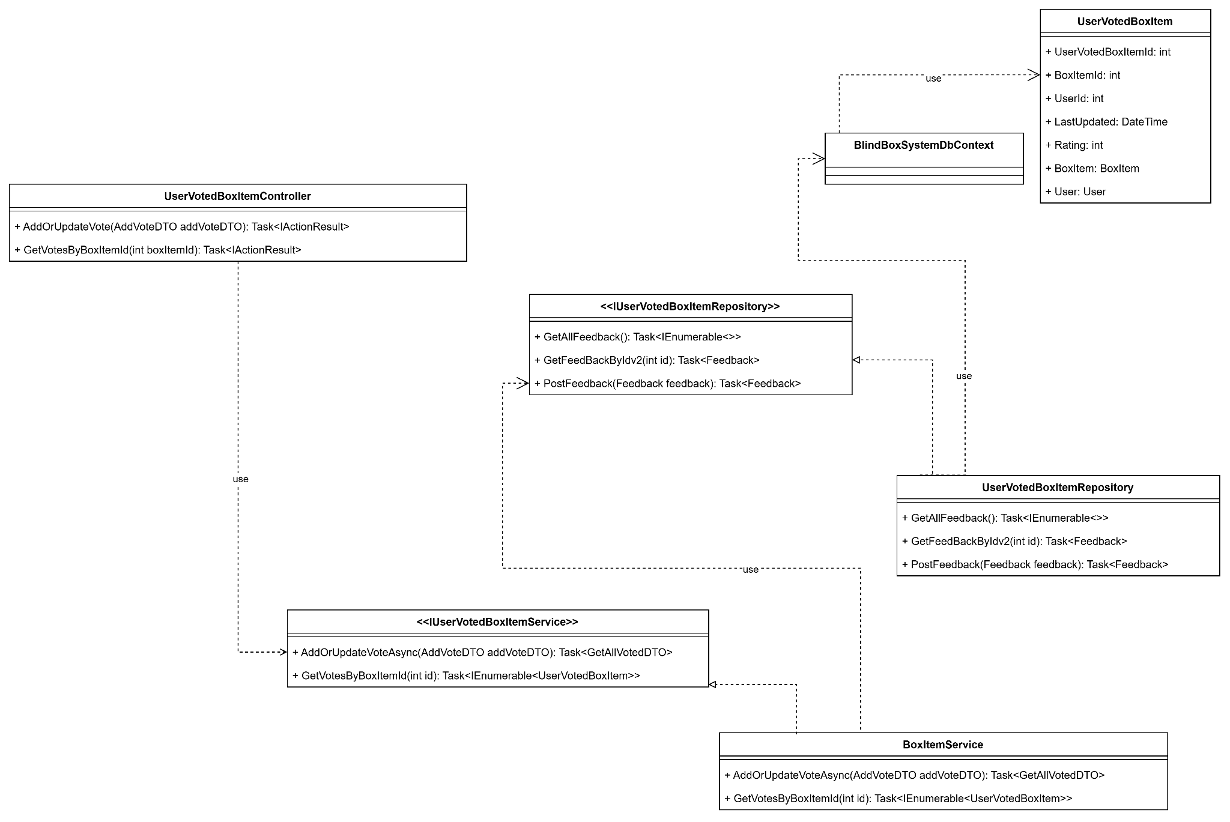

#### 3.4.7 Feedback (Quốc Phong)

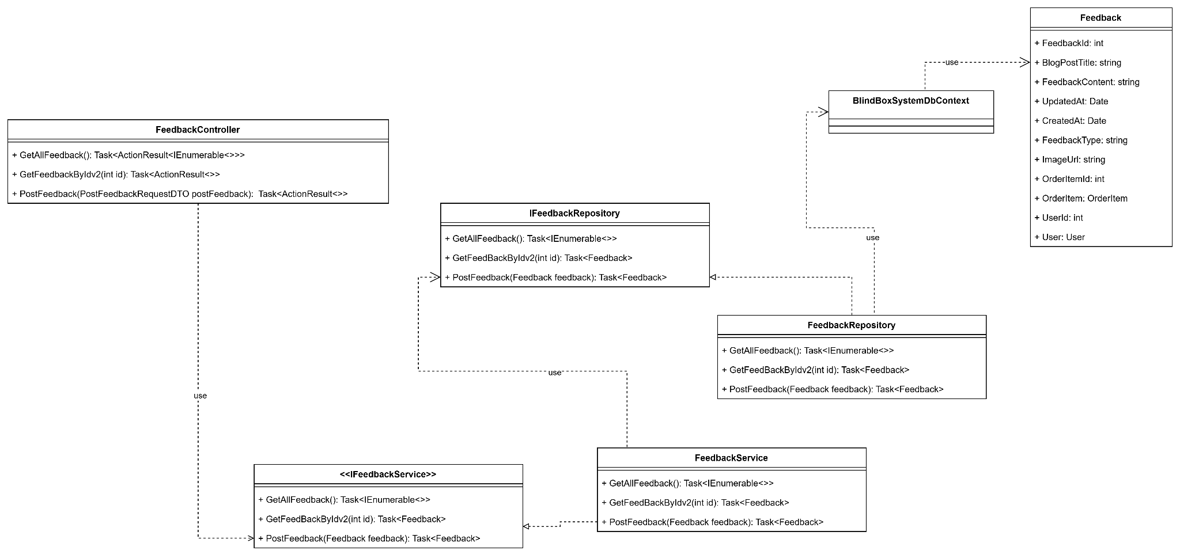

#### 3.4.8 Blog (Quốc Phong)

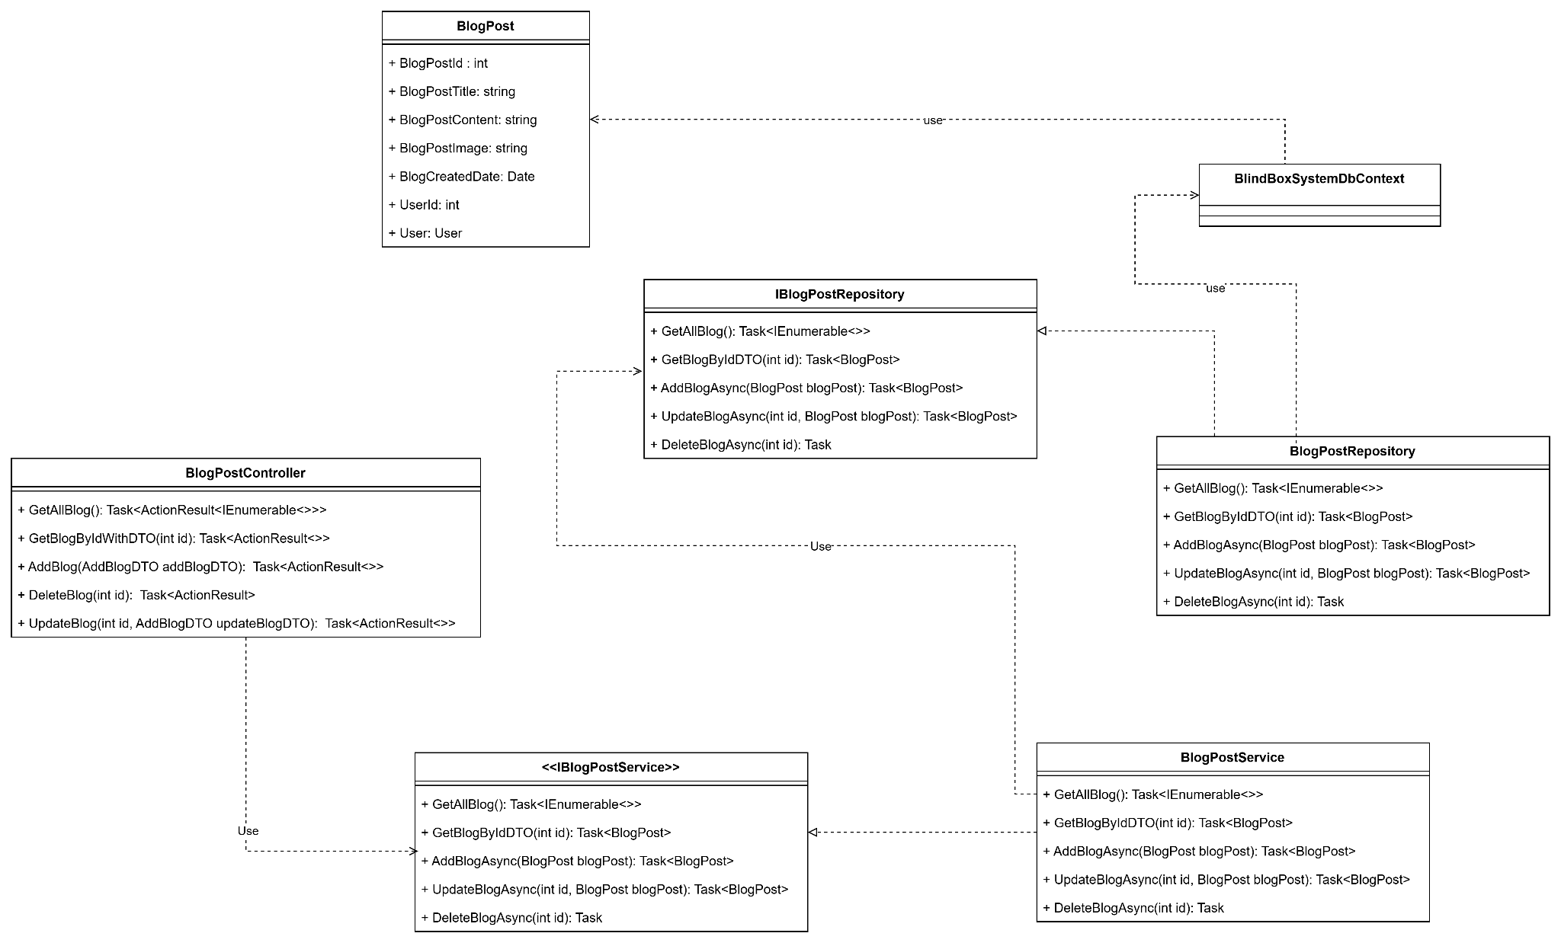

#### 3.4.9 Messenger (Quốc Phong)

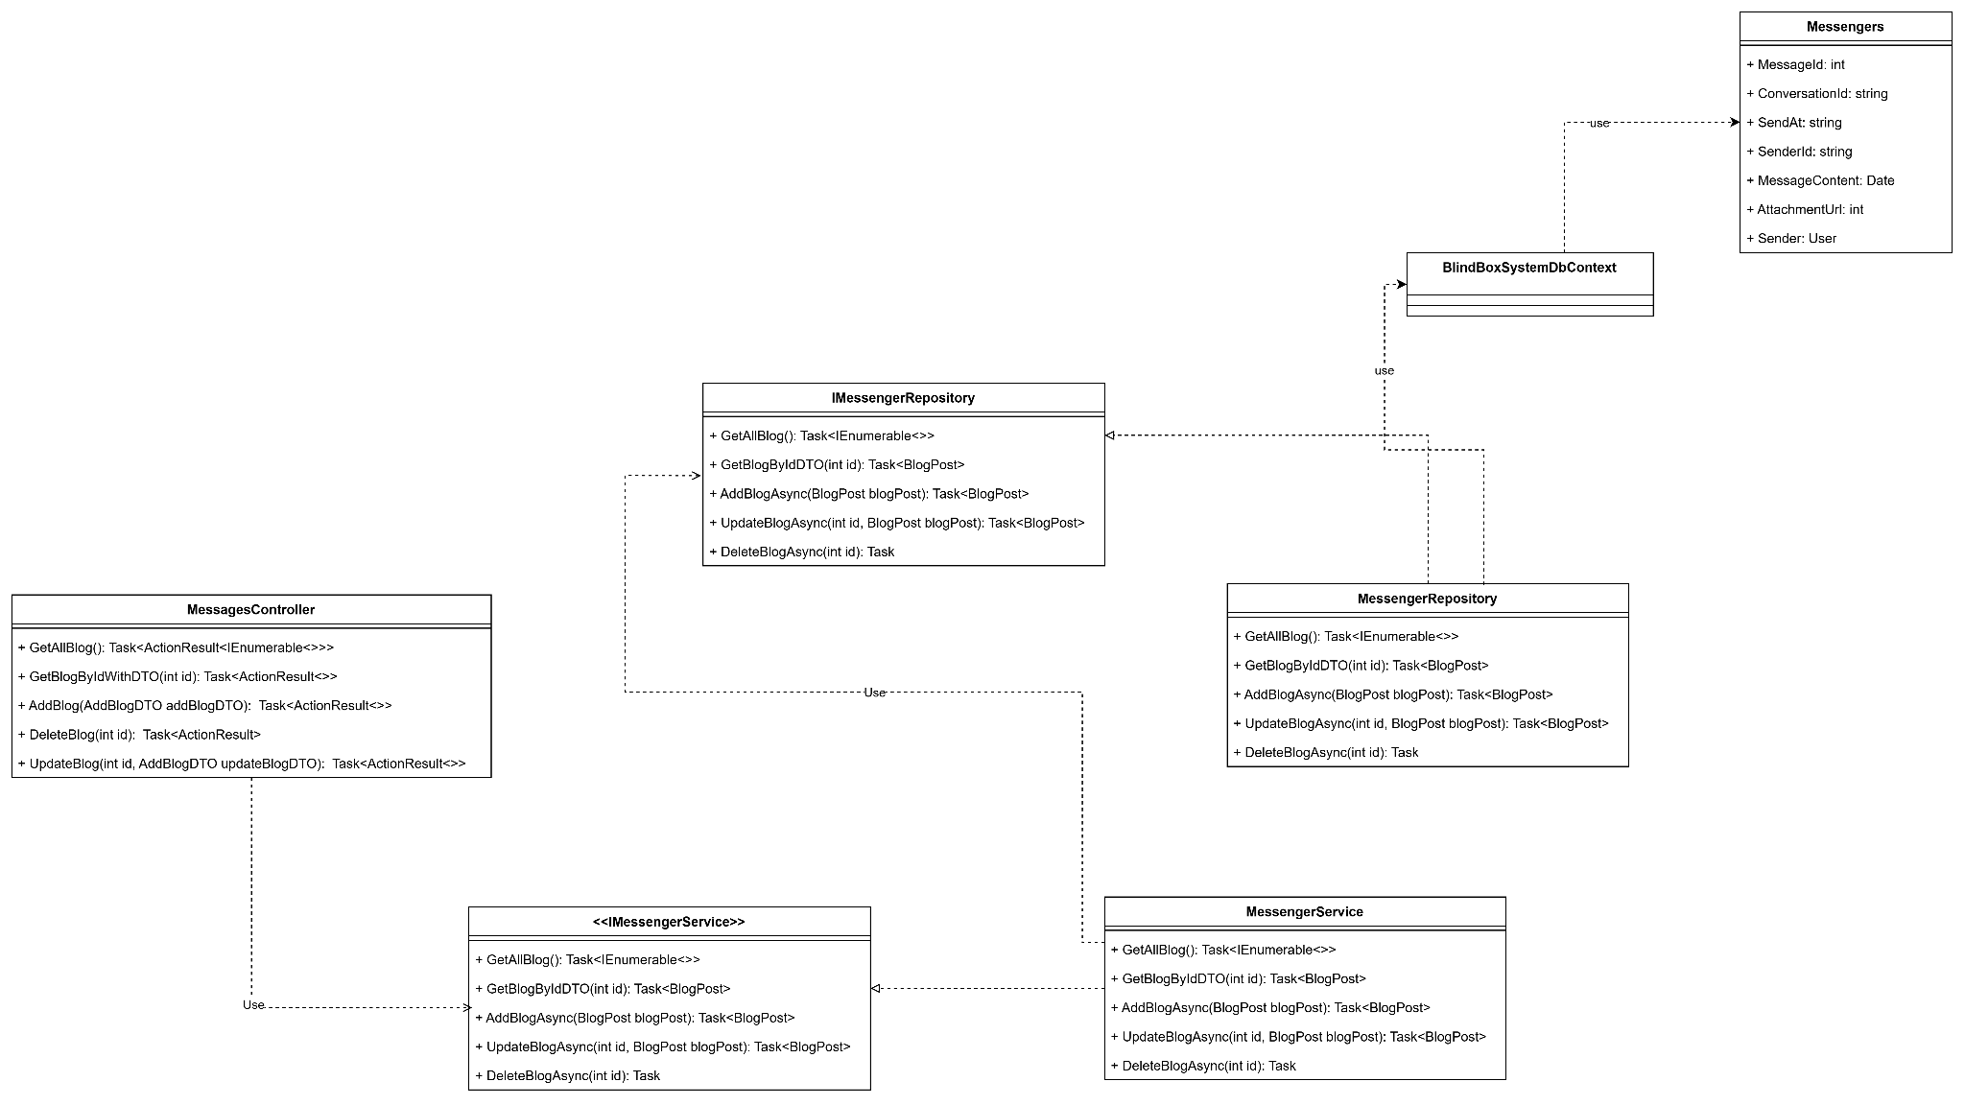

#### 3.4.10 Box (Quang Giáp)

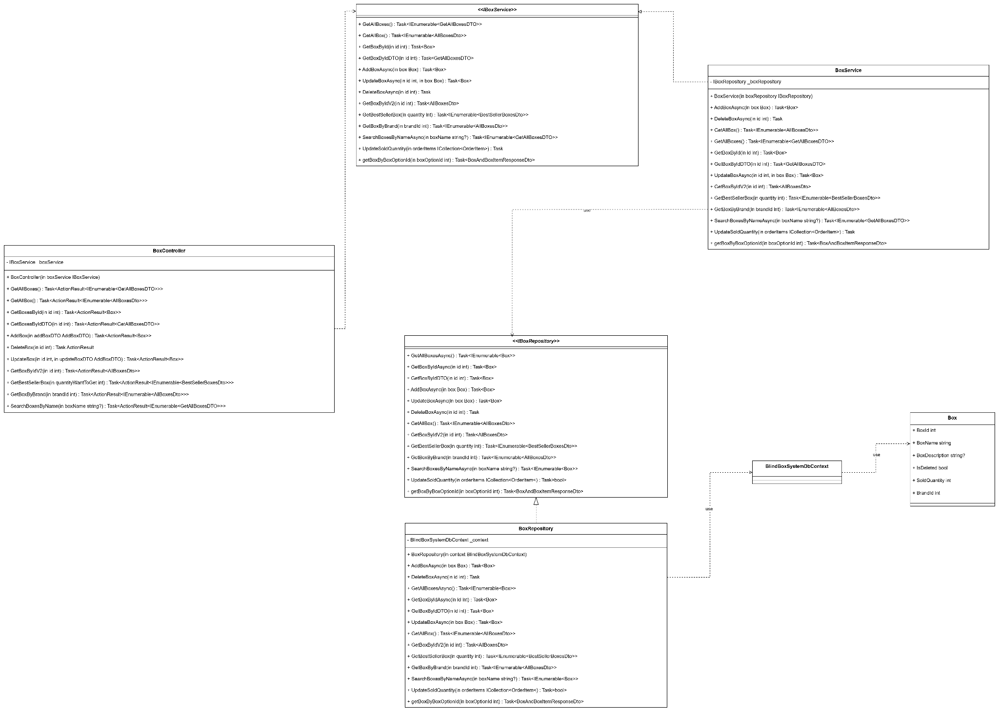

#### 

#### 

#### 

#### 3.4.11 Order (Quang Giáp)

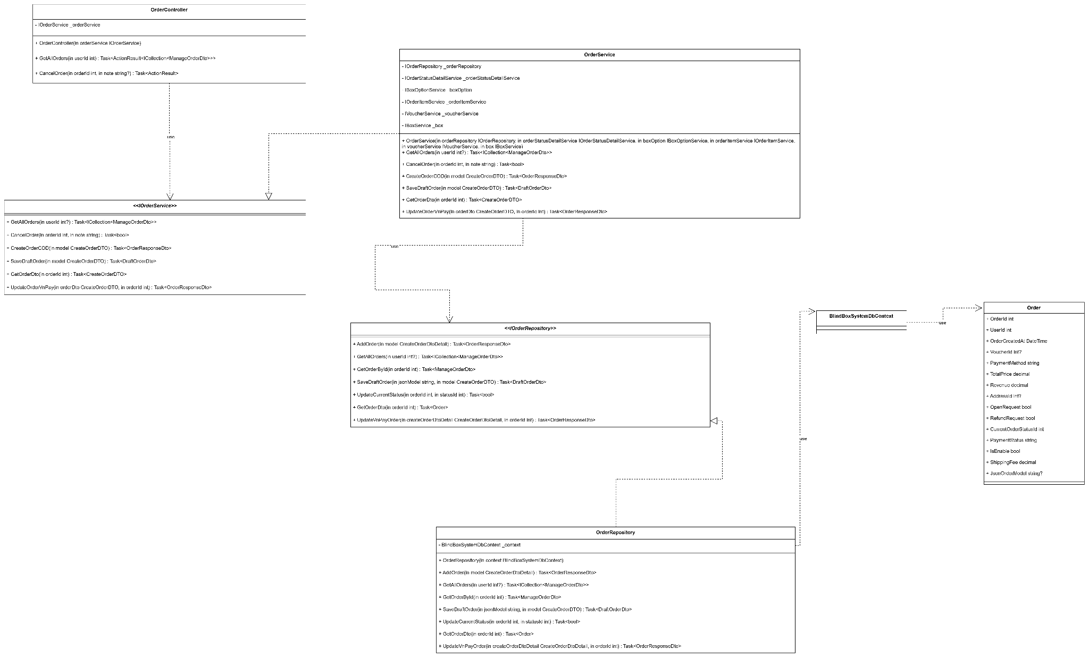

#### 3.4.12 Order Item (Quang Giáp)

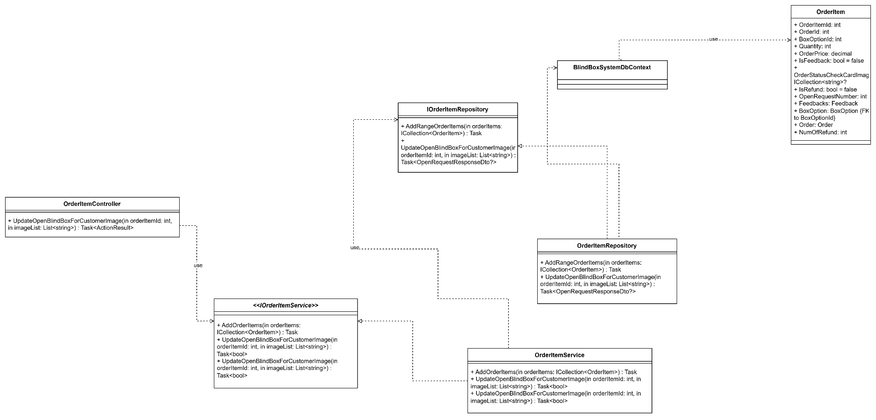

#### 3.4.13 Online Serie Box (Quang Giáp)

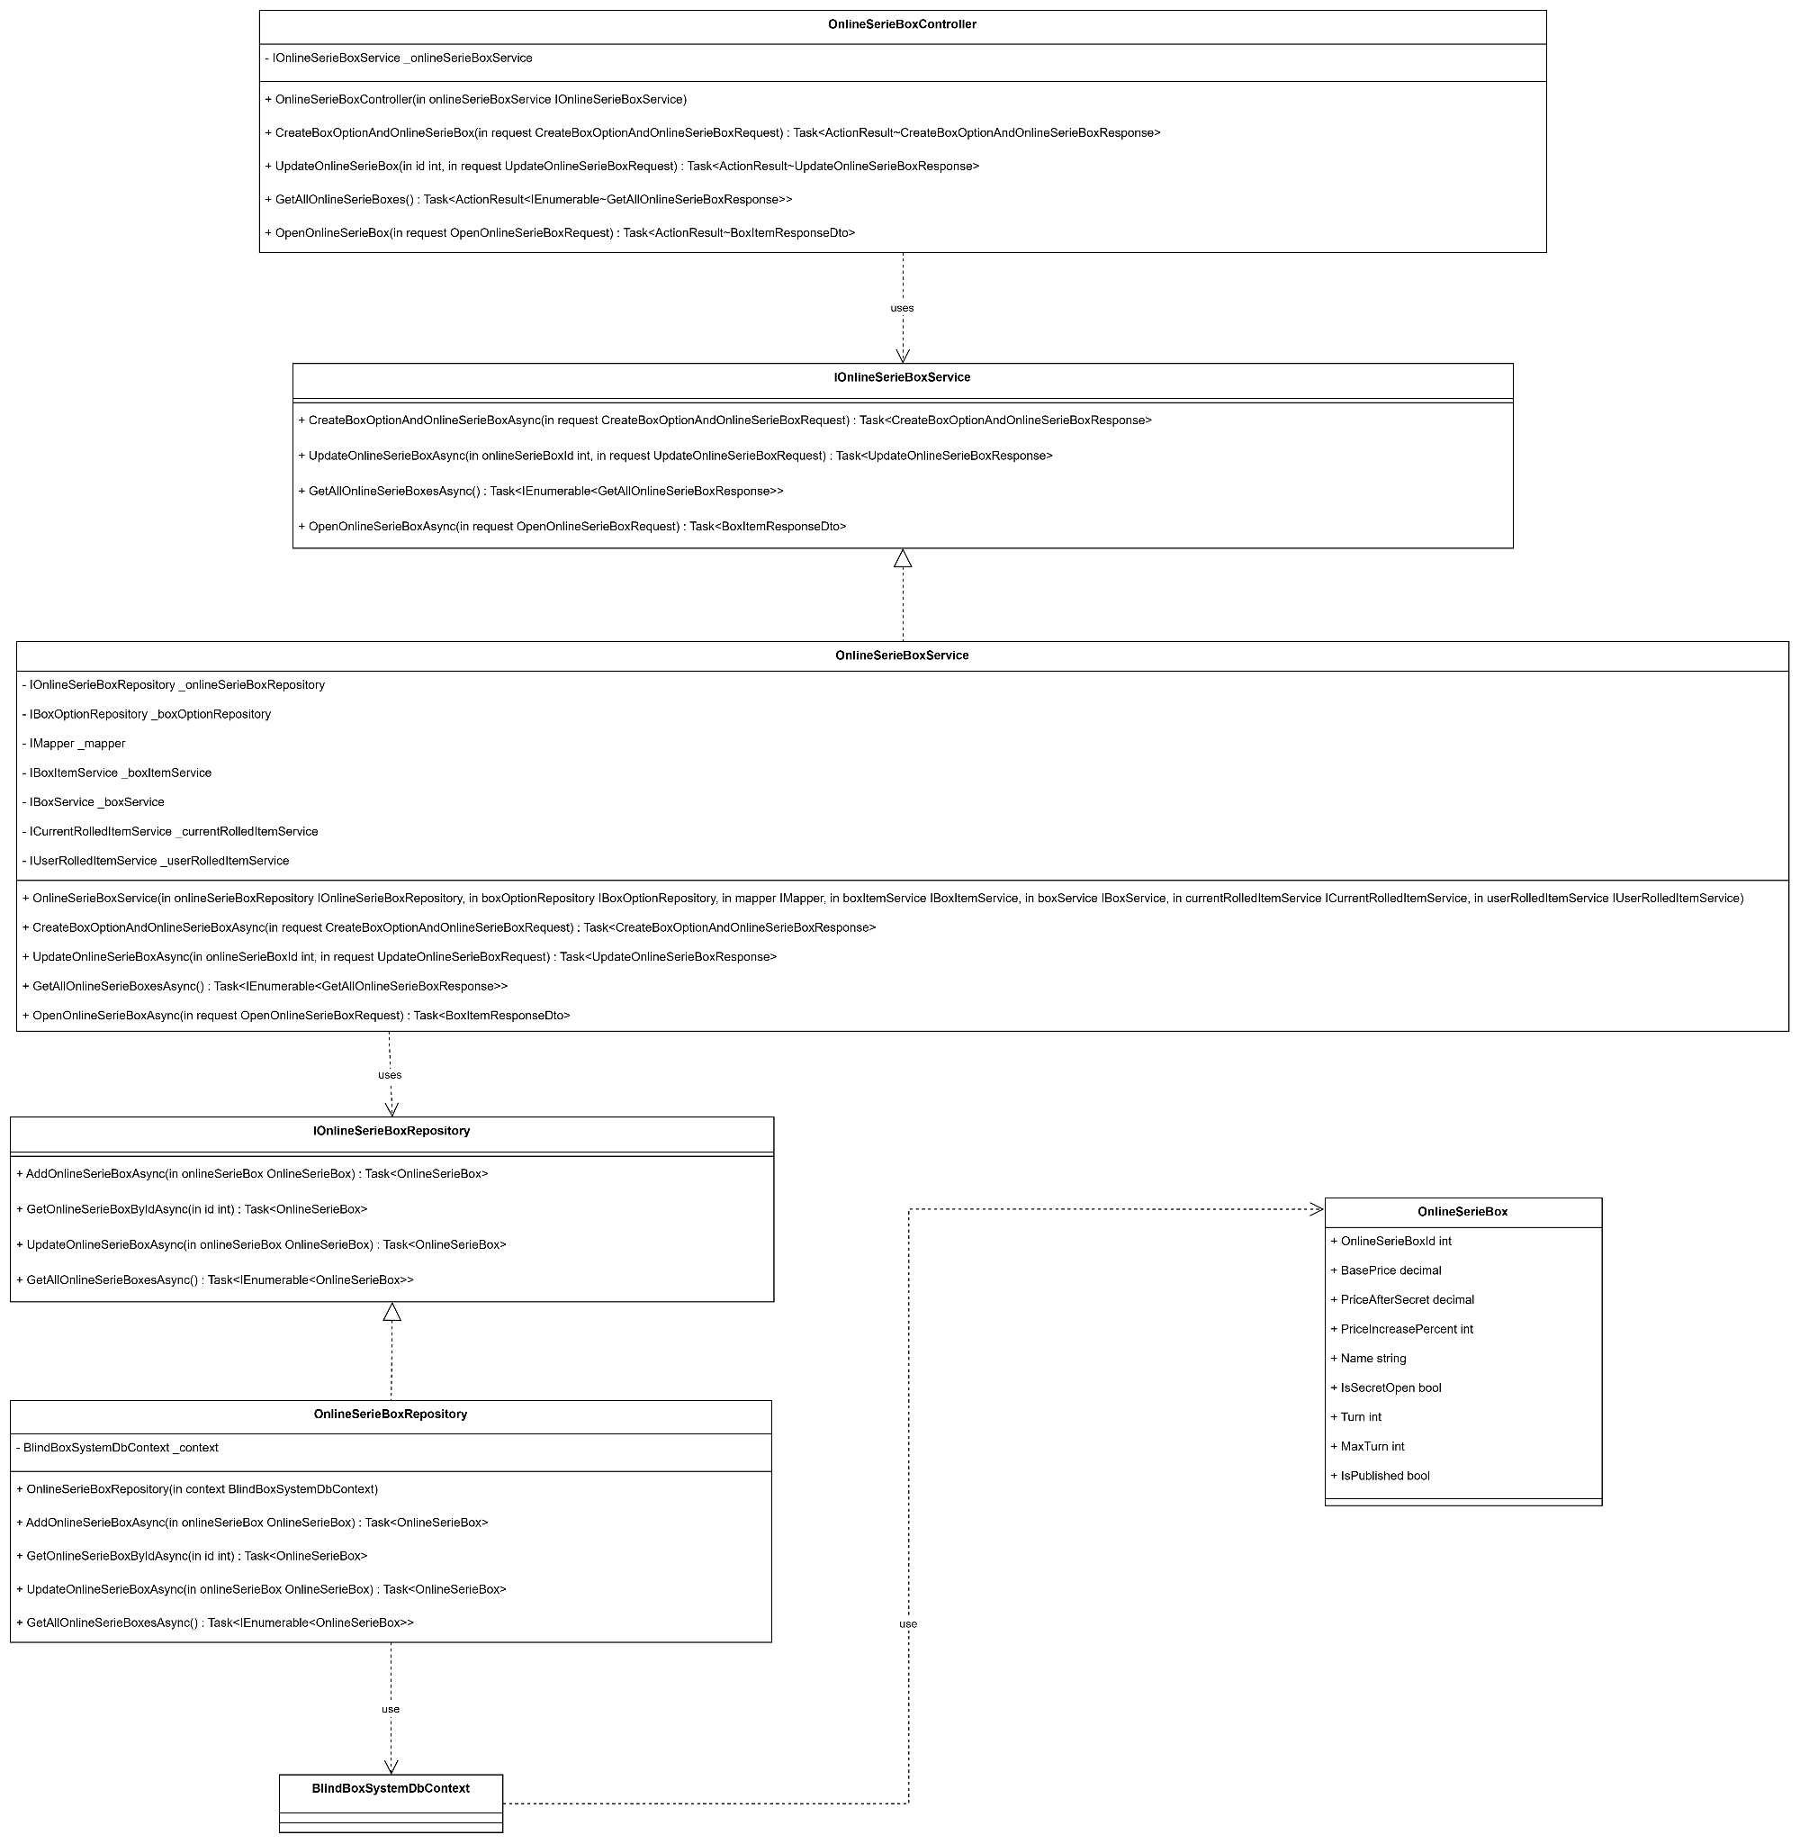

#### 3.4.14 Current Rolled Item (Quang Giáp)

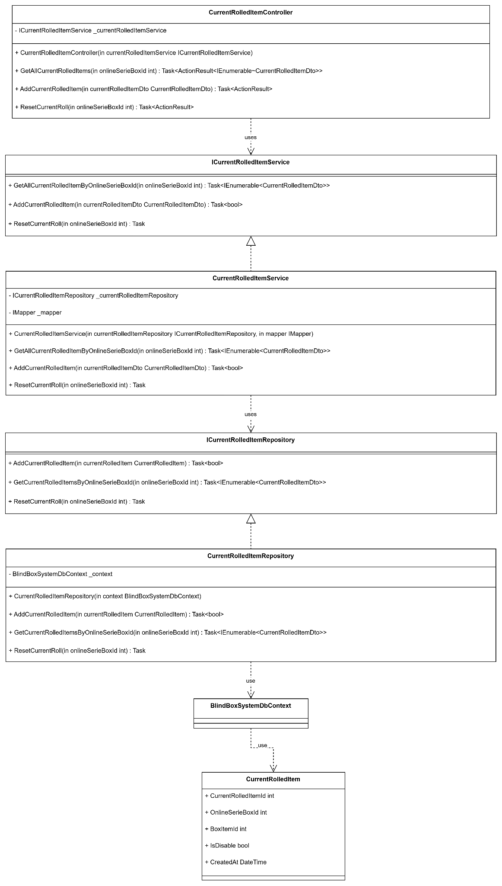

#### 3.4.15 User Rolled Item (Quang Giáp)

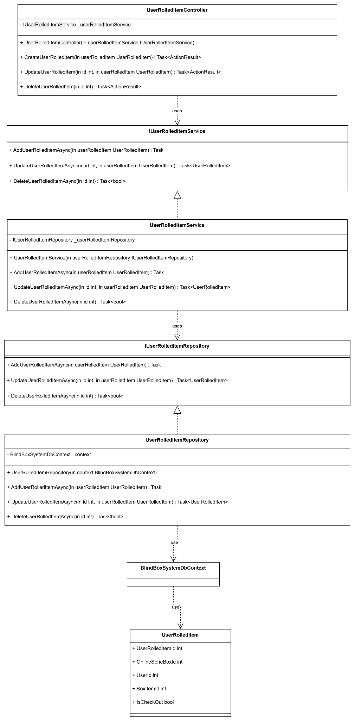

#### 3.4.16 Box Item (Thảo Vi)

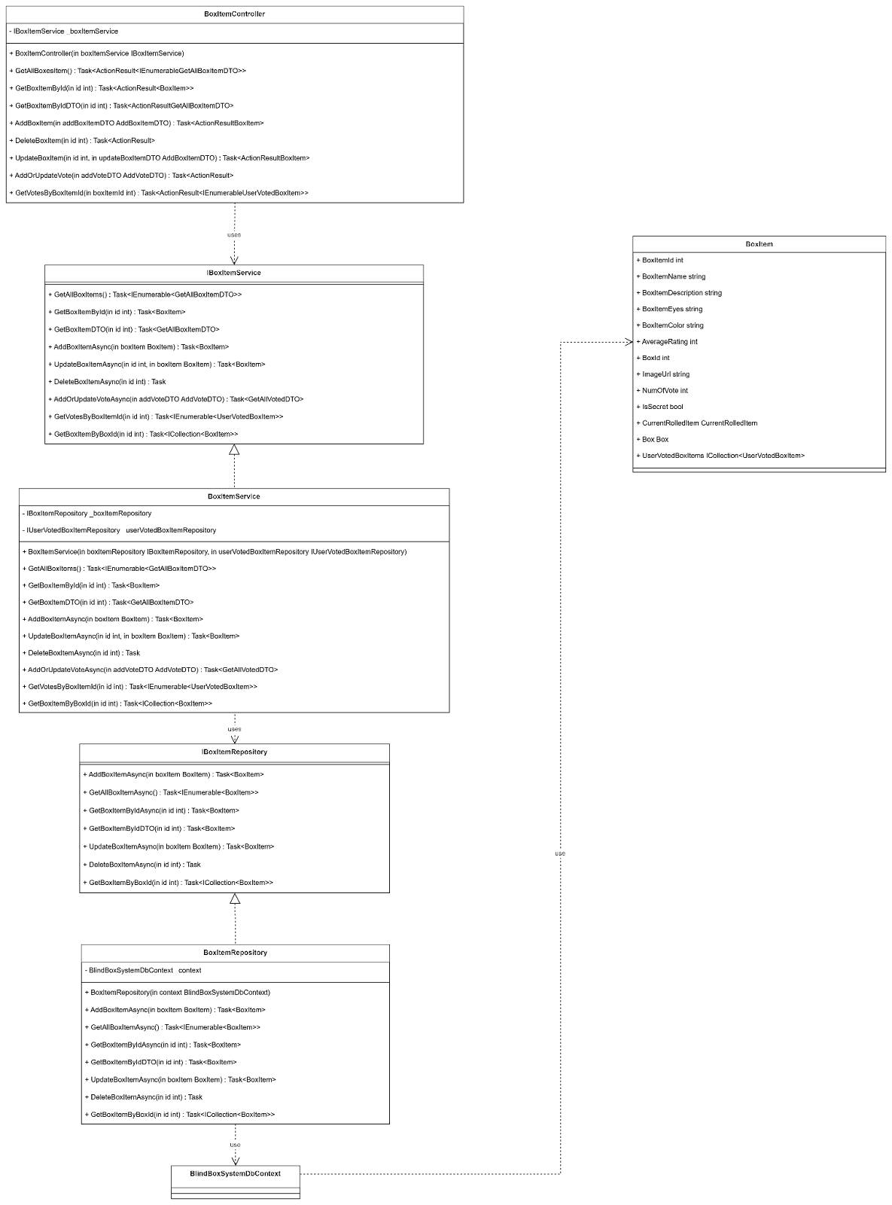

#### 3.4.17 User (Thảo Vi)

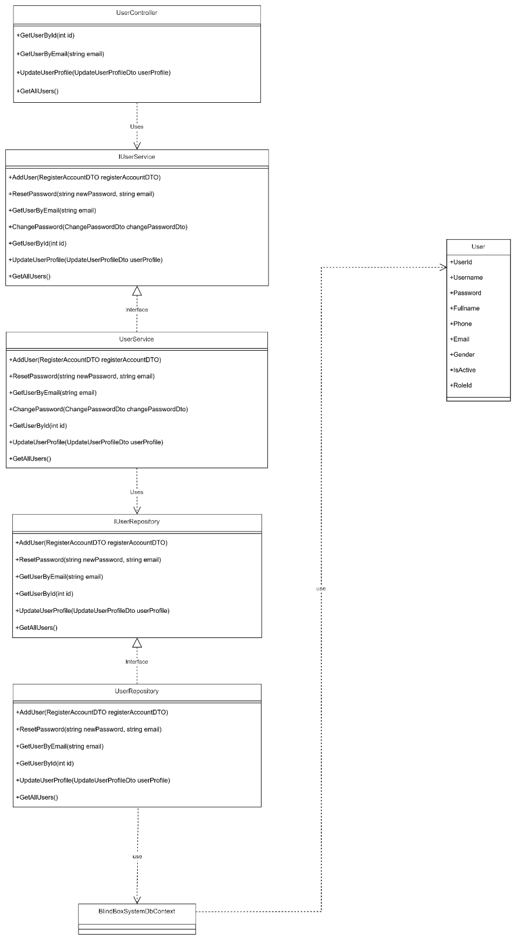

#### 

#### 3.4.18 Box Image(Thảo Vi)

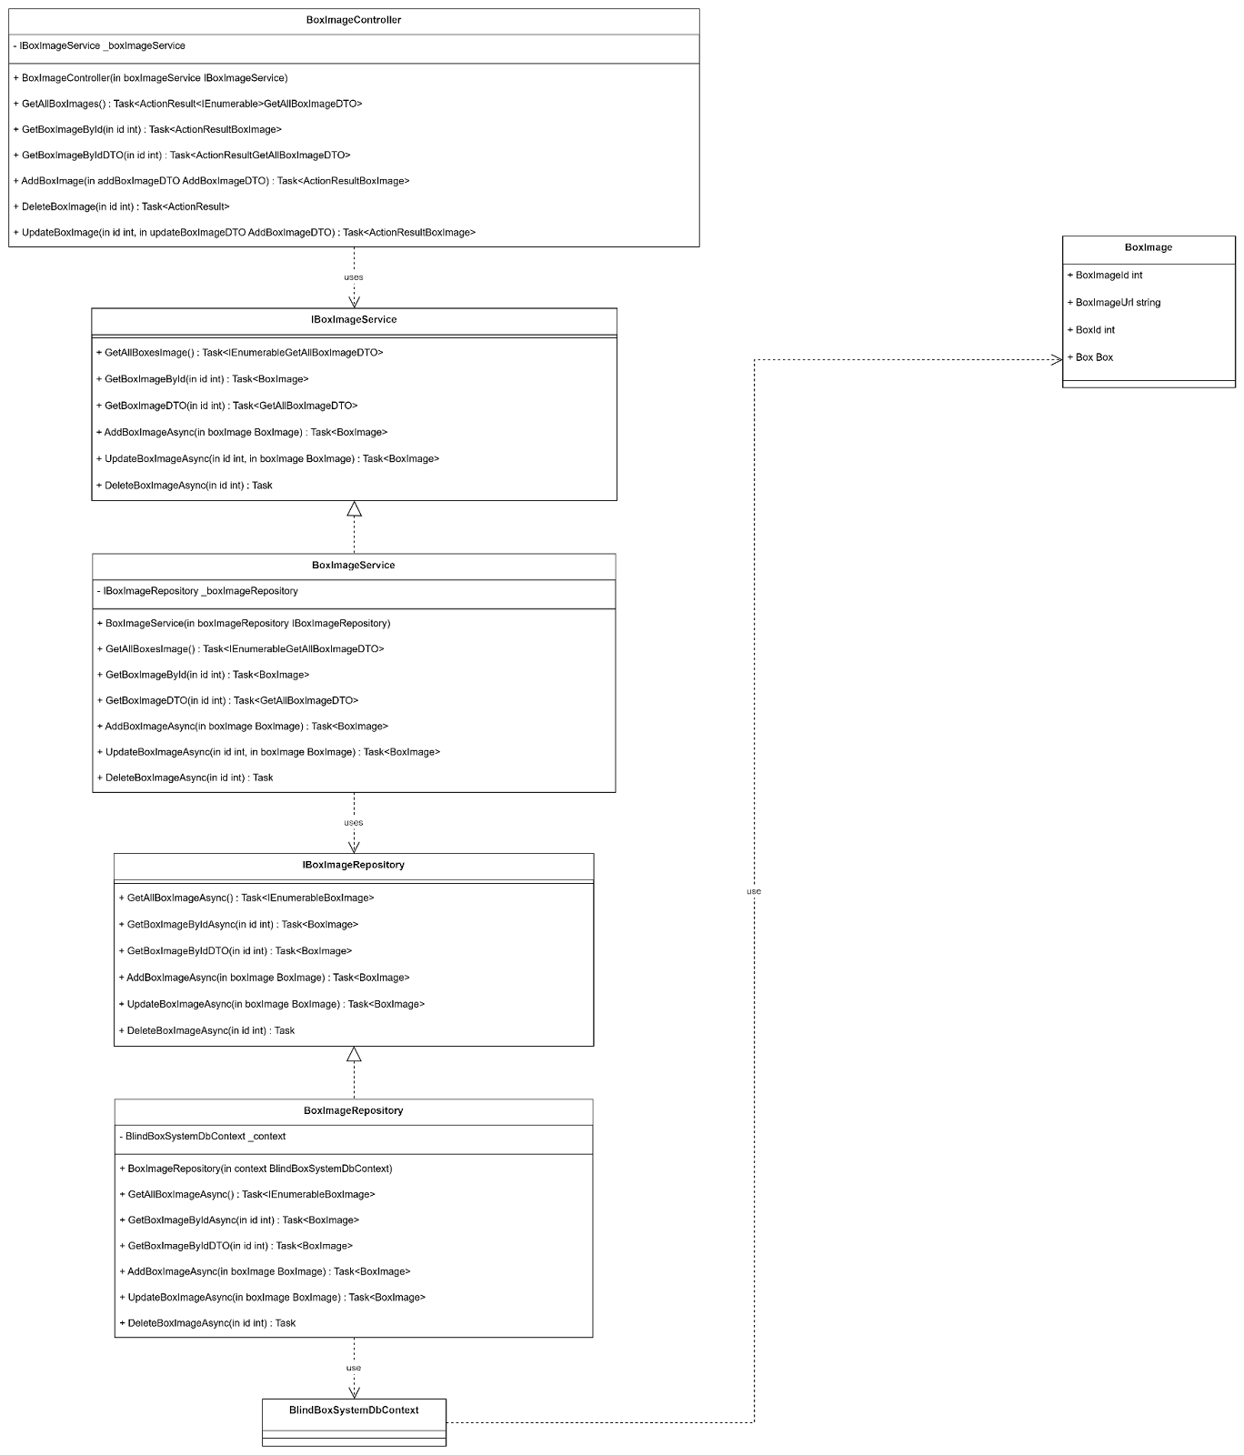

#### 3.4.19 Conversation (Quốc Phong)

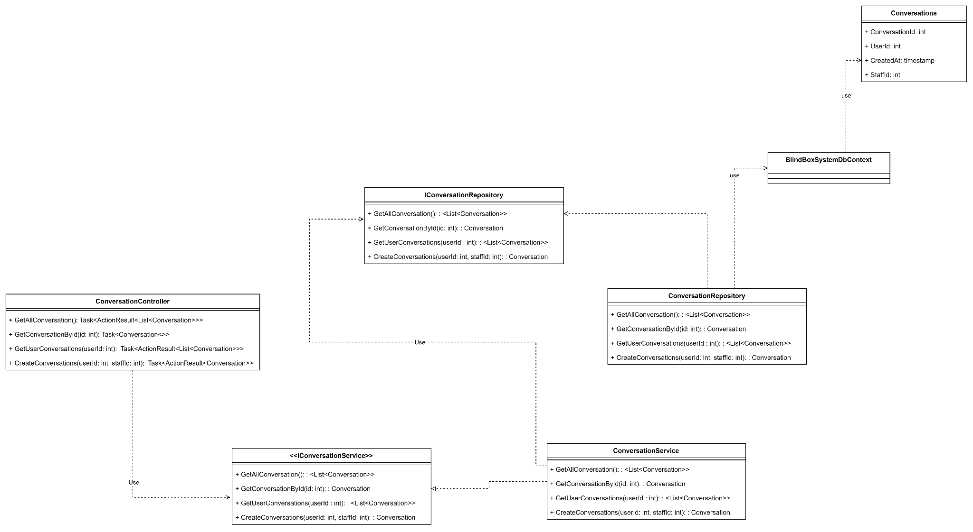

#### 3.4.20 Message (Quốc Phong)

